[COVER PAGE]
Design Standards & Product Specification for DoE Facilities

Part 1: Primary Schools
Western Australia

WA Primary Education Facilities Design Standards 2023
Guidelines relevant to Galvin Engineering product selection

*This Galvin Engineering document gives a snap shot of key points within the Primary School Subconsultants Brief and a snapshot of suitable products. For further details please refer to the relative subsection within the official brief document.

General Guidelines
This brief has been prepared to the define scope of consultant services, project details and design requirements for the Department of Finance (DoF) Standard Pattern Primary School.
DoF is responsible with the leading, delivery and management of buildings for Government, including State owned education facilities.
This document has been developed to assist consultants achieve the objectives of the State for primary school hydraulic services works and ensure that State’s aspirations for the construction and management of new building works is fully integrated within the vision of providing healthy, vibrant, equitable, safe and stimulating environments for education.
There shall be no deviation from the brief, unless explicitly authorised by the Department of Education (DoE) and provided in writing by the Department of Finance (DoF) project manager.

Soil, Waste and Vents (5.10.11.1)
- Cleanouts shall be used between manholes and on branch drains at locations required by AS3500 and the Regulating Plumbing Authority.
- Cleanouts shall be avoided within buildings wherever possible. Where this cannot be avoided, consideration to their location with respect to the disruption of school operation and access of drain cleaning equipment must be given.
- Cleanout points within a building shall be screwed down type of nickel bronze or similar and set flush with the finished floor level.
- Cleanout points external to a building and within paved or concrete areas shall be constructed of the drain or waste material and finished with a screwed access cap housed in a hinged cast iron box set flush with the finished surface lever. Box shall be cast into a concrete base and embossed with the word “SEWER”.
- All floor waste gullies shall consist of a 100mm P-trap, 100mm gully riser and a nickel bronze or similar grate set flush with finished surface level.

Location | Product Description | Image | Notes
FLOOR DRAIN OPTION 1; tile/concrete floor | 302182X  HeelGrate® Stainless Steel Floor Drain Grate Round 100x80 PVC Slip-In |  | - Square also available  - Other sizes also available  - Kits with cast iron bodies and puddle flanges also available
FLOOR DRAIN  OPTION 2;  tile/concrete  floor | 302185X  HeelGrate® Stainless Steel Floor Drain Grate Round 150x100 PVC/HDPE/CU Slip-In | 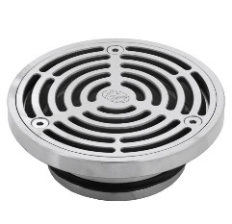 | - Square also available  - Other sizes also available  - Kits with cast iron bodies and puddle flanges also available
FLOOR DRAIN  OPTION 3;  vinyl floor | 303176X  Stainless Steel Floor Drain Grate Ass Vinyl 100x80 PVC Slip-In | 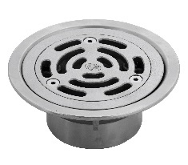 | - Other sizes also available  - Kits with cast iron bodies and puddle flanges also available
FLOOR DRAIN OPTION 4; vinyl floor | 303185X  HeelGrate® Stainless Steel Floor Drain Vinyl Round 150 x 100 with Stainless Steel Body PVC/HDPE/CU Slip-In | 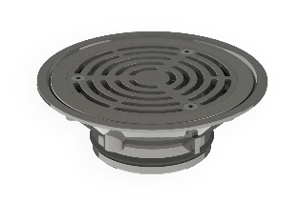 | - Other sizes also available  - Kits with cast iron bodies and puddle flanges also available
CLEANOUT  OPTION 1;  tile/concrete  floor | 67790X  Slip-Safe® SS316 Bolted Cleanout Round 150x100 PVC/HDPE/CU Slip-In | 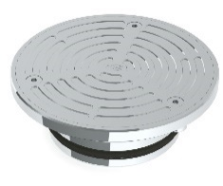 | - Other sizes also available  - Kits with cast iron bodies and puddle flanges also available
CLEANOUT  OPTION 2;  tile/concrete  floor, square | 67778X  HeelGrate® Slip-Safe® SS316 Bolted Cleanout Square 150x100 PVC / HDPE Slip-In | 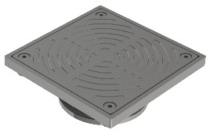 | - Kits with cast iron bodies and puddle flanges also available
CLEANOUT  OPTION 3;  vinyl floor | 69468X  Slip-Safe® SS Vinyl Bolted Cleanout 150 x 100 PVC/HDPE/CU Slip-In | 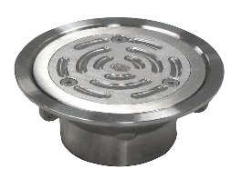 | - Other sizes also available  - Kits with cast iron bodies and puddle flanges also available

Trade Waste (5.10.11.2)
- Canteen sink outlets and floor waste gullies shall incorporate removable primary and fixed secondary strainers in accordance with Water Corporation Western Australia.

Location | Product Description | Image | Notes
Industrial Floor Waste Combo; round, tile/concrete | DI4M06RX  Industrial Floor Waste Combo - Stainless Steel Round Grate 150x100 PVC/HDPE/CU & Stainless Steel Dual Strainers | 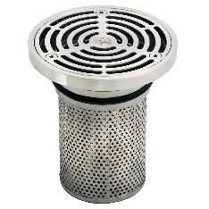 | - AS 3996 Class C and EN1253 Class C load rating  - AS/NZS 4994:1998 Discharge of commercial and industrial waste water to sewer
Industrial Floor Waste Combo; square, tile/concrete | DI4M06SX  Industrial Floor Waste Combo - Stainless Steel Square Grate 150x100 PVC/HDPE/CU & Stainless Steel Dual Strainers | 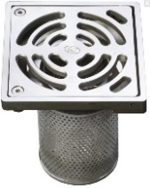 | - Single and double strainer options available  - Load rated to Class C
Industrial Floor Waste Combo; square, tile/concrete | DI4M08SX  Industrial Fl/Waste Combo - Stainless Steel Square Grate 200X100 PVC/HDPE/CU & Stainless Steel Dual Strainers | 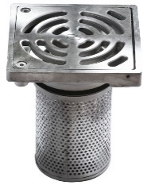 | - Single and double strainer options available  - Load rated to Class C
Industrial Floor Waste Combo; round, vinyl | DI4M06VX  Industrial floor waste combo Stainless Steel vinyl round grate 150x100 PVC/HDPE & dual S/S strainer | 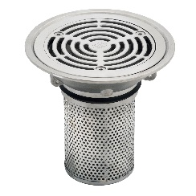 | - AS 3996 Class C and EN 1253 M125  - AS/NZS 4994:1998 Discharge of commercial and industrial waste water to sewer

Stormwater Drainage (5.10.11.3)
- Grated channels and/or paving drains shall be located at pavement low points in paved areas around buildings. Wherever possible, pavement low points shall be not in the centre of pathways.
- The channel grates or paving drain grates in trafficable or pedestrian areas shall be of a design that allows wheelchairs, trolleys or bicycles to be safely wheeled across them, anti-slip and have the ability to be locked down. Paving drain grates in pedestrian areas are to be stainless steel with a minimum dimension of 300x300mm. Grates located in areas subject to vehicle loads shall be rated accordingly.

Location | Product Description | Image | Notes
PAVING DRAIN; round | 302205X  HeelGrate® Stainless Steel Floor Drain Grate Assembly Round 300x150BSP | 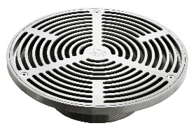 | - 5mm gap between bars  - Suitable for concourse paving and tiled applications
PAVING DRAIN; square | 302605X  HeelGrate® Stainless Steel Floor Drain Grate Assembly Square 300x150BSP | 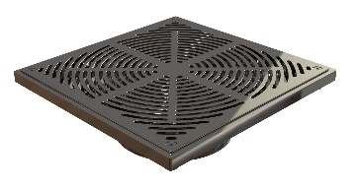 | - 5mm gap between bars  - Suitable for concourse paving and tiled applications  - Load tested to Class B of AS 3996
PAVING DRAIN ADAPTOR | 302180  ABS Floor Drain Adaptor 150BSP FI X 100PVC Slip-In | 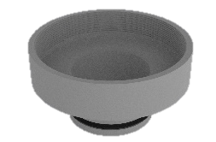
PAVING DRAIN ADAPTOR | 302173  ABS Floor Drain Adaptor 150BSP FI X 150PVC Slip-in | 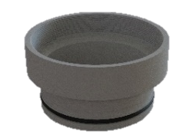

Heated Water Service (5.10.11.5)
- Provide a tempered water service connection of 45°C to the following fixtures:
  - UAT Showers & Basins
  - Staff Basins (excluding dental therapy)
  - Medical room basin
  - Science and Arts practical trough (1 and 2 only)
  - Pre Primary Kitchen Sinks
  - Activity Area Sinks
  - Library Resource area sinks (only relevant with the staff room is not incorporated into library block.
- A thermostatic mixing valve shall be located at the water heater in a visible and easily accessible position and to be set to deliver 45°C water at the outlet.

Location | Product Description | Image | Notes
TMV | 101.70.00.00  CliniMix® Lead Safe™ Thermostatic Mixing Valve With - 15 Inlet & 15/20 Outlet | 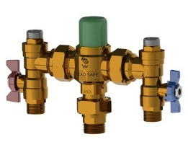 | - Lead Safe™ DZR Brass with less than 0.25% lead content  - Scald or cold water shock protection
TMV IN CABINET | 101.10.70.10  CliniMix® Lead Safe™ TMV SS Cabinet Assembly with Universal Door 20 Bottom In & Out | 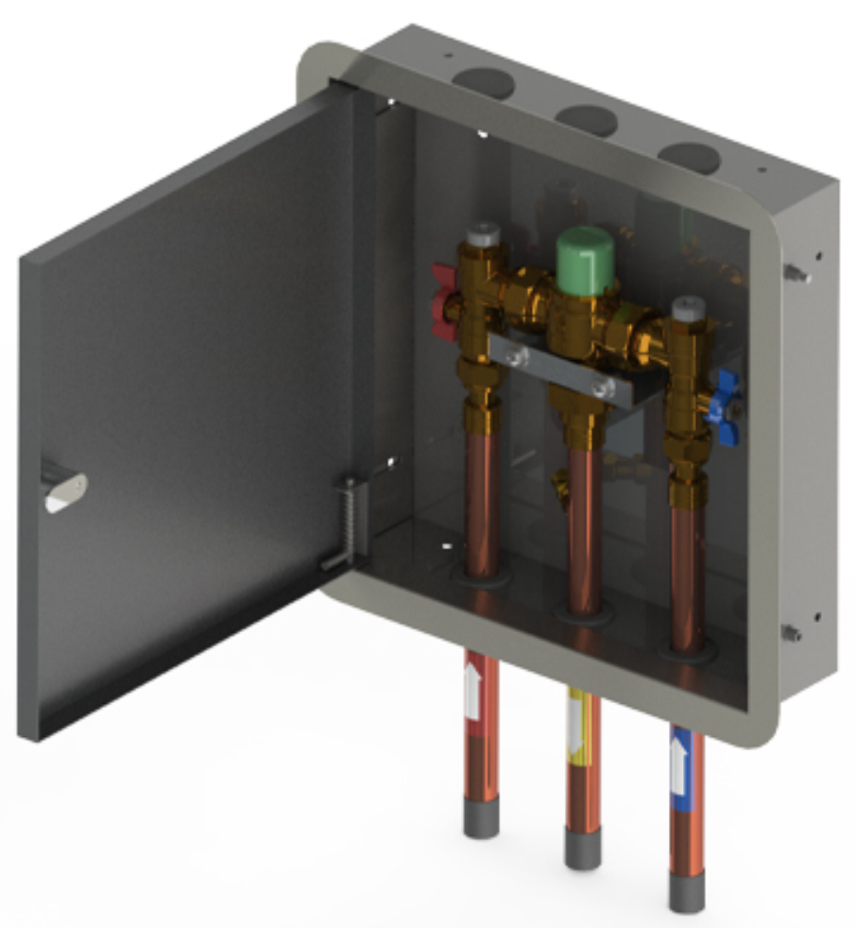 | - Lead Safe™ DZR Brass with less than 0.25% lead content  - Scald or cold water shock protection
TMV IN CABINET; with bypass | 101.11.70.10  CliniMix® Lead Safe™ TMV SS Cabinet Assembly with Universal Door 20 Cold Bypass, Bottom In & Out | 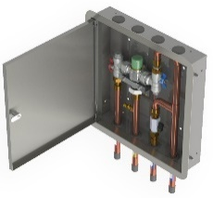 | - Lead Safe™ DZR Brass with less than 0.25% lead content  - Scald or cold water shock protection

Water end Energy Saving (5.10.11.6)
All fixtures and tapware shall comply with the WELS standard AS6400, specifically:
- A tap or outlet used for a shower, basin, ablution trough, practical trough or sink must be a minimum of 3 star WELS rated and discharge not more than 9 litres per minute.
- Cisterns or flushing devices for water closets must have a dual flush mechanism and be a minimum 3 star WELS rating discharging not more than 6 litres or 4.5 litres for a full flush.
- Student ablution troughs shall be fitted with suitable cold only time flow tapware.
- The shower outlet specified should be suitable for use with a reduced flow rate. It should be noted that some shower heads with inbuilt water conservation systems give an uncomfortable and unsatisfactory shower, these types must be avoided.

Fire Service (5.10.11.7)
- Hydrants shall be located in easily accessible locations and highly visible from intended DFES appliance hardstand areas though as not to obstruct the movement of staff and students.
- The hydrant valves shall generally point in the direction of the DFES hardstand.
- In situations where hydrants are susceptible to vehicular contact, protection bollards shall be installed and painted to match.
- Hydrant vandal resistant covers shall be installed over the hydrant valves, chained secure and padlocked all keyed alike.
- Generally, fire hose reels are NOT required to serve buildings such as the administration, library, canteen, assembly and gymnasium where fire compartments may be greater than 500m2.

Location | Product Description | Image | Notes
HYDRANT RISER | 381337  Hydrant Pipe Riser with Dual Head, Flanged Vert Inlet 100TE x 1500 Long (Galv & Painted) |  | - Hot dipped galvanised to AS/NZS 4680  - Drilled Table E flange
HYDRANT RISER | 381358  Hydrant Pipe Riser with Dual Head, Flanged Vert Inlet 150TE x 1400 Long (Galv & Painted) |  | - Hot dipped galvanised to AS/NZS 4680  - Drilled Table E flange
HYDRANT VALVE; threaded | 381301  Red Emperor® Fire Valve 65 BIC withTop B/Fly Cap [WA] Painted - BSP Inlet with Nylon Plug | 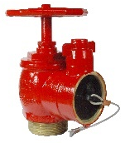 | - AS 2419.2 compliant
HYDRANT VALVE; roll groove | 381301RG  Red Emperor® Fire Valve 65 BIC with Top B/Fly Cap [WA] Painted- R/Groove Inlet with Nylon Plug | 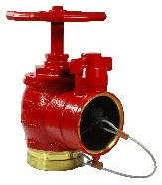 | - AS 2419.2 compliant
TAMPER COVER | 381331  Tamper Resistant Dual Hydrant Valve Cover (Painted) w /003 Padlock | 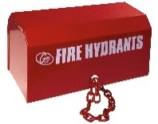 | - Tamper resistant protection for fire landing valves  - Only suitable for dual head riser
FIRE HOSE REEL; fixed | 383026RE  Red Emperor® F Series Standard Fixed Fire Hose Reel with Swing Guide Arm 36m – Red | 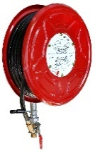 | - Certified to AS/NZS 1221
FIRE HOSE REEL; swing | 382523  Red Emperor® G Series Premium Swing Fire Hose Reel LH/RH with Fixed Waterway 36m – Red | 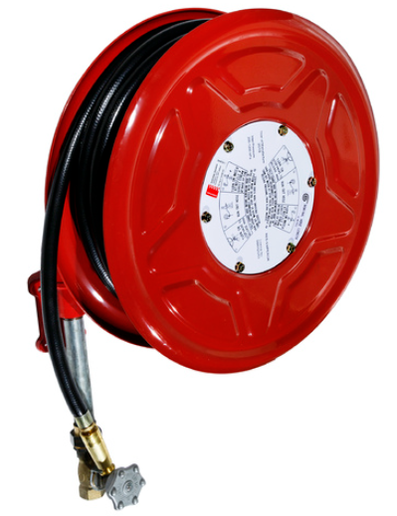 | - Can be paired with hose reel cabinets  - Certified to AS/NZS 1221
HOSE REEL CABINET | 381905  Type A Standard Fire Reel Box Exposed (Painted) | 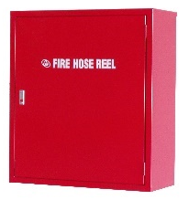 | - Designed to suit G Series reels
HYDRANT BOOSTER | 380162  WA/NT Pipeset for 100TE Firemain Booster & Hydrant (Painted & Assembled) | 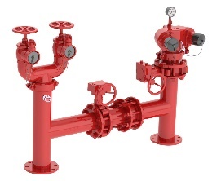 | - Kits also available with cabinet.  - Kits also available with suction riser  - Drilled Table E flange  - AS 2419.1 and AS 2419.3 compliant
HYDRANT BOOSTER | 380170  WA/NT Pipeset for 150TE Quad Firemain Booster & Hydrant (Painted & Semi-Assembled) | 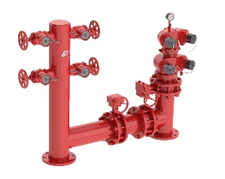 | - Kits also available with cabinet.  - Kits also available with suction riser  - Drilled Table E flange  - AS 2419.1 and AS 2419.3 compliant

Water Closets (5.10.12.1)
- Toilets on ducts shall consist of a wall mounted concealed P-trap pan with induct 3/4.5 litre cistern, fixing kit, pneumatic dual flush button and soft closing double flap seat.
- Generally, toilets elsewhere shall consist of a concealed S-trap pan, close coupled vitreous china 3 / 4.5 litre cistern with vandal resistant lid, and soft closing double flap seat.
- Disabled toilets shall consist of disabled concealed P-trap pan, mid mounted vitreous china cistern with separate backrest, chrome plated disabled flush buttons; chrome plated flush pipe and disabled grey coloured single flap seat with 30% contrast in colour.
- Particular attention shall be given to the set-out of disabled fixtures to comply with AS1428.
- Junior pans shall not be installed.

Location | Product Description | Image | Notes
TOILET SUITE | 105.10.00.00  GalvinAssist® Wall Faced, Clean Flush, Easy Care Toilet Suite with Soft Close Seat | 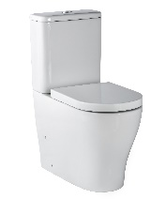 | - Soft-closing, easy-clean quick release seat  - Suitable for S or P trap installations
TOILET SUITE; ambulant | 105.10.20.00  GalvinAssist® Wall Faced, Clean Flush, Easy Care, Ambulant Toilet Suite with Soft Close Seat | 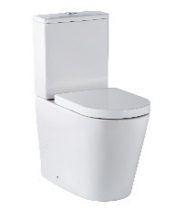 | - Soft-closing, easy-clean quick release seat  - Suitable for S or P trap installations  - Compliant with AS1428.1 Ambulant guidelines
TOILET SUITE; disabled | 105.10.10.01  GalvinAssist® Wall Faced, Clean Flush, Easy Care, Ambulant Toilet Suite with Soft Close Seat | 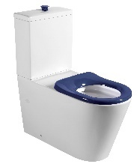 | - Soft-closing, easy-clean quick release seat  - Suitable for S or P trap installations  - Compliant with AS1428.1 Ambulant guidelines
TOILET PAN | 105.11.00.00  GalvinAssist® Wall Faced, Clean Flush, Easy Care, Toilet Pan with Soft Close Seat |  | - To be paired with in wall cistern and push buttons  - Soft-closing, easy-clean quick release seat  - Suitable for S or P trap installations
TOILET PAN; disabled | 105.11.10.01  GalvinAssist® Wall Faced, Clean Flush, Easy Care, Accessible Toilet Pan with Blue Seat | 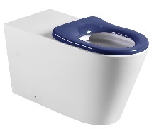 | - To be paired with in wall cistern and disabled push buttons  - Soft-closing, easy-clean quick release seat  - Suitable for S or P trap installations  - Compliant with AS1428.1 Ambulant guidelines
IN WALL CISTERN | 105.94.00.00  GalvinAssist® Slim Design Inwall Cistern, Less Flush Plate | 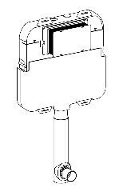 | - Suits floor mount toilet pan  - Front access to cistern through flush plate
PUSH BUTTONS | 105.95.00.00  GalvinAssist® Chrome, Dual Flush Plate, Pneumatic Push to Suit Inwall Cistern | 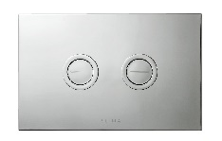 | - Premium pneumatic system  - Provides complete access to in-wall cistern
PUSH BUTTONS; disabled | 105.96.00.00  GalvinAssist® Chrome, Accessible Dual Flush Plate, Pneumatic Push to Suit Inwall Cistern |  | - Premium pneumatic system  - Provides complete access to in-wall cistern

Basins (5.10.12.2)
UAT & AAT
- Basins shall be vitreous china wall hung approximately 550mm wide x 435mm deep with one tap hole and secured with heavy duty wall brackets.
- Particular attention shall be given to the set-out of the disabled fixtures to comply with AS1428.
Staff
- Basins shall be vitreous china semi recessed approximately 500mm wide x 430mm deep with one tap hole and secured with heavy duty tie brackets.
Canteen
- Basins shall be vitreous china wall hung approximately 550mm wide x 435mm deep with one tap hole and secured with heavy duty wall brackets.
Dental Therapy
- Refer to the DoF standard hydraulic dental therapy drawing.

Location | Product Description | Image | Notes
UAT, AAT & CANTEEN; LH bowl, 1TH | 105.33.10.01  GalvinAssist® Accessible, 600mm Wall Mount Basin, LH Bowl, 1 TH with Overflow | 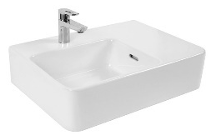 | - Accessories not included  - Left hand bowl  - 1 taphole
UAT, AAT & CANTEEN; RH bowl, 1TH | 105.33.11.01  GalvinAssist® Accessible, 600mm Wall Mount Basin, RH Bowl, 1 TH with Overflow | 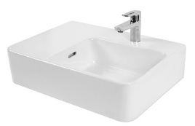 | - Accessories not included  - Right hand bowl  - 1 taphole
UAT, AAT & CANTEEN; LH bowl, 3TH | 105.33.11.03  GalvinAssist accessible 600mm wall mount basin LH bowl 3TH |  | - Accessories not included  - Left hand bowl  - 3 taphole
UAT, AAT & CANTEEN; RH bowl, 3TH | 105.33.10.03  GalvinAssist accessible 600mm wall mount basin RH bowl 3TH |  | - Accessories not included  - Right hand bowl  - 1 taphole
STAFF; 1TH | 105.36.01.01  GalvinAssist® Semi Recessed Basin, 500mm  1 TH with Overflow |  | - Accessories not included  - 1 taphole
STAFF; 3TH | 105.36.01.03  GalvinAssist® Semi Recessed Basin, 500mm  3 TH with Overflow |  | - Accessories not included  - 3 taphole
BOTTLE TRAP | 105.93.00.00  GalvinAssist® Chrome, Round Bottle Trap, Wall Exit, Suits 32mm & 40mm Waste Holes |  | - Suits 32 or 40 mm wastes  - Designed for use with wall basins and installations with exposed plumbing

Kitchen Sinks (5.10.12.3)
Medical Room
- Stock pattern single end bowl stainless steel inset sink approximately 1235mm wide x 470mm deep with one tap hole centre to bowl.
Staff Room
- Stock pattern double centre bowl stainless steel inset sink approximately 1540mm wide x 470mm deep with one tap hole centre to bowls.
Library
- Stock pattern single end bowl stainless steel inset sink approximately 1235mm wide x 470mm deep with one tap hole centre to bowl (only relevant with staff room is not incorporated into library block).
Activity Areas
- Stock pattern single end bowl stainless steel inset sink approximately 1235mm wide x 470mm deep with one tap hole centre to bowl.
Pre-Primary Kitchens
- Stock pattern double centre bowl stainless steel inset sink approximately 1540mm wide x 470mm deep with one tap hole centre to bowls.

Canteen
- Forms part of the architectural brief.
Dental Therapy
- Refer to the DoF standard hydraulic dental therapy drawing.

Location | Product Description | Image | Notes
STAFF ROOM & PRE PRIMARY KITCHENS | 105.82.00.01  GalvinAssist® SS, 1500mm Sink, Double Centre Bowls, 1 TH |  | - Sound deadening, designer basket waste

Tapware and Outlets (5.10.13)
In general terms, tapware and outlets shall be WELS registered, carry Watermark standards, incorporate vandal resistant features, of chrome plated brass construction, fitted with heavy duty brass jumper valves and colour coded buttons indicating either cold or hot.

Basins (5.10.13.2)
UAT & AAT
- Chrome plated solid brass basin mixer tap with soft close ceramic disc cartridge, extended lever handle and 150mm swivel outlet.
Staff
- Chrome plated solid brass basin mixer tap with soft close ceramic disc cartridge and 150mm swivel outlet.
Canteen
- Chrome plated solid brass knee operated valve kit with 150mm gooseneck spout.
Dental Therapy
- Refer to the DoF standard hydraulic dental therapy drawing.

Location | Product Description | Image | Notes
UAT & AAT | TM-BASCPD  CliniLever® CP-BS Hospital Single Lever Basin Mixer with 165 Disabled Lever |  | - Anti-scald adjustable stop ring  - Optional warm/cold indicator decal  - AS 1428.1 accessible compliant
UAT & AAT | TM-BASCPDL  GalvinAssist® Single Lever Basin Mixer with 165mm Accessible Lever | 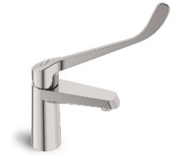 | - Anti-limescale aerator M 24 x 1  - Optional warm/cold indicator decal  - AS 1428.1 accessible compliant
UAT & AAT; stainless steel | TM-BASXD  CliniLever® Stainless Steel Lead Safe™ Basin Mixer with Accessible Lever | 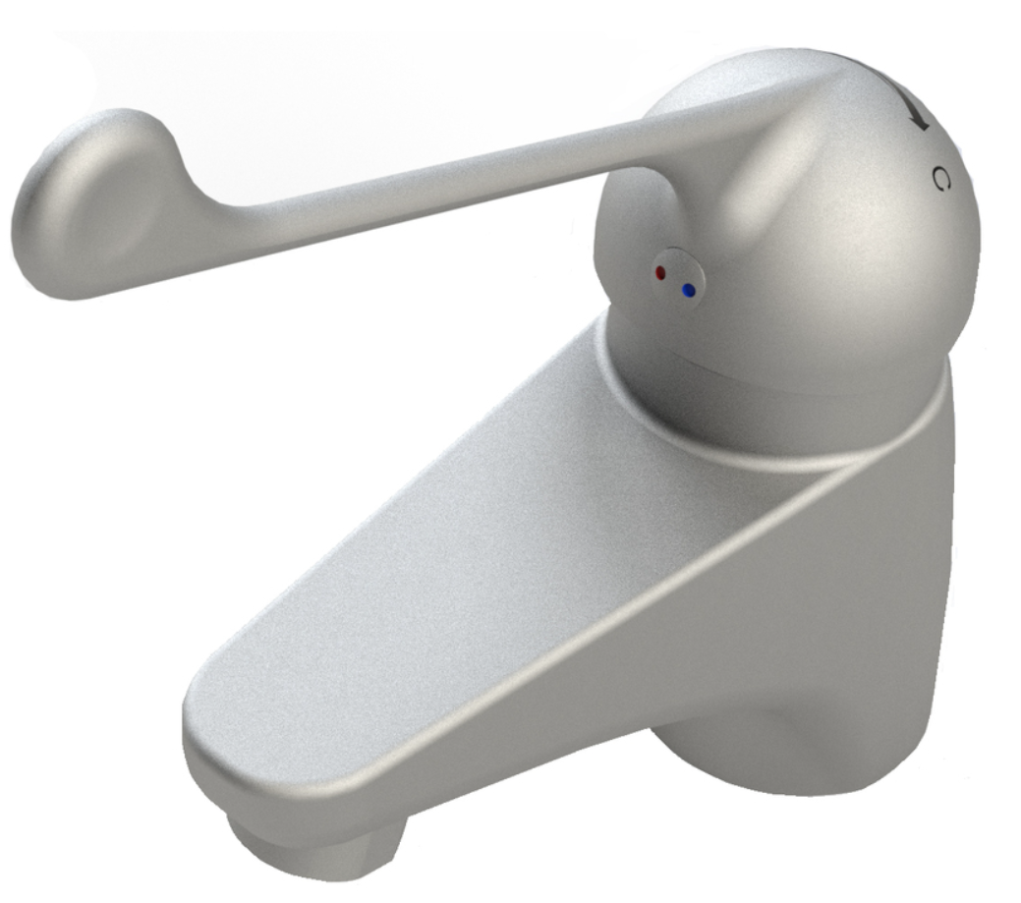 | - Lead Safe™ material  - AS 1428.1 accessible compliant
STAFF | TM-BASCP  CliniLever® CP-BS Hospital Single Lever Basin Mixer | 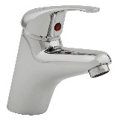 | - Vandal-resistant  - Anti-scald adjustable stop ring  - Optional warm/cold indicator decal
STAFF | TM-BASCPL  GalvinAssist® Single Lever Basin Mixer | 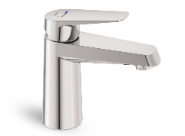 | - 2 Step ceramic cartridge  - Anti-limescale aerator M 24 x 1
STAFF; stainless steel | TM-BASX  CliniLever® Stainless Steel Lead Safe™ Basin Mixer | 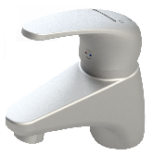 | - Lead Safe™ material
CANTEEN | TP08045K  Chrome Plated Brass Knee Operated Timeflow Valve with Regulator, Spout & Connection Kit | 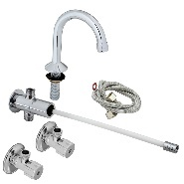 | - Robust lever for heavy usage

Sinks (5.10.13.3)
Medical Room
- Chrome plated solid brass sink mixer tap with soft close ceramic disc cartridge and 150mm swivel outlet.
Staff Room
- Chrome plated solid brass sink mixer tap with soft close ceramic disc cartridge and 240mm swivel outlet.
Library
- Chrome plated solid brass sink mixer tap with soft close ceramic disc cartridge and 150mm swivel outlet (only relevant with staff room is not incorporated into library block).
Activity Areas
- Chrome plated solid brass sink mixer tap with soft close ceramic disc cartridge and 150mm swivel outlet.
Pre-Primary Kitchens
- Chrome plated solid brass sink mixer tap with soft close ceramic disc cartridge and 240mm swivel outlet.
Canteen
- Chrome plated solid brass sink mixer tap with soft close ceramic disc cartridge and 240mm swivel outlet.
Dental Therapy
- All three taps servicing sinks are to have extended single lever mixers to allow for elbow operation confirming to the Department of Health infection protocols.
- Refer to the DoF standard hydraulic dental therapy drawing.
Cleaner Sinks
- 1 No. chrome plated solid brass vandal resistant cold and hot wall set with 200mm swivel gooseneck outlet
- 1 No. non-potable cold water threaded bib tap over cleaners sink connected to a double check valve mounted on wall; and
- 1 No. wall mounted handheld eye wash / body spray with wall bracket, twin outlet spray head, automatic stay open trigger handle, and flexible hose assembly in accordance with AS4775.
Canteen Pot Sink
- Over each pot sink – chrome plated solid brass cold and hot wall set with heavy duty chrome plated brass 300mm swivel goose neck outlet.
Gardener Trough
- Chrome plated solid brass sink mixer tap with soft close ceramic disc cartridge and 240mm swivel outlet.
Ablution Troughs
- Pre Primary – 4 No. lever action time flow chrome plated solid brass bib taps with 50mm bib extensions.
- Primary – 4 No. push button time flow chrome plated solid brass bib taps with 50mm bib extensions.
Practical Troughs
- Pre Primary – 4 No. chrome plated solid brass bib taps with 50mm bib extensions.
- Art Room – 1 No. chrome plated solid brass vandal resistant cold and hot wall set with 200mm swivel gooseneck outlet and; 3 No. Cold ONLY chrome plated solid brass wall sets with 200mm swivel gooseneck outlets.
- Art Room – 4 No. Cold chrome plated solid brass wall sets with 200mm swivel gooseneck outlets.
- Dental Therapy – Refer to the DoF standard hydraulic dental therapy drawing.

Location | Product Description | Image | Notes
MEDICAL, ACTIVITY ROOM & LIBRARY | TM-SNKGCPL  GalvinAssist® Single Lever Gooseneck Sink Mixer | 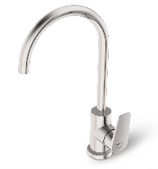 | - Oversized coloured directional temperature indicators  - Temperature adjusting rings  - Anti-limescale aerator M 24 x 1
MEDICAL, ACTIVITY ROOM & LIBRARY | TM-SNKGX  CliniLever® Stainless Steel Lead Safe™ Gooseneck Sink Mixer |  | - Lead Safe™ material
STAFF, CANTEEN, GARDENER & PRE PRIMARY KITCHEN | TM-SNKCP  CliniLever® CP-BS Hospital Single Lever Sink Mixer 250 Reach with 165 Disabled Lever | 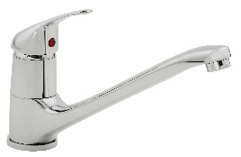 | - Anti-scald adjustable stop ring  - Extended 165mm lever for easy access  - AS 1428.1 accessible compliant
STAFF, CANTEEN, GARDENER & PRE PRIMARY KITCHEN | TM-SNKCPL  GalvinAssist® Single Lever Sink Mixer | 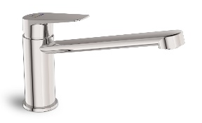 | - Oversized coloured directional temperature indicators  - Temperature adjusting rings  - Anti-limescale aerator M 24 x 1
STAFF, CANTEEN, GARDENER & PRE PRIMARY KITCHEN | TM-SNKX  CliniLever® Stainless Steel Lead Safe™ Sink Mixer | 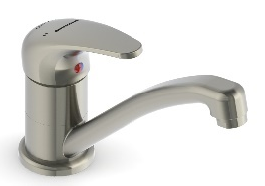 | - Lead Safe™ material
DENTAL THERAPY | TM-SNKCPD  CliniLever® CP-BS Hospital Single Lever Sink Mixer 250 Reach with 165 Disabled Lever | 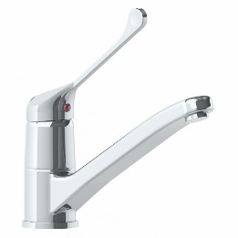 | - Extended 165mm lever for easy access  - Anti-scald adjustable stop ring  - AS 1428.1 accessible compliant
DENTAL THERAPY | TM-SNKXD  CliniLever® Stainless Steel Lead Safe™ Sink Mixer with Disabled Lever | 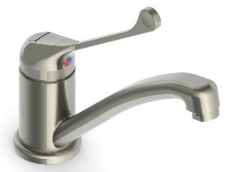 | - Lead Safe™ material  - AS 1428.1 accessible compliant
CLEANERS SINK | 49949  Vandal Resistant Chrome Plated Brass J/V Wall Sink Set (NSW) with 120H Swivel G/Neck & V/R Aerator | 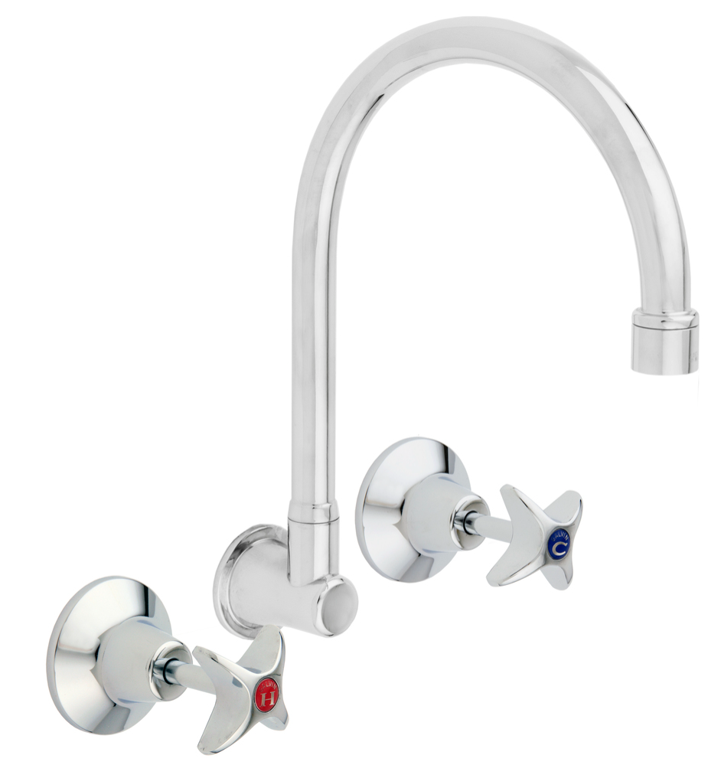 | - Vandal resistant handle  - Half turn ceramic disc available on request
CLEANERS SINK | 49965  Vandal Resistant CP-BS J/V Hose Tap - Cold | 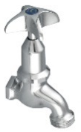 | - Hot also available  - Vandal resistant handle
CLEANERS SINK | 190.42.65.32  GalvinSafe® Eye/Face Wash, Wall Mtd, Hand Held, 3.6mtr Recoil Hose, AXION® MSR Head (HAWS) | 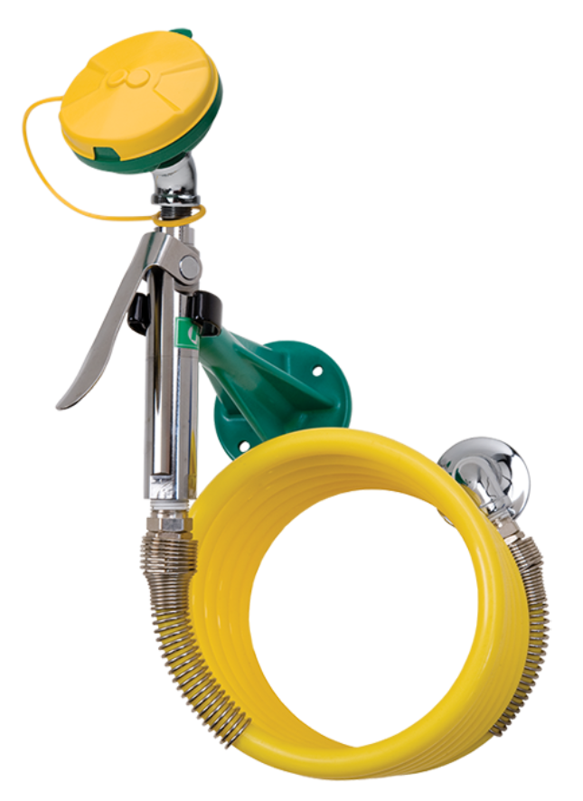
CANTEEN POT SINK | TF76WC-ESS  Ezy-Wash® CP-BS Wall Mounted Exposed Mixing Unit Type 76 FI Inlet with 300 Reach | 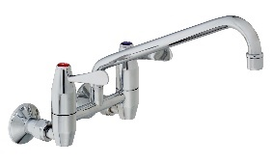 | - Lever action handles with red and blue indicator buttons  - 300mm reach swivel spout
ABLUTION TROUGH; pre primary | 173.46.23.00  Ezy-Lever CP-BS Lead Safe™ Timeflow Lever Action Vandal Resistant Deluxe Bib Tap |  | - Lead Safe™ DZR Brass with less than 0.25% lead content  - Vandal resistant
ABLUTION TROUGH; primary | 173.46.21.00  Ezy-Push® CP-BS Lead Safe™ Timeflow Push Button Deluxe Bib Tap - 6 Sec (MI) | 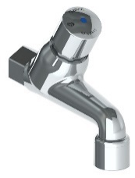 | - 15 second version also available  - Lead Safe™ DZR Brass with less than 0.25% lead content  - Vandal resistant
PRACTICAL TROUGH; pre primary | 49882  Vandal Resistant CP-BS J/V Deluxe Bib Tap Aerated Cold | 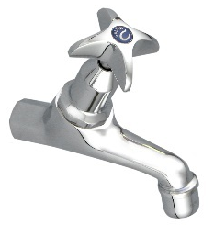 | - Ceramic disc also available  - Hot also available  - Vandal resistant
PRACTICAL TROUGH; art room | 49949  Vandal Resistant Chrome Plated Brass J/V Wall Sink Set (NSW) with 120H Swivel G/Neck & V/R Aerator |  | - Vandal resistant handles  - Half turn ceramic disc available on request
PRACTICAL TROUGH; art room, cold only | 49949COLD  Vandal Resistant Chrome Plated Brass J/V Wall Sink Set (NSW) with 120H Swivel G/Neck & V/R Aerator (Cold Only) | 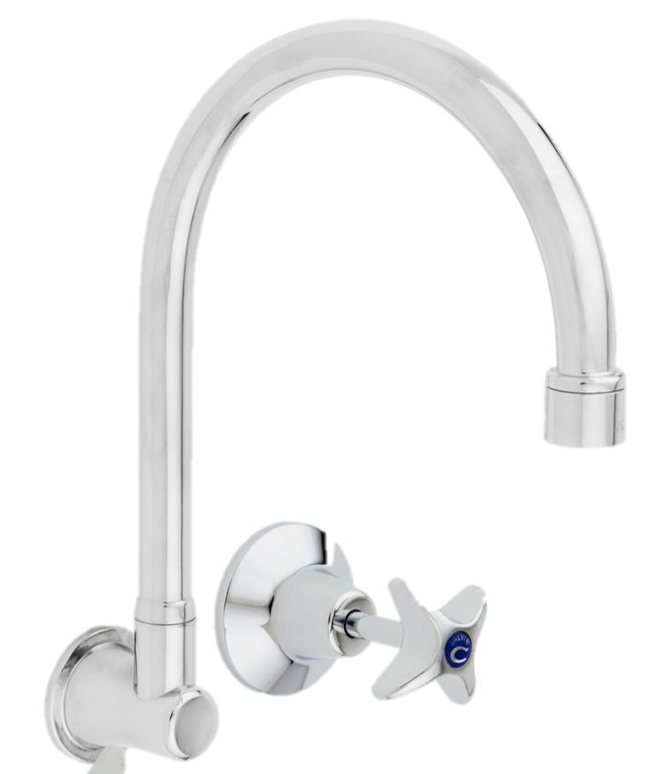 | - Vandal resistant handle  - Half turn ceramic disc available on request

Cold Water Drinking Units (Drinking Troughs) (5.10.13.9)
- 2 No. front mounted on/off push button taps and top mounted angled outlets fitted with rubber mouth guards.
- 2 No. face mounted on/off push button taps and two concealed jug fillers in stainless steel protective shrouds.

Location | Product Description | Image | Notes
BUBBLER | 170.81.13.01  Ezy-Drink® CP-BS Lead Safe™ Remote Push Button Drinking Bubbler Tap – FI | 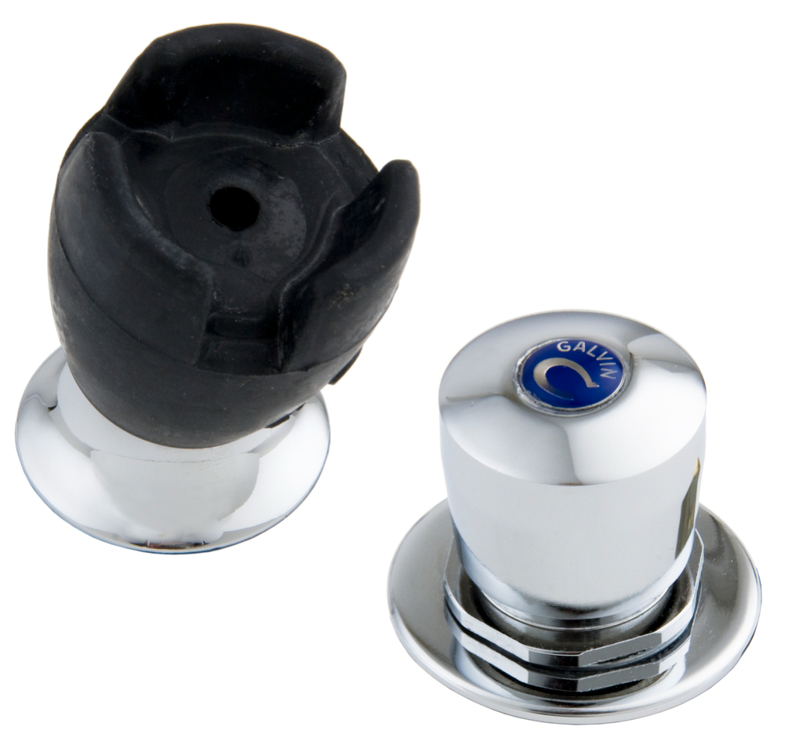 | - Lead Safe™ DZR Brass with less than 0.25% lead content  - Vandal resistant design  - AS 4020 approved mouthguard
BUBBLER | TD15XP  Ezy-Drink® 316 SS Lead Safe™ Remote Push Button Drinking Bubbler Tap – FI |  | - Lead Safe™ material  - Vandal resistant design  - AS 4020 approved mouthguard
BUBBLER | 170.81.12.00  Ezy-Drink® CP-BS Lead Safe™ Remote Electronic Drinking Bubbler Tap FI (Mains) | 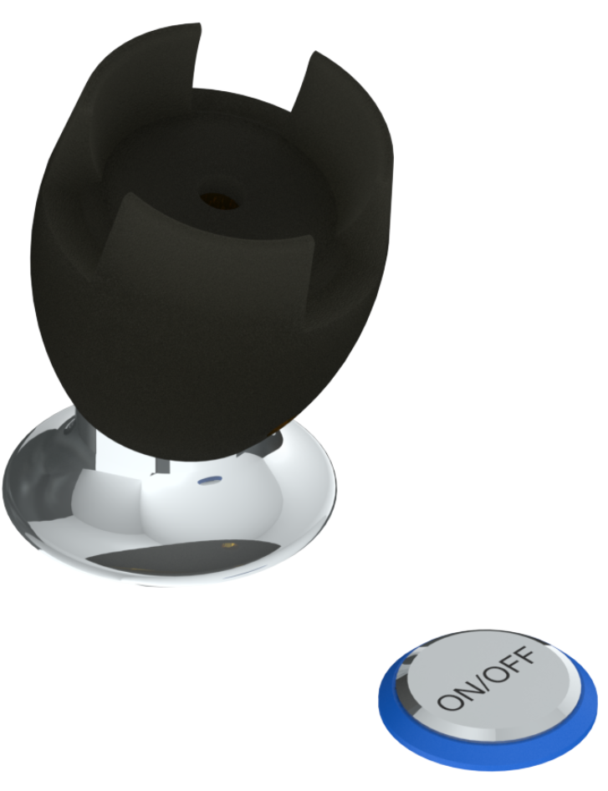 | - Lead Safe™ DZR Brass with less than 0.25% lead content  - Vandal resistant design  - AS 4020 approved mouthguard  - Battery also available
JUG FILLER | 170.81.73.01  Ezy-Drink® Lead Safe™ Remote Push Button Activation Valve Only |  | - Lead Safe™ DZR Brass with less than 0.25% lead content

UAT & AAT Showers (5.10.13.11)
- Shower mixer tap with soft close ceramic disc cartridge and with extended handle, 1500mm long flexible hose fitted with chrome plated dual check valve and handheld outlet on 32mm diameter 900mm long stainless steel rail in accordance with AS1428.

Location | Product Description | Image | Notes
SHOWER MIXER | TM-SHWCP  CliniLever® CP-BS Hospital Single Lever Shower Mixer | 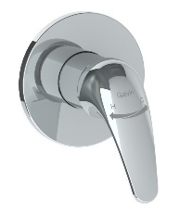
SHOWER MIXER | TM-SHWCPD  CliniLever® CP-BS Hospital Single Lever Shower Mixer with 165 Disabled Lever |  | - Extended 165mm lever for easy access  - AS 1428.1 accessible compliant
SHOWER MIXER | TM-SHWX  CliniLever® Stainless Steel Lead Safe™ Shower or Bath Mixer | 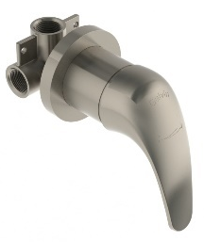 | - Lead Safe™ material  - AS 1428.1 accessible compliant
RAIL SHOWER | 41999  GalvinAssist® Hand Shower Kit with 900x32 Stainless Steel Hygienic Grab Rail | 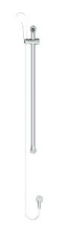 | - Chrome plated version also available  - AS 1428.1 accessible compliant
RAIL SHOWER | CLEVA035  GalvinAssist® Hand Shower Kit with 900 x 32 Stainless Steel Hygienic Grab Rail, ClevaCare® Shower - Low |  | - Chrome plated version also available  - AS 1428.1 accessible compliant

Design Standards & Product Specification for DoE Facilities
Part 2: Secondary Schools
Western Australia
\

[COVER PAGE]

WA Secondary School Facilities Design Standards 2023
Guidelines relevant to Galvin Engineering product selection

*This Galvin Engineering document gives a snap shot of key points within the Primary School Subconsultants Brief and a snapshot of suitable products. For further details please refer to the relative subsection within the official brief document.

General Guidelines
This brief has been prepared to the define scope of hydraulic consultant services, project details and design requirements for secondary schools in Western Australia delivered by the Department of Finance (DoF) responsible with the leading, delivery and management of buildings for Government, including State owned education facilities.
The project shall:
- Meet relevant building codes, Australian Standards, DFES requirements, local authority approvals, Water Corporation, Alinta, and Finance requirements for spatial design, organisation, service and amenity provision;
- Integrate appropriate environmentally sustainable principles;
- Integrate fully coordinated hydraulic services systems and built form;
- Integrate robust, durable and easily replaceable / maintainable materials and systems;
- Respond to the history, heritage and character of the site and context;
- Resolve site constraints and capitalise on site assets;
- Create a safe environment that draws on evidence based design principles to encourage the best learning environment and education facility possible; and
- Contribute to the project achieving a minimum 4 star Green Star rating uring the Green Building Council of Australia’s Rating Tool. (The project shall not be submitted for GBCA assessment unless required by DoE).

Soil, Waste and Vents (6.9.12.1)
- Cleanouts shall be used between manholes and on branch drains at locations required by AS3500 and the Regulating Plumbing Authority.
- Cleanouts shall be avoided within buildings wherever possible. Where this cannot be avoided, consideration to their location with respect to the disruption of school operation and acceSSof drain cleaning equipment must be given.
- Cleanout points within a building shall be screwed down type of nickel bronze or similar and set flush with the finished floor level.
- Cleanout points external to a building and within paved or concrete areas shall be constructed of the drain or waste material and finished with a screwed acceSScap housed in a hinged cast iron box set flush with the finished surface lever. Box shall be cast into a concrete base and embossed with the word “SEWER”.
- All floor waste gullies shall consist of a 100mm P-trap, 100mm gully riser and a nickel bronze or similar grate set flush with finished surface level.

Location | Product Description | Image | Notes
FLOOR DRAIN OPTION 1; tile/concrete floor | 302182X  HeelGrate® Stainless Steel Floor Drain Grate Round 100x80 PVC Slip-In | 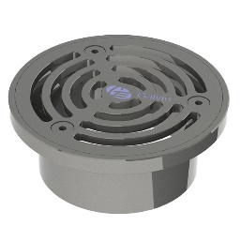 | - Square also available  - Other sizes also available  - Kits with cast iron bodies and puddle flanges also available
FLOOR DRAIN OPTION 2;  tile/concrete floor | 302185X  HeelGrate® Stainless Steel Floor Drain Grate Round 150x100 PVC/HDPE/CU Slip-In | 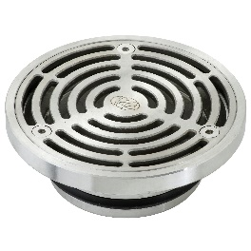 | - Square also available  - Other sizes also available  - Kits with cast iron bodies and puddle flanges also available
FLOOR DRAIN OPTION 3;  vinyl floor | 303176X  Stainless Steel Floor Drain Grate Assembly Vinyl 100x80 PVC Slip-In | 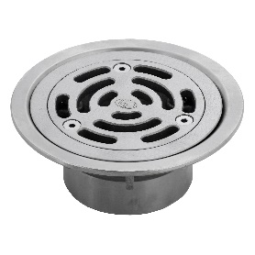 | - Other sizes also available  - Kits with cast iron bodies and puddle flanges also available
FLOOR DRAIN OPTION 4;  vinyl floor | 303185X  HeelGrate® Stainless Steel Floor Drain Vinyl Round 150x100 with Stainless Steel Body PVC/HDPE/CU Slip-In |  | - Other sizes also available  - Kits with cast iron bodies and puddle flanges also available
CLEANOUT OPTION 1; tile/concrete floor | 67790X  Slip-Safe® SS316 Bolted Cleanout Round 150x100 PVC/HDPE/CU Slip-In |  | - Other sizes also available  - Kits with cast iron bodies and puddle flanges also available
CLEANOUT OPTION 2; tile/concrete floor, square | 67778X  HeelGrate® Slip-Safe® SS316 Bolted Cleanout Square 150x100 PVC / HDPE Slip-In |  | - Kits with cast iron bodies and puddle flanges also available
CLEANOUT OPTION 3;  vinyl floor | 69468X  Slip-Safe® SS Vinyl Bolted Cleanout 150x100 PVC/HDPE/CU Slip-In |  | - Other sizes also available  - Kits with cast iron bodies and puddle flanges also available

Trade Waste (6.9.12.2)
- Cafeteria sink outlets and floor waste gullies shall incorporate removable primary and fixed secondary strainers in accordance with Water Corporation Western Australia.
Location | Product Description | Image | Notes
Industrial Floor Waste Combo;  round, tile/concrete | DI4M06RX  Industrial Floor Waste Combo Stainless Steel Round Grate 150x100 PVC/HDPE & Dual S/S Strainer |  | - AS 3996 Class C and EN1253 Class C load rating  - AS/NZS 4994:1998 Discharge of commercial and industrial waste water to sewer
Industrial Floor Waste Combo; square, tile/concrete | DI4M06SX  Industrial Floor Waste Combo Stainless Steel Square Grate 150x100 PVC/HDPE & Dual S/S Strainer |  | - Single and double strainer options available  - Load rated to Class C
Industrial Floor Waste Combo; square, tile/concrete | DI4M08SX  Industrial Floor Waste Combo Stainless Steel Square Grate 200x100 PVC/HDPE & Dual S/S Strainer |  | - Single and double strainer options available  - Load rated to Class C
Industrial Floor Waste Combo;  round, vinyl | DI4M06VX  Industrial Floor Waste Combo Stainless Steel Vinyl Round Grate 150x100 PVC/HDPE & Dual S/S Strainer |  | - AS 3996 Class C and EN 1253 M125  - AS/NZS 4994:1998 Discharge of commercial and industrial waste water to sewer

Stormwater Drainage (6.9.12.3)
- The landscape architect shall advise the hydraulic consultant on the positions/low points of required grated channels and/or paving drains and the area size discharging to these. The hydraulic consultant shall design a suitable system based on these requirements.
- The channel grates or paving drain grates in trafficable or pedestrian areas shall be of a design that allows wheelchairs, trolleys or bicycles to be safely wheeled across them, anti slip and have the ability to be locked down. Grates located in areas subject to vehicle loads shall be rated accordingly.

Location | Product Description | Image | Notes
PAVING DRAIN; round | 302205X  HeelGrate® Stainless Steel Floor Drain Round 300x150 BSP | 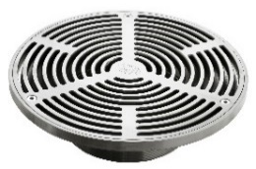 | - 5mm gap between bars  - Suitable for concourse paving and tiled applications
PAVING DRAIN; square | 302605X  HeelGrate® Stainless Steel Floor Drain Square 300x150 BSx | 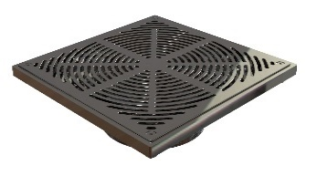 | - 5mm gap between bars  - Suitable for concourse paving and tiled applications  - Load tested to Class B of AS 3996
PAVING DRAIN ADAPTOR | 302180  ABS Floor Drain Adaptor 150BSP FI X 100PVC Slip-In
PAVING DRAIN ADAPTOR | 302173  ABS Floor Drain Adaptor 150BSP FI x 150PVC Slip-In

Heated Water Service (6.9.12.5)
- Provide a tempered water service connection to supply the nominated maximum required temperatures to the following fixtures to all staff and student handbasins, eye wash facilities and showers including learning/teaching, change rooms, administration, student support, library and cafeteria.
- A thermostatic mixing valve shall be located at the water heater in a visible and easily accessible position and to be set to deliver the nominated temperature water at the outlet.
  - UAT/AAT Hand Basin 45°
  - UAT/AAT Showers (where provided) 45°
  - General eye wash facilities/emergency shower units 15.6° - 37.8° in compliance with AS4775
  - Change rooms/student toilets hand basins cold water only
  - Staff toilets hand basins 45°
  - Change rooms showers 45°
- Provide a hot water service connection at the maximum nominated temperature to the preparation sinks to the cafeteria, tea preparation/kitchenettes sinks, cleaner’s trough, food learning areas and food preparation sinks to administration, library and learning/teaching areas.
  - Food technology studios student sinks 50°
  - Materials/technology workshops activity troughs 50°
  - Art studios activity troughs 50°
  - Staff tea prep sinks/kitchens – learning blocks/administration/library sinks 60°
  - Cleaners troughs cleaners sink/trough 60°
  - Cafeteria sink 75°

Location | Product Description | Image | Notes
TMV | 101.70.00.00  CliniMix® Lead Safe Thermostatic Mixing Valve |  | - Lead Safe™ DZR Brass with less than 0.25% lead content  - Scald or cold water shock protection
TMV IN CABINET | 101.10.70.10  CliniMix® Lead Safe TMV with Universal Cabinet |  | - Lead Safe™ material  - Scald or cold water shock protection
TMV IN CABINET; with bypass | 101.11.70.10  CliniMix® Lead Safe TMV with Universal Cabinet with Bypass |  | - Lead Safe™ material  - Scald or cold water shock protection

Water end Energy Saving (6.9.12.6)
Suitable flow limiting valves should be fitted to showers, basins, ablution troughs, practical troughs and sinks. All fixtures and tapware shall comply with the WELS standard AS6400, specifically:
- Student ablution troughs shall be fitted with suitable cold only time flow tapware.
- The shower outlet specified should be suitable for use with a reduced flow rate. It should be noted that some shower heads with inbuilt water conservation systems give an uncomfortable and unsatisfactory shower, these types must be avoided.

Fire Service (6.9.12.7)
- Hydrants shall be located in easily accessible locations and highly visible from intended DFES appliance hardstand areas though as not to obstruct the movement of staff and students.
- The hydrant valves shall generally point in the direction of the DFES hardstand.
- In situations where hydrants are susceptible to vehicular contact, protection bollards shall be installed.
- Hydrant vandal resistant covers shall be installed over the hydrant valves, chained secure and padlocked all keyed alike.

Location | Product Description | Image | Notes
HYDRANT RISER | 381337  Hydrant Riser with Dual Head, Flanged Inlet 100TE x 1500mm Long (Galv & Painted) |  | - Hot dipped galvanised to AS/NZS 4680  - Drilled Table E flange
HYDRANT RISER | 381358  Hydrant Riser with Dual Head, Flanged Inlet 150TE x 1400mm Long (Galv & Painted) |  | - Hot dipped galvanised to AS/NZS 4680  - Drilled Table E flange
HYDRANT VALVE; threaded | 381301  Red Emperor® Fire Valve 65BIC with BSP Inlet and Nylon Plug |  | - AS 2419.2 compliant
HYDRANT VALVE; roll groove | 381301rg  Red Emperor® Fire Valve 65bic with Roll Grooved Inlet and Nylon Plug |  | - AS 2419.2 compliant
TAMPER COVER | 381331  Tamper Proof Resistant Dual Hydrant Valve Cover with 003 Padlock. |  | - Tamper resistant protection for fire landing valves  - Only suitable for dual head riser
FIRE HOSE REEL; fixed | 383026re  Red Emperor® F Series Fixed Fire Hose Reel with Swing Guide Arm |  | - Certified to AS/NZS 1221
FIRE HOSE REEL; swing | 382523  Red Emperor® G Series Swing Fire Hose Reel with Swing Guide Arm |  | - Can be paired with hose reel cabinets
HOSE REEL CABINET | 381905  Type A Exposed Fire Reel Cabinet |  | - Designed to suit G Series reels
HYDRANT BOOSTER | 380162  WA/NT Pipeset For 100TE Firemain Booster & Hydrant (Painted & Assembled) |  | - Kits also available with cabinet.  - Kits also available with suction riser
HYDRANT BOOSTER | 380170  WA/NT Pipeset For 150TE Firemain Booster & Hydrant (Painted & Assembled) |  | - Kits also available with cabinet.  - Kits also available with suction riser

Gas Service (6.9.12.9)b
- Provide reticulated gas service to new science buildings for room heating and for gas turrets to science laboratories.
Location | Product Description | Image | Notes
GAS TURRET; single outlet | TG37C  GalvinLab® CP 1-Way Straight Gas Turret Type 37 | 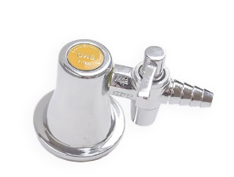
GAS TURRET; single outlet | TG37RAC  GalvinLab® CP 1-Way Right Angle Gas Turret Type 37 | 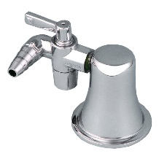
GAS TURRET; dual outlet | TG40C  GalvinLab® CP 2-Way Straight Gas Turret Type 40 – 90° | 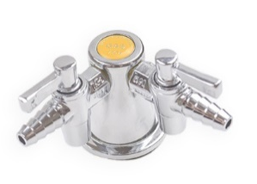 | - Other dual outlet configurations also available
GAS TURRET; dual outlet | TG40RAC  GalvinLab® CP 2-Way Right Angle Gas Turret Type 40 – 90° | 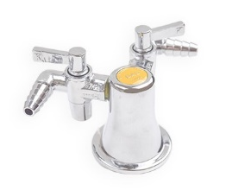 | - Other dual outlet configurations also available
GAS TURRET; triple outlet | TG41C  GalvinLab® CP 3-Way Straight Gas Turret Type 41 | 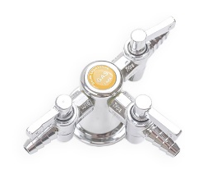
GAS TURRET; quad outlet | TG42C  GalvinLab® CP 4-Way Straight Gas Turret Type 42 | 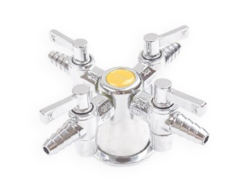

Water Closets (6.9.13.1)
- There is a general preference for toilet cisterns to be concealed to prevent unauthorised access and accidental damage and vandalism. Access to cisterns for maintenance purposes nay be either via built in ducts or vandal resistant front access panels.
- Typically, toilets on ducts shall consist of a wall mounted concealed P-trap pan with induct 3/4.5 litre cistern, fixing kit, pneumatic dual flush button and soft closing double flap seat.
- Where concealment of toilet cisterns is not possible toilets should consist of a concealed S trap pan, close coupled vitrous china ¾.5 litre cistern with vandal resistant lid, and soft closing double flap seat.
- Disabled toilets shall consist of disabled concealed P-trap pan, mid mounted vitreous china cistern with separate backrest, chrome plated disabled flush buttons; chrome plated flush pipe and disabled grey coloured single flap seat with 30% contrast in colour.
- Particular attention shall be given to the set-out of disabled fixtures to comply with AS1428.

Location | Product Description | Image | Notes
TOILET SUITE | 105.10.00.00  GalvinAssist® Wall Faced, Clean Flush Toilet Suite with Soft Close Seat |  | - Soft-closing, easy-clean quick release seat  - Suitable for S or P trap installations
TOILET SUITE; ambulant | 105.10.20.00  GalvinAssist® Wall Faced, Clean Flush Ambulant Toilet Suite with Soft Close Seat |  | - Soft-closing, easy-clean quick release seat  - Suitable for S or P trap installations  - Compliant with AS1428.1 Ambulant guidelines
TOILET SUITE; disabled | 105.10.10.01  GalvinAssist® Wall Faced, Clean Flush Disabled Toilet Suite with Blue Soft Close Seat |  | - Soft-closing, easy-clean quick release seat  - Suitable for S or P trap installations  - Compliant with AS1428.1 Ambulant guidelines
TOILET PAN | 105.11.00.00  GalvinAssist® Wall Faced, Clean Flush Toilet Pan with Soft Close Seat |  | - To be paired with in wall cistern and push buttons  - Soft-closing, easy-clean quick release seat  - Suitable for S or P trap installations
TOILET PAN; disabled | 105.11.10.01  GalvinAssist® Wall Faced, Clean Flush Disabled Toilet Pan with Blue Soft Close Seat |  | - To be paired with in wall cistern and disabled push buttons  - Soft-closing, easy-clean quick release seat  - Suitable for S or P trap installations  - Compliant with AS1428.1 Ambulant guidelines
IN WALL CISTERN | 105.94.00.00  GalvinAssist® Slim Design Inwall Cistern |  | - Suits floor mount toilet pan  - Front access to cistern through flush plate
PUSH BUTTONS | 105.95.00.00  GalvinAssist® Chrome, Dual Flush, Pneumatic Buttons and Plate |  | - Premium pneumatic system  - Provides complete access to in-wall cistern
PUSH BUTTONS; disabled | 105.96.00.00  GalvinAssist® Chrome, Dual Flush, Pneumatic Disabled Buttons and Plate |  | - Premium pneumatic system  - Provides complete access to in-wall cistern

Basins (6.9.13.2)
Student (typical)
- Basins shall be vitreous china or to approval approximately 500mm wide x 430mm deep with one tap hole and secured with heavy duty tie brackets.
UAT (typical)
- Basins shall be vitreous china wall hung approximately 550mm wide x 435mm deep with one tap hole and secured with heavy duty wall brackets.
- Particular attention shall be given to the set-out of disabled fixtures to comply with AS1428.
Staff (typical)
- Basins shall be vitreous china or to approval approximately 500mm wide x 430mm deep with one tap hole and secured with heavy duty tie brackets. Basin to be inset to vanity bench nominally 600mm depth, length to suit number of staff utilising ablutions.

Cafeteria
- Basins shall be vitreous china wall hung approximately 550mm wide x 435mm deep with one tap hole and secured with heavy duty wall brackets.

Location | Product Description | Image | Notes
STUDENT | 105.32.10.01  GalvinAssist® 500mm Wall Mounted Basin 1TH | 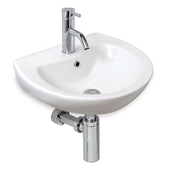
STUDENT / STAFF | 105.32.12.01  GalvinAssist® Plati Square Above Counter Basin 1TH | 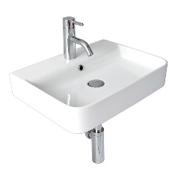
UAT / CAFETERIA; left hand bowl | 105.33.10.01  GalvinAssist® Accessible 600mm Wall Basin, LH Bowl, 1TH | 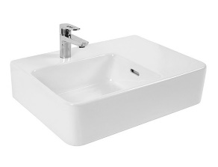 | - Accessories not included  - Left hand bowl  - 1 taphole
UAT / CAFETERIA; right hand bowl | 105.33.11.01  GalvinAssist® Accessible 600mm Wall Basin, RH Bowl, 1TH | 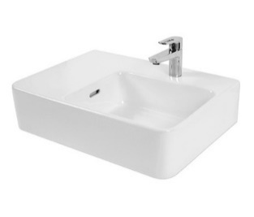 | - Accessories not included  - Left hand bowl  - 1 taphole
BOTTLE TRAP | 105.93.00.00  GalvinAssist® Chrome Round Bottle Trap Suits 32/40mm Waste | 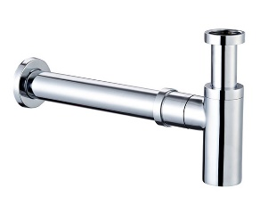 | - Suits 32 or 40 mm wastes  - Designed for use with wall basins and installations with exposed plumbing

Sinks and Troughs (6.9.13.3)
Medical Room
- Stock pattern single end bowl stainless steel inset sink with one tap hole centre to bowl.
Staff Room
- Stock pattern double centre bowl stainless steel inset sink with one tap hole centre to bowls.
Library
- Stock pattern single end bowl stainless steel inset sink with one tap hole centre to bowl.

Cleaners Sink
- Stock pattern stainless steel cleaners sink with rear tile upstand, hinged stainless steel grate and fixed on heavy duty galvanised steel wall brackets.
Cafeteria Sink
- Stock pattern double centre bowl stainless steel inset sink with one tap hole centre to bowls.
Gardeners Trough
- Stock pattern stainless steel inset laundry trough with one tap hole.
Ablution Troughs
- Stock pattern stainless steel ablution trough nominally 1200mm length with tile upstand and fixed on heavy duty galvanised steel wall brackets.
Practical Troughs
- Stock pattern stainless steel typically 1800mm x 600mm x 200mm deep with rear tile upstand and fixed on mild tubular steel to match bench support. Typically located to design and technology – visual arts studio.

Location | Product Description | Image | Notes
STAFF ROOM / CAFETERIA SINK | 105.82.00.01  GalvinAssist® Stainless Steel 1500mm Double Bowl Sink 1TH |  | - Sound deadening, designer basket waste
MEDICAL ROOM / LIBRARY; left hand bowl | 105.80.00.01  GalvinAssist® Stainless Steel 800mm Single LH Bowl Sink 1TH | 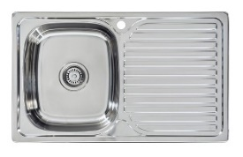
MEDICAL ROOM / LIBRARY; right hand bowl | 105.80.10.01  GalvinAssist® Stainless Steel 800mm Single RH Bowl Sink 1TH | 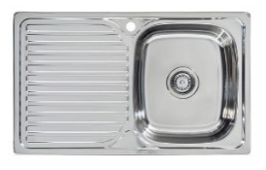

Tapware and Outlets (6.9.14)
In general terms, tapware and outlets shall:
- Be WELS rater (refer Green Star Rating Tool);
- Carry Watermark standards;
- Incorporate vandal resistant features;
- Of chrome plated brass construction;
- Fitted with heavy duty jumper brass jumper valves;
- Colour coded buttons indicating either cold or hot; and
- Mixer tap hoses shall connect to mini stop isolation valves.

Basins (6.9.14.2)
Students
- Chrome plated solid brass basin mixer tap with soft close ceramic disc cartridge, lever handle and 150mm swivel outlet of similar length.
UAT
- Chrome plated solid brass basin mixer tap with soft close ceramic disc cartridge, extended lever handle and 150mm swivel outlet of similar length.
Staff
- Chrome plated solid brass basin mixer tap with soft close ceramic cartridge and 150mm swivel outlet.

Location | Product Description | Image | Notes
STUDENTS / STAFF | TM-BASCP  CliniLever® CP Single Lever Basin Mixer | 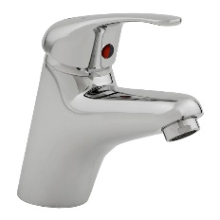 | - Vandal-resistant  - Anti-scald adjustable stop ring  - Optional warm/cold indicator decal
STUDENTS / STAFF | TM-BASX  CliniLever® Stainless Steel LeadTM Safe Basin Mixer | 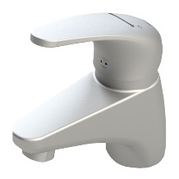 | - Lead Safe™ material
UAT | TM-BASCPD  CliniLever® CP Single Lever Disabled Basin Mixer with Extended Lever | 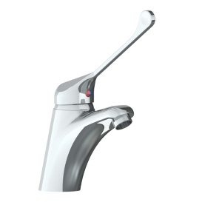 | - Anti-scald adjustable stop ring  - Optional warm/cold indicator decal  - AS 1428.1 accessible compliant
UAT | TM-BASXD  CliniLever® Stainless Steel Lead SafeTM Disabled Basin Mixer with Extended Lever | 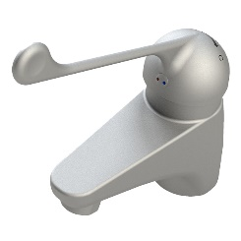 | - Lead Safe™ material  - AS 1428.1 accessible compliant

Sinks and Troughs (6.9.14.3)
Medical Room
- Chrome plated solid brass sink mixer tap with soft close ceramic disc cartridge and 150mm swivel outlet.
Staff Room
- Chrome plated solid brass sink mixer tap with soft close ceramic disc cartridge and 240mm swivel outlet.
Library
- Chrome plated solid brass sink mixer tap with soft close ceramic disc cartridge and 150mm swivel outlet.
Cafeteria
- Chrome plated solid brass sink mixer tap with soft close ceramic disc cartridge and 240mm swivel outlet.
- Over pot sink - chrome plated solid brass cold and hot wall set with heavy duty chrome plated braSS300mm swivel goose neck outlet.
Cleaners Sink
- 1 No. chrome plated solid brass vandal resistant cold and hot wall set with 200mm swivel gooseneck outlet.
- 1 No. non-potable cold water threaded bib tap over cleaners sink connected to a double check valve mounted on wall.
Gardeners Trough
- Chrome plated solid brass sink mixer tap with soft close ceramic disc cartridge and 240mm swivel outlet.
Ablution Troughs
- Push button time flow chrome plated solid brass or approved equal bib taps with 50mm bib extensions (cold only). Number of outlets to suit length of trough provided.
Practical Troughs
- Typically located to design and technology & visual arts studio.
- 1 No. cold and hot chrome plated solid brass wall set with 200mm swivel gooseneck outlet.
- 3 No. cold ONLY chrome plated solid brass wall sets with 200mm swivel gooseneck outlet.

Location | Product Description | Image | Notes
STAFF ROOM / CAFETERIA / GARDENERS TROUGH | TM-SNKCP  CliniLever® CP Single Lever Sink Mixer |  | - Anti-scald adjustable stop ring  - Extended 165mm lever for easy access  - AS 1428.1 accessible compliant
STAFF ROOM / CAFETERIA / GARDENERS TROUGH | TM-SNKX  CliniLever® Stainless Steel Lead SafeTM Sink Mixer |  | - Lead SafeTM material
CAFETERIA | TF76WC-ESS  Ezy-Wash® CP Wall Mounted Exposed Mixing Unit Type 76 with 300mm Reach | 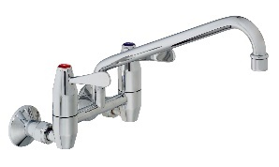
CLEANERS SINK | 174.51.22.03  Vandal Resistant CP Lead SafeTM Wall Sink Set with Swivel Gooseneck | 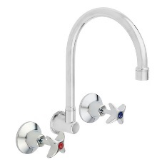 | - Ceramic disc also available
CLEANERS SINK | 49965  Vandal Resistant CP Hose Tap - Cold |  | - Ceramic disc also available  - Hot also available  - Vandal resistant handle
ABLUTION TROUGHS | 173.46.21.00  Ezy-Push® CP Lead SafeTM Timeflow Push Button Bib Tap 6 Second | 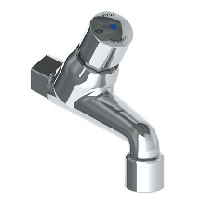 | - 15 second also available
PRACTICAL TROUGHS; hot and cold | 174.51.22.03  Vandal Resistant CP Lead SafeTM Wall Sink Set with Swivel Gooseneck | 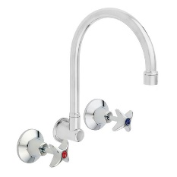 | - Ceramic disc also available
PRACTICAL TROUGHS; cold only | 174.51.22.03C  Vandal Resistant CP Lead SafeTM COLD ONLY Wall Sink Set with Swivel Gooseneck

Cold Water Drinking Units (6.9.14.4)
- Front mounted on/off push button taps for bubblers, end mounted on/off push button taps for bottle fillers and top mounted angled outlets fitted with rubber mouthguards. Number of outlets to suit length of trough provided.

Location | Product Description | Image | Notes
BUBBLER | 170.81.13.01  Ezy-Drink® CP Lead SafeTM Remote Push Button Drinking Bubbler |  | - Lead Safe™ material  - Vandal resistant design  - AS 4020 approved mouthguard
BUBBLER | TD15XP  Ezy-Drink® SS316 Lead SafeTM Remote Push Button Drinking Bubbler |  | - Lead Safe™ material  - Vandal resistant design  - AS 4020 approved mouthguard
BUBBLER | 170.81.12.00  Ezy-Drink® CP Lead SafeTM Remote Electronic Drinking Bubbler (Mains) |  | - Lead Safe™ material  - Vandal resistant design  - AS 4020 approved mouthguard  - Battery also available
JUG FILLER | 170.81.73.01  Ezy-Drink® CP Lead SafeTM Remote Push Button Valve Only |  | - Lead SafeTM material

UAT & AAT Showers (5.10.13.11)
- Shower mixer tap with soft close ceramic disc cartridge and with extended handle, 1500mm long flexible hose fitted with chrome plated dual check valve and handheld outlet on nominally 32mm diameter 900mm long stainless steel rail in accordance with AS1428.

Location | Product Description | Image | Notes
SHOWER MIXER | TM-SHWCP  CliniLever® Single Lever Shower Mixer CP
SHOWER MIXER | TM-SHWCPD  CliniLever® Single Lever Shower Mixer with Disabled lever CP |  | - Extended 165mm lever for easy access  - AS 1428.1 accessible compliant
SHOWER MIXER | TM-SHWX  CliniLever® Stainless Steel Single Lever Shower Mixer |  | - Lead Safe™ material  - AS 1428.1 accessible compliant
RAIL SHOWER | 41999  GalvinAssist® Hand Shower Kit with 900mm Stainless Steel Rail |  | - Chrome plated version also available  - Other rail configurations also available  - AS 1428.1 accessible compliant
RAIL SHOWER | CLEVA035  GalvinAssist® Hand Shower Kit with 900mm Stainless Steel Grab Rail & ClevaCare® Shower |  | - Other configurations also available  - Chrome plated version also available  - AS 1428.1 accessible compliant

Urinals (6.9.14.7)
- Urinal flushing via 240 volt automatic electronic flusher with a ceiling mounted microwave motion sensor and induct solenoid valve. A 20mm ball valve, line strainer and water hammer arrestor to be installed upstream of the solenoid valve. An air break device inline to a 40mm PVC flush pipe shall be installed downstream of the solenoid valve.
- The flusher shall be programmed to operate a pre-flush on detection of a user, a full flush on detection that the user is out of range and a janitor flush set to operate automatically every 6 hours.

Location | Product Description | Image | Notes
URINAL | TZ-FLOWFLUS  Flowmatic Automatic Flusher for Urinal | 