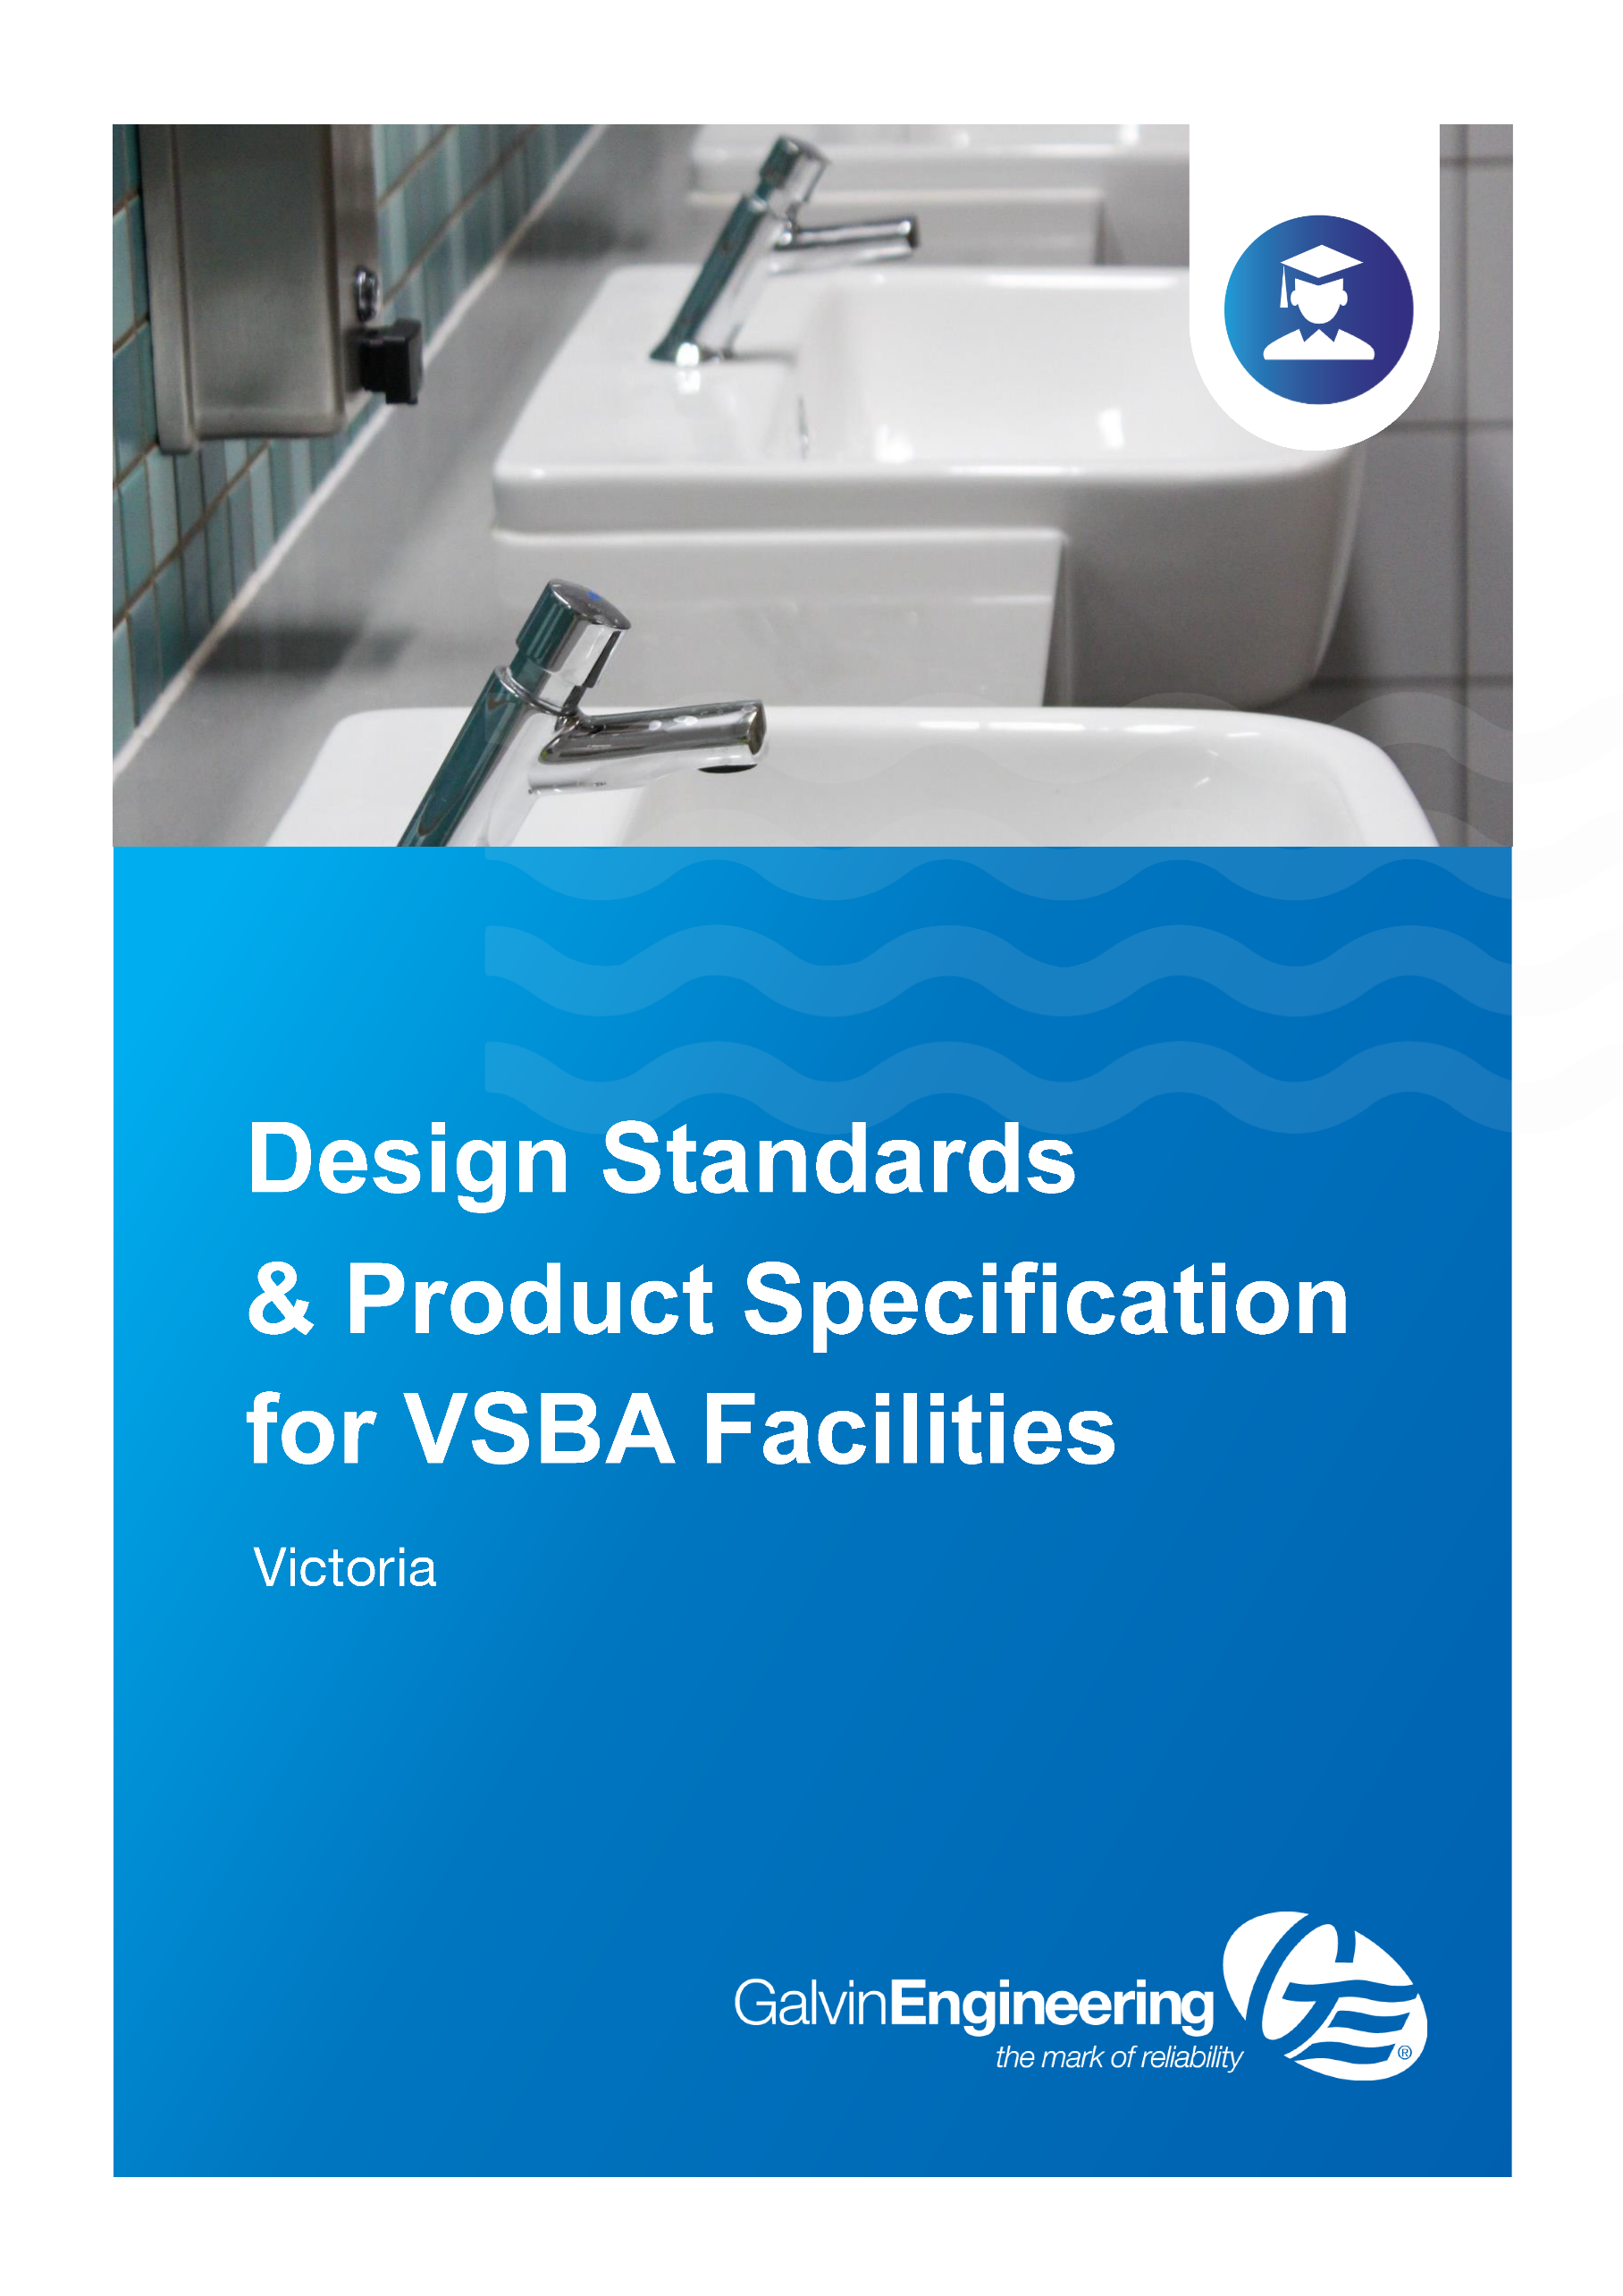

Building Quality Standards Handbook May 2022
VSBA Guideline Pages relevant to Galvin Engineering product selection

Lead Content in School Plumbing
Any piping, tapware or ﬁttings that hold or distribute potable water, or form part of a water source where a child could ﬁll a cup or drink bottle for consumption, must be comprised of products that either:
- Do not contain lead, or
- Do not allow contact between brass-containing lead and water (referred to here as ‘lead-safe’ products), where appropriate products are available on the Australian market.
In scope are all tapware, ﬁttings, piping systems and infrastructure that form part of a drinking water service. Pipe ﬁttings, breeches and thermostatic mixing valves, hot and cold tapware, and boiling water units are subject to this requirement. These elements can be made from stainless steel, copper, cross-linked polyethylene and copper tubing, lead-safe and plastic plumbing products.
This requirement does not apply to ﬁxtures such as sinks, troughs and basins, external vandal-proof taps or infrastructure associated with ﬁre, waste or sewerage plumbing systems, however, tapware for troughs, sinks and basins that is not vandal-proof must comply with above lead-safe or -free requirements.
Deadlegs must be avoided in all parts of a plumbing system. The design team must log any departures and rationale for these during the design phase.
Additionally, all plumbing ﬁxtures, materials and ﬁttings installed in new Victorian schools or in upgrades to existing schools must be certiﬁed under the WaterMark Certiﬁcation Scheme.

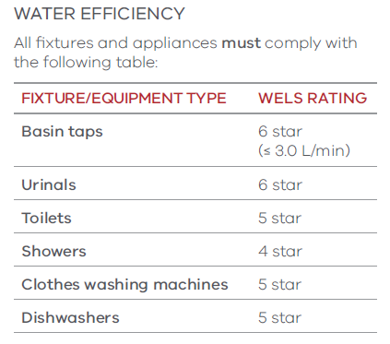

Temperature Monitoring Systems
Location | Product Description | Image | Notes
TMV OPTION 1 | 201.70.11.09  CliniMix® 1500 Lead Safe™ Thermostatic Mixing Valve | 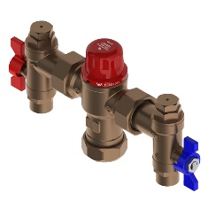 | - Made from Lead Safe DR brass (<0.25% lead)  - Thermal disinfection capable
TMV OPTION 2: in cabinet | 201.10.70.10  CliniMix® 1500 Lead Safe™ Thermostatic Mixing Valve in Cabinet | 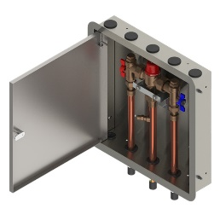 | - Made from Lead Safe DR brass (<0.25% lead)  - Thermal disinfection capable
TMV OPTION 3: in cabinet with bypass | 201.11.70.10  CliniMix® 1500 Lead Safe™ Thermostatic Mixing Valve with Cold Bypass in Cabinet | 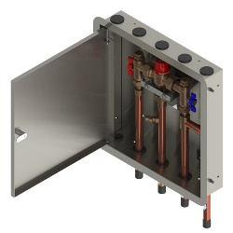 | - Made from Lead Safe DR brass (<0.25% lead)  - Thermal disinfection capable

Tap Fittings and Fixtures
Robust, tamper-proof tap fittings and fixtures are required with either timed delivery or appropriate water-saving requirements.
Project consultants must select and satisfy tap fittings and fixtures that meet the following requirements:
- Be satin chrome-plate finish on metal
- Where possible, use the same model and manufacture throughout a school.
Tapware for later stages is to match the first stage.
Cold water tapware must be coded ‘blue’ and hot water tapware must be coded ‘red’. Cold water tapware must be fixed on the right-hand side of the fixture and hot water tapware must be fixed on the left-hand side.
Laboratory-type tapware must be high goose-neck type, bench-mounted or sink-mounted, and must be acid resistant to suit the application.
Drinking fountain tapware must be lever spring-action drinking cocks with mouthguard and 100mm-long flanged horizontal extension to tap. Location of taps and troughs must minimise potential vandalism or other damage.
For hygiene, water conservation and consistency with the principles of inclusion, taps should be press button self-closing systems or top lever timeflow bib taps. Taps in kitchen situations must be pillar mixer taps.
Where cleaners’ taps are provided, these must be positioned at a height to allow a bucket to be easily filled and be fitted with anti-vandal tap spindles.
External taps that deliver recycled water must be fitted with anti-vandal tap spindles.
Hands-free tap operation must be provided at hand wash basins where required by local government by-laws for food service areas.
Press button, self-closing/timeflow taps, or top lever timeflow bib taps, that do not need to be manually turned off after use, must be installed at handwash basins for infection control (where fitted for junior students operation is to be sufficiently ‘soft’ for them to use).

Basin Tapware
Location | Product Description | Image | Notes
STUDENT BASINS OPTION 1: time-controlled tap | 173.15.21.00  Ezy-Push® CP-BS Lead Safe™ Timeflow Push Button Pillar Tap - 6 Sec | 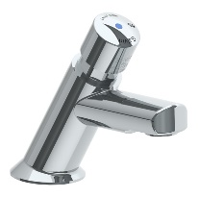 | - Made from Lead Safe DR Brass  - WELS 6* rated
STUDENT BASINS OPTION 2: time-controlled tap | 368696X  Ezy-Push® SS316 Lead Safe™ Timeflow Push Button Pillar Tap 6 Sec – MI | 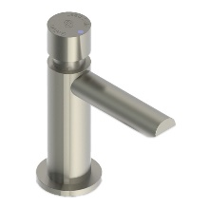 | - Made from Lead Safe SS316  - WELS 6* rated
STUDENT BASINS OPTION 3: time-controlled tap, lever handle | 173.15.23.00  Ezy-Lever CP-BS Lead Safe™ Timeflow Lever Action Vandal Resistant Pillar Tap | 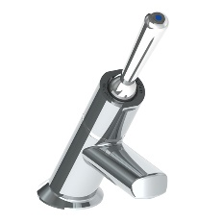 | - Made from Lead Safe DR Brass  - Lever handle to assist younger children who haven't yet developed the strength for push buttons  - WELS 6* rated
STAFF BASINS OPTION 1: basin mixer | TM-BASX  CliniLever® Stainless Steel Lead Safe™ Basin Mixer | 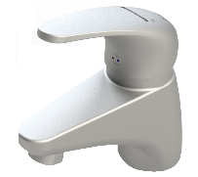 | - Made from Lead Safe SS316 WELS 6* & 5* rated
STAFF BASINS OPTION 2: basin set | 49910  Vandal Resistant CP-BS J/V Basin Set (NSW) with Aerator | 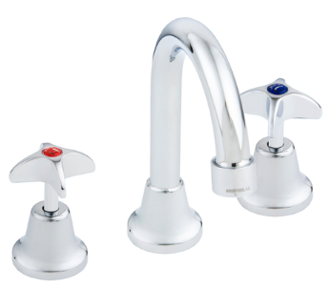 | - WELS 5* rated
DISABLED BASINS: basin mixer | TM-BASXD  CliniLever® Stainless Steel Lead Safe™ Basin Mixer with Accessible Lever | 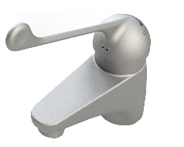 | - Made from Lead Safe SS316  - WELS 6* & 5* rated
ADDITIONAL BASIN OPTIONS: sensor tap option 1 | TZ-FL20SM  Conti Electronic Flamingo IR Hob Basin Tap without Temp Mixer - Mains Power | 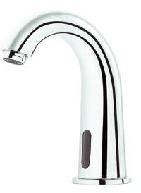 | - Battery powered option also available  - Lead Safe technology  - WELS 6* rated
ADDITIONAL BASIN OPTIONS: sensor tap option 2 | TZ-FLOWHOBSP  Flowmatic® Hob Basin Tap Single Temperature - Mains Power | 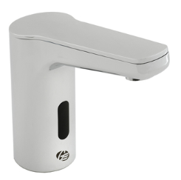 | - Made from Lead Safe DR Brass  - Battery powered option also available  - Temperature mixing models also available  - WELS 6* rated
ADDITIONAL BASIN OPTIONS: integrated TMV | 100.00.71.00  CliniMix® Lead Safe™ Hob Mtd Thermostatic Progressive Basin Mixer – Lever | 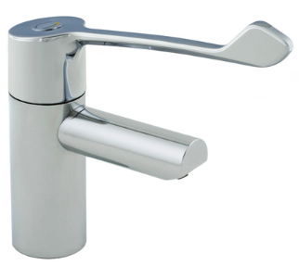 | - Made from Lead Safe DR Brass  - Integrated TMV making it ideal for singular basin installations  - Min flow rate 6 LPM

Sink Tapware
Location | Product Description | Image | Notes
SINK MIXER OPTION 1 | TM-SNKX  CliniLever® Stainless Steel Lead Safe™ Sink Mixer | 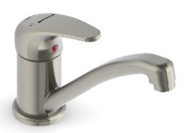 | - Made from Lead Safe SS316  - WELS 6* & 5* rated
SINK MIXER OPTION 2 | TM-SNKGX  CliniLever® Stainless Steel Lead Safe™ Gooseneck Sink Mixer | 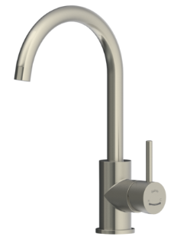 | - Made from Lead Safe SS316  - WELS 6* & 5* rated
DISABLED SINKS: sink mixer | TM-SNKXD  CliniLever® Stainless Steel Lead Safe™ Sink Mixer with Disabled Lever | 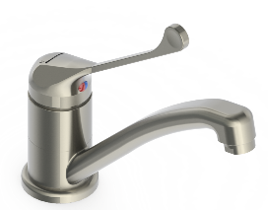 | - Made from Lead Safe SS316  - WELS 6* & 5* rated

Cleaners Room Tapware
Location | Product Description | Image | Notes
CLEANER SINK | 174.51.22.03  Vandal Resistant CP-BS J/V Basin Set (NSW) with Aerator | 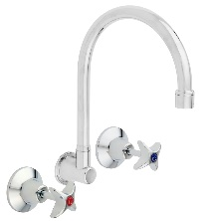 | - Made from Lead Safe DR Brass  - WELS 5* rated
HOSE COCK | 49965  Vandal Resistant CP-BS J/V Hose Tap - Cold | 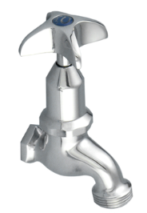 | - Hot option available also

Drinking Fountains
Accessible, potable water is a health and safety requirement. Drinking water should be provided based on one tap per 30 students.
Drinking fountains must be dispersed throughout the school in convenient areas, ensuring all students can access them when needed.
Project consultants must select and satisfy drinking fountains that meet the following requirements:
- Accessible to all users, including specific fountains dedicated for wheelchair accessibility
- Be made from lead-free or lead-safe products
- Appropriate to the age and height of users (ages 5–12 in primary schools, 12+ in secondary schools)
- Be placed near locations where physical activities occur, such as active play and sports areas, and where students are likely to eat lunch
- Be designed to allow students to fill water bottles.
Consideration should also be given in the design process to locating fountains in a way that minimises damage and vandalism.

Trough Tapware
Location | Product Description | Image | Notes
ABLUTION TROUGHS OPTION 1: timeflow tapware | 173.46.21.00  Ezy-Push® CP-BS Lead Safe™ Timeflow Push Button Deluxe Bib Tap - 6 Sec (MI) | 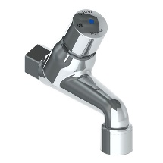 | - Made from Lead Safe DR Brass  - WELS 6* rated
ABLUTION TROUGHS OPTION 2: timeflow tapware | 368667X  Ezy-Push® SS316 Lead Safe™ Timeflow Push Button Deluxe Bib Tap 6 Sec - MI | 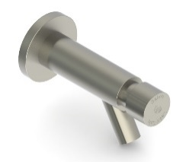 | - Made from Lead Safe SS316  - WELS 6* rated
ABLUTION TROUGHS OPTION 3: timeflow tapware, lever | 173.46.23.00  Ezy-Lever CP-BS Lead Safe™ Timeflow Lever Action Vandal Resistant Deluxe Bib Tap | 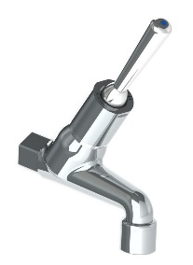 | - Made from Lead Safe DR Brass  - Lever handle to assist younger children who haven't yet developed the strength for push buttons  - WELS 6* rated
STUDENT LEARNING AREA TROUGHS VARIOUS OPTION 1: bib tap | 49882  Vandal Resistant CP-BS J/V Deluxe Bib Tap Aerated Cold | 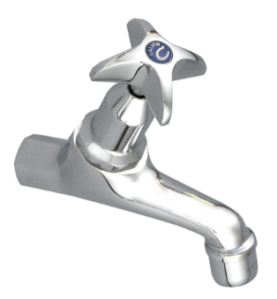 | - Hot version also available  - WELS 3* rated
STUDENT LEARNING AREA TROUGHS VARIOUS OPTION 2: type 16 lab tap | 167.16.32.00  GalvinLab® CP-BS Lead Safe™ Lab Set 1-Way Type 16 DPW Fixed J/V #8 Aerator | 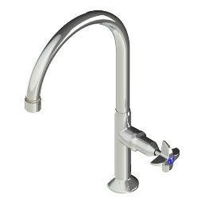 | - Made from Lead Safe DR Brass  - Comes with anti-rotation pins  - Lever handle available for AS1428 applications  - Wall mounted version also available  - WELS 5* rated
DRINK TROUGHS OPTION 1 | TD15XP  Ezy-Drink® SS316 Lead Safe™ Remote Push Button Drinking Bubbler Tap – FI | 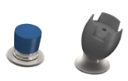 | - Made from Lead Safe SS316  - Automatic shut off  - WELS 6* rated
DRINK TROUGHS OPTION 2 | TD00XP  Ezy-Drink® SS316 Lead Safe™ Vertical Push Button Drinking Bubbler Tap – MI | 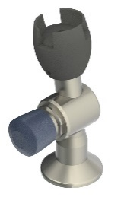 | - Made from Lead Safe SS316  - Automatic shut off  - Available in left and right-hand models  - WELS 6* rated
DRINK TROUGHS OPTION 3: electronic | TD15XEM  Ezy-Drink® SS316 Lead Safe™ Remote Electronic Drinking Bubbler Tap FI - Mains | 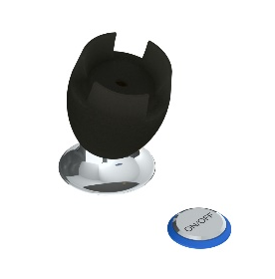 | - Made from Lead Safe SS316  - Battery option available  - Customisable settings including auto-line purge after periods of non-use  - Suitable for AS1428 applications  - WELS 6* rated
DRINK TROUGHS OPTION 4: | 170.50.14.00  Ezy-Drink® CP-BS Lead Safe™ Horizontal Lever Action Drinking Bubbler Tap - FI | 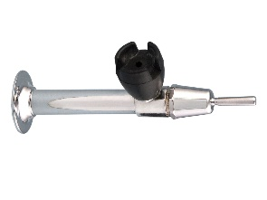 | - Made from Lead Safe DR Brass  - Lever handle to assist younger children who haven't yet developed the strength for push buttons  - WELS 6* rated
DRINK TROUGHS OPTION 5: | 170.50.13.01  Ezy-Drink® CP-BS Lead Safe™ Horizontal Push Button Drinking Bubbler - FI | 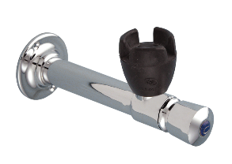 | - Made from Lead Safe DR Brass  - Lever handle to assist younger children who haven't yet developed the strength for push buttons  - WELS 6* rated
DRINK TROUGHS BOTTLE FILLER OPTION 1 | 170.13.33.00  Ezy-Drink® CP-BS Lead Safe™ Hob Mtd Bottle Filler Tap RH- MI |  | - Made from Lead Safe DR Brass  - WELS 6* rated
DRINK TROUGHS BOTTLE FILLER OPTION 2: electronic | TDBFXEB  Ezy-Drink® SS316 Lead Safe™ Remote Electronic Bottle Filler Tap FI - Battery | 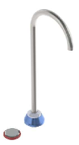 | - Made from Lead Safe SS316  - Battery option available  - Customisable settings including auto-line purge after periods of non-use  - Suitable for AS1428 applications  - WELS 6* rated
WALL BOTTLE FILLER OPTION 1 | 170.53.13.00  Ezy-Drink® CP-BS Lead Safe™ Wall Mtd Push Button Bottle Filler | 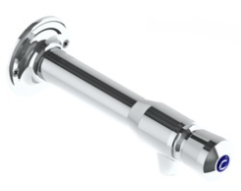 | - Made from Lead Safe SS316  - WELS 6* rated
WALL BOTTLE FILLER OPTION 2 | 170.53.14.00  Ezy-Drink® CP-BS Lead Safe™ Wall Mtd Lever Action Bottle Filler | 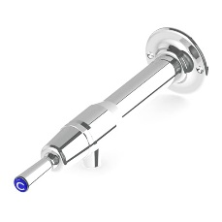 | - Made from Lead Safe SS316  - WELS 6* rated

Sanitaryware
Suitable sanitary fittings and fixtures are to be provided that support and complete the delivery of functional spaces and meet the needs of users. Installation of all sanitary fixtures and fittings connected to service pipework must include all required anchorages, fixings, lugged elbows and the like, as necessary for a robust, durable, impact-resistant installation.
Project consultants should select and satisfy sanitary fixtures and fittings that meet the following requirements:
- Be new, free from defects, damage, corrosion and surface blemishes
- Be chemically and electrolytically compatible with adjacent materials and products, substrates, and adjacent work, or separated by suitable spacers
- Adjacent materials and products, including adhesives and sealants, will not stain, corrode or contaminate, and must not cause visual or structural defects in adjacent materials
- All pans in schools are to be fixed at a standard height to maintain flexibility of use; junior pans are not required [refer kindergarten requirements below]
- Use similar models and manufacturers throughout to achieve design coherence
- Wall-mounted cisterns are preferred as they are easier to maintain (if unconcealed wall mounted, they must be made as tamperproof as possible)
- Press button, self-closing/timeflow taps, or top lever timeflow bib taps, that do not need to be manually turned off after use, must be installed at handwash basins for infection control (where fitted for junior students operation is to be sufficiently ‘soft’ for them to use)
- Pans and toilet pipes must be of an appropriate capacity and durability for school use
- Plumbing fixtures must drain adequately and not create blockages
- Low flushing toilets must only be used if gradients include a safety allowance to allow for low flushing.
Specifications for sanitaryware must be considered in line with Hydraulic services, and specifications relating to the trapment and drainage of water.
Toilets must be floor-mounted vitreous china with wall-backed pan and have a strong vandal-proof fixing between the seat and pan, with anti-vandal fixing accessories. Toilets provided for adults must have a double-flap hinged toilet seat with Single-flap toilet seats will be provided for student toilets.
All pans in schools are to be fixed at a standard height to maintain flexibility of use [i.e. junior pans are not required in schools. Refer below for kindergarten requirements].
Where required, accessible toilet pans as specified in the Disability Discrimination Act (DDA) must be provided, with wall extension pedestal and easily accessible flush button.
Accessible toilets must be provided as per DDA requirements and counted towards the base NCC toilet calculation.
Toilet Pans
Location | Product Description | Image | Notes
TOILET SUITE STANDARD | 105.10.00.00  GalvinAssist® Wall Faced, Clean Flush, Easy Care Toilet Suite with Soft Close Seat | 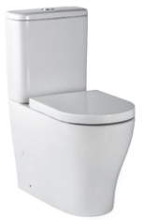 | - Clean Flush rimless pan design for an efficient, powerful flush  - Suitable for S or P trap installations  - Universal cistern, suits back entry or bottom entry plumbing  - WELS 4* Rating
TOILET SUITE AMBULANT | 105.10.20.00  GalvinAssist® Wall Faced, Clean Flush, Easy Care, Ambulant Toilet Suite with Soft Close Seat | 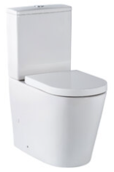 | - Clean Flush rimless pan design for an efficient, powerful flush  - Suitable for S or P trap installations  - Universal cistern, suits back entry or bottom entry plumbing  - WELS 4* Rating
TOILET SUITE DISABLED | 105.10.10.01  GalvinAssist® Wall Faced, Clean Flush, Easy Care, Accessible Toilet Suite with Blue Seat | 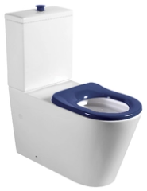 | - Suitable for S or P trap installations  - Universal cistern, suits back entry or bottom entry plumbing  - WELS 4* Rating
STANDARD TOILET PAN – INWALL CISTERN | 105.11.20.00  GalvinAssist® Wall Faced, Clean Flush, Easy Care, Toilet Pan with Soft Close Seat | 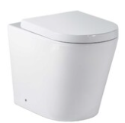 | - Universal traps suitable for S or P trap installations  - Hidden cistern activated through a premium pneumatic system connected to the flush plate buttons  - WELS 4* Rating
AMBULANT TOILET PAN – INWALL CISTERN | 105.11.00.00  GalvinAssist® Wall Faced, Clean Flush, Easy Care, Ambulant Toilet Pan with Soft Close Seat | 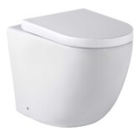 | - Universal traps suitable for S or P trap installations  - Hidden cistern activated through a premium pneumatic system connected to the flush plate buttons  - WELS 4* Rating
DISABLED TOILET PAN – INWALL CITERN | 105.11.10.01  GalvinAssist® Wall Faced, Clean Flush, Easy Care, Accessible Toilet Pan with Blue Seat | 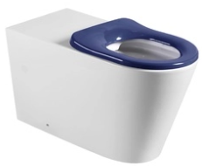 | - Care toilet seat, soft closing, quick release for easy removal and cleaning  - Suitable for S or P trap installations  - WELS 4*Rating
INWALL CISTERN | 105.94.00.00  GalvinAssist® Slim Design Inwall Cistern less buttons | 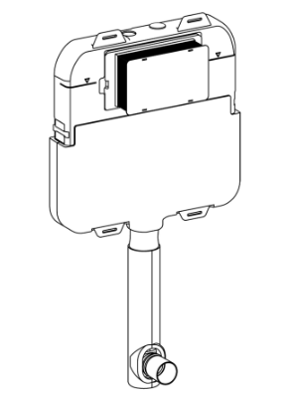 | - Slim design, 80 mm thick to suit floor mount pan  - Fits within standard wall cavity, front access through flush plate  - Fully insulated with anti-condensation foam to prevent moisture escape  - Hidden cistern activated through a premium pneumatic system connected to the flush plate buttons  - Easy to install and service through the flush plate  - WELS 4* Rating
PUSH BUTTONS FOR STANDARD INWALL SUITE | 105.95.00.00  GalvinAssist® Chrome, Dual Flush Plate, Pneumatic Push to Suit Inwall Cistern | 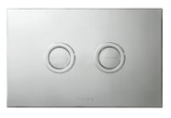
PUSH BUTTONS FOR DISABLED INWALL SUITE | 105.96.00.00  GalvinAssist® Chrome, Accessible Dual Flush Plate, Pneumatic Push to Suit Inwall Cistern | 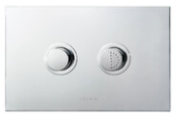

Hand Wash Basins
Basins for hand washing are required throughout the school.
A soap dispenser unit must be installed at each handwash basin and positioned to avoid dripping on benchtops or floors.
Project consultants must select and satisfy hand wash basins that meet the following requirements:
- Vitreous china basins, wall hung
- Mounted at an appropriate height for students and staff, with particular basins adjusted for accessibility.
Self-rimming inset hand wash basins into joinery bench tops can be used in staff areas only.
For student areas, basins must be fixed into solid substructure and be resistant to damage by vandalism, including climbing.
Basins provided for primary school students must use cold water only. Basins in staff-assisted student bathrooms at special, supported inclusion and special development schools must be provided with cold and tempered hot water (45°C) to reduce the risk of scalding.
No plugs are required for all hand wash basins.

Hand Basins
Location | Product Description | Image | Notes
WALL BASIN | 105.32.10.01 (1TH)  105.32.10.03 (3TH)  GalvinAssist® 500mm Wall Mount Basin with Overflow | 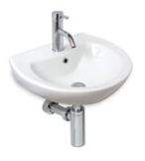 | - Maximises bowl capacity in a compact space  - Optional shroud available
SEMI-RECESSED BASIN | 105.36.01.01 (1TH)  105.36.01.03 (3TH)  GalvinAssist® Semi Recessed Basin, 500mm with Overflow | 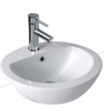 | - Semi-recessed basin  - 7 litre capacity
BASIN SHROUD ONLY | 105.35.20.00  GalvinAssist® Shroud Only to Suit 500mm Wall Mount Basin |  | - Suits 500mm Wall Basin
BASIN – BOTTLE TRAP | 105.93.00.00  GalvinAssist® Chrome, Round Bottle Trap, Wall Exit, Suits 32mm & 40mm Waste |  | - Material: Brass alloy  - Finish: Chrome
DISABLED BASIN – LEFT HAND BOWL | 105.33.10.01 (1TH)  105.33.11.03 (3TH)  GalvinAssist® Accessible, 600mm Wall Mount Basin, LH Bowl with Overflow | 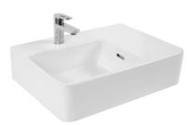 | - Shelf wall basin
DISABLED BASIN – RIGHT HAND BOWL | 105.33.11.01 (1TH)  105.33.10.03 (3TH)  GalvinAssist® Accessible, 600mm Wall Mount Basin, RH Bowl with Overflow | 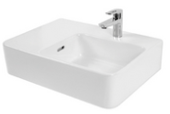 | - Shelf wall basin

Toilet Amenities Fixtures and Fittings
Grab Rails
Location | Product Description | Image | Notes
BACKREST | 105.76.02.01  GalvinAssist® PWD Backrest | 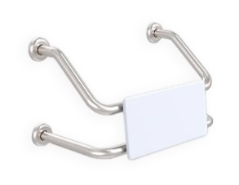 | - Suits single PWD cubicle with either conventional or wall faced pans  - Suits combined PWD compartment featuring WC and shower recess grab rail  - Polar White UV stabilised HDPE rounded edge back support
GRAB RAIL ANGLED | 105.05.03.31 (L/Hand)  105.05.03.41 (R/Hand)  GalvinAssist® Angled 700 x 450 Grab Rail | 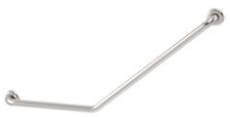 | - Suit Ambulant  - Other finishes/colours also available
GRAB RAIL 90D | 105.08.09.31 (L/H)  105.08.09.41 (R/H)  GalvinAssist® Angled 960 x 600mm Grab Rail | 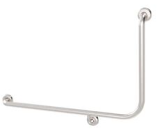 | - Suit Ambulant  - Other finishes/colours also available
GRAB RAIL STRAIGHT | 105.00.00.01 (300mm)  105.00.03.01 (450mm)  105.00.09.01 (900mm)  GalvinAssist® Straight Grab Rail Stainless Steel | 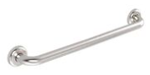 | - Available finishes: polished, machined diamond and white.

Showers
Showers are to be provided to student changing rooms, staff changing rooms and DDA accessible student toilet/bathroom facilities. Showers must be safe, self-draining and designed to allow for privacy for each user.
DDA accessible showers must be fitted with stainless steel grab rails, a shower seat and shower curtains, hooks and all other associated and required fittings to meet required Australian Standards. Where shower rooms are fitted with overhead hoists and ceiling-mounted hoist tracking, project consultants must provide a curtain solution that does not rely on ceiling support brackets.
Shower heads to general purpose showers must be anti-vandal, fixed head type outlets.
Shower heads for DDA accessible showers must comprise a vertical wall rail, hand shower on flexible hose, integral soap dish, and wall bracket.

Shower Tapware
Location | Product Description | Image | Notes
ALL SHOWERS; shower mixer | TM-SHWX  CliniLever® Stainless Steel Lead Safe™ Shower or Bath Mixer | 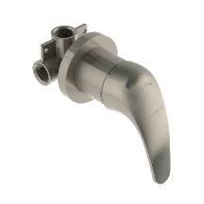 | - Made from Lead Safe SS316
ALL SHOWERS; shower mixer option 2 | TM-SHWCP  CliniLever® CP Single Lever Shower Mixer - Hot/Cold | 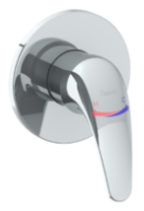 | - XL hot & cold indicators assisting people with visual impairment
DISABLED SHOWERS OPTION 1; rail shower | 41999  GalvinAssist® Hand Shower Kit with 900 x 32mm SS Hygienic Grab Rail | 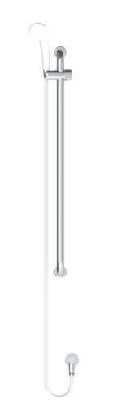 | - Available with white or chrome plated PVC hose and handpiece  - WELS 3* rated
DISABLED SHOWERS OPTION 2; inverted T rail shower | 41978  GalvinAssist® Hand Shower with Inverted T 700 x 1100mm SS Hygienic Grab Rail (Centre) | 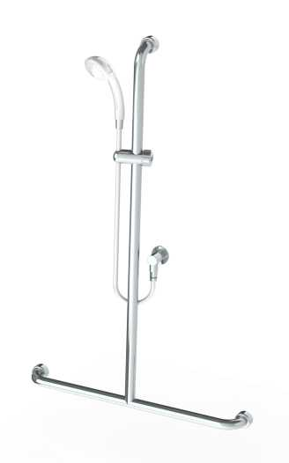 | - Available in left, right and centre inverted T rail  - WELS 3* rated
DISABLED SHOWERS OPTION 3; CLEVA shower | CLEVA035  GalvinAssist® Hand Shower Kit with 900 x 32mm SS Hygienic Grab Rail, ClevaCare® Shower - Low Wall Outlet | 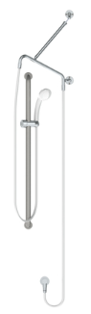 | - Available with white or chrome plated PVC hose and handpiece  - WELS 3* rated
STAFF AND STUDENT SHOWERS | 121.33.64.00  GalvinCare® CP-BS Lead Safe™ Mental Health Anti-Ligature Wall Mtd Shower Rose 65 - Std | 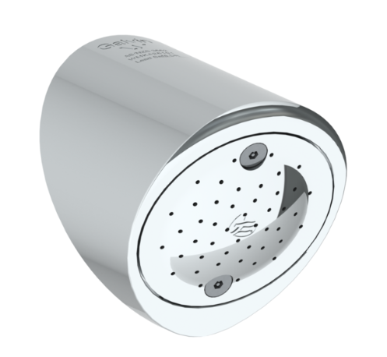 | - Made from Lead Safe DR Brass  - WELS 4* rated

Emergency Shower and Eyewash
Emergency Showers and Eyewash Equipment
Location | Product Description | Image | Notes
EYE WASH OPTION 1 | 190.42.11.12  GalvinSafe® Eye/Face Wash, Wall Mtd, Hand Activated, AXION® MSR Head & SS Bowl | 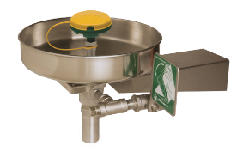 | - Includes Type 304 stainless steel in-line 50 x 50 mesh water strainer
EYE WASH OPTION 2 | 190.82.11.12  GalvinSafe® Pedestal Floor Mtd, AXION® MSR Eye/Face Wash Head, SS Bowl Hand Act | 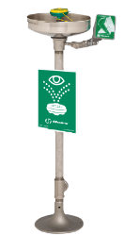 | - Includes Type 304 stainless steel in-line 50 x 50 mesh water strainer  - Product complies with AS 4775
EYE WASH OPTION 3 | 190.12.55.32  GalvinSafe® Eye/Face Wash, Hob Mtd, Hand Held , AXION® MSR Eyewash Head (HAWS) | 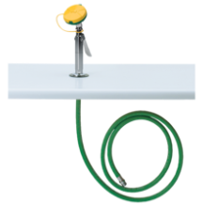 | - Zero Vertical Velocity™  - Product complies with AS 4775
EYE WASH OPTION 4 | 190.42.65.32  GalvinSafe® Eye/Face Wash, Wall Mtd, Hand Held, 3.6mtr Recoil Hose, AXION® MSR Head (HAWS) | 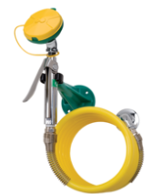 | - Zero Vertical Velocity™  - Product complies with AS 4775
DELUGE SHOWER OPTION 1 | 190.80.10.12  GalvinSafe® Free Standing Combi Shower, AXION® MSR ABS Eye/Face Wash, Hand Act (HAWS) | 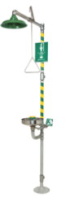 | - Powder coating various colours available  - Audio visual alarms also available  - Includes Type 304 stainless steel in-line 50 x 50 mesh water strainer  - Product complies with AS 4775
DELUGE SHOWER OPTION 3 | 190.41.12.12  GalvinSafe® Drench Shower, Wall Mounted, Pull Rod AXION® MSR ABS Shower | 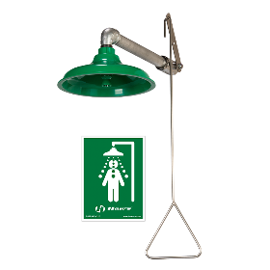 | - Product complies with AS 4775

Drainage and Cleanouts
Drains and Cleanouts
Location | Product Description | Image | Notes
FLOOR DRAIN OPTION 1; tile/concrete floor | 302182X  HeelGrate® SS316 Floor Drain Grate Round 100x80 PVC Slip-In | 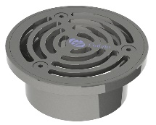 | - Square also available  - Other sizes also available  - Kits with cast iron bodies and buddle flanges also available
FLOOR DRAIN OPTION 2; tile/concrete floor | 302185X  HeelGrate® SS316 Floor Drain Grate Round 150x100 PVC/HDPE/CU Slip-In | 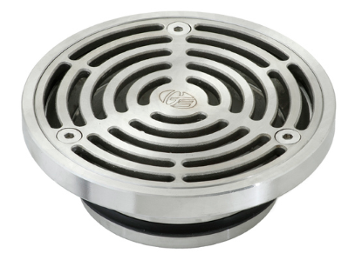 | - Square also available  - Other sizes also available  - Kits with cast iron bodies and buddle flanges also available
FLOOR DRAIN OPTION 3; vinyl floor | 303176X  Stainless Steel Floor Drain Grate Vinyl 100X80PVC Slip-In | 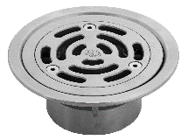 | - Square also available  - Other sizes also available  - Kits with cast iron bodies and buddle flanges also available
FLOOR DRAIN OPTION 4; vinyl floor | 303185X  HeelGrate® SS Floor Drain Vinyl Round 150 x 100 with SS Body PVC/HDPE/CU Slip-In | 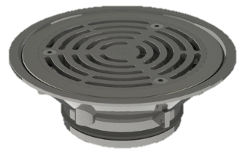 | - Square also available  - Other sizes also available  - Kits with cast iron bodies and buddle flanges also available
CLEANOUT OPTION 1; tile/concrete floor | 67790X  Slip-Safe® SS316 Bolted Cleanout Round 150x100 PVC/HDPE/CU Slip-In | 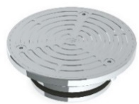 | - Square also available  - Other sizes also available  - Kits with cast iron bodies and buddle flanges also available
CLEANOUT OPTION 2; tile/concrete floor, square | 67778X  HeelGrate® Slip-Safe® SS316 Bolted Cleanout Square 150x100 PVC / HDPE Slip-In | 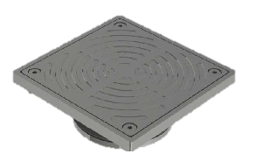 | - Kits with cast iron bodies and buddle flanges also available
CLEANOUT OPTION 3; vinyl floor | 69468X  Slip-Safe® SS Vinyl Bolted Cleanout 150 x 100 PVC/HDPE/CU Slip-In | 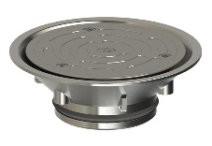 | - Other sizes also available  - Kits with cast iron bodies and buddle flanges also available

Laboratory Tapware
Laboratory Tapware
Location | Product Description | Image | Notes
STUDENT LAB TAP OPTION 1; cold only | TL26.DFJ8C  GalvinLab® CP-BS Lab Set Bib Tap Bench Mtd Type 26 DPW Fixed J/V #8 V/R Aerator | 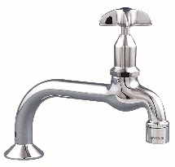 | - Australian Made  - Vandal resistant aerator  • WELS 6* & 5* rated
STUDENT LAB TAP OPTION 2; cold only | TL16FJ16C  GalvinLab® CP-BS Lab Set 1-Way Type 16 Fixed J/V #16XT Tube Nozzle | 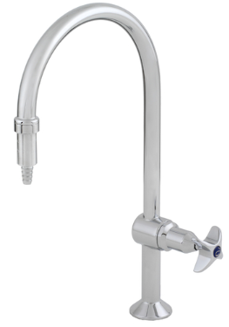 | - Australian Made  - Vandal resistant aerator also available  - Swivel outlet also available  - Anti-rotation pins also available  - for AS1428 applications  - WELS 6* & 5* rated
STUDENT LAB TAP; cold only with DDA Lever Handle | TL16.DFJL16CL  GalvinLab® CP-BS Lab Set 1-Way Type 16 Fixed J/V #16XT Tube Nozzle with DDA Lever Handle | 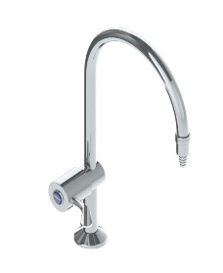 | - Australian Made  - Vandal resistant aerator also available  - Swivel outlet also available  - Anti-rotation pins also available  - Suitable for AS1428  - WELS 6* & 5* rated
TEACHER LAB TAP OPTION 1; hot and cold | 167.13.11.00  GalvinLab® CP-BS Lead Safe™ Lab Set H&C Mixing Unit Type 13 Swivel J/V #16XT Tube Nozzle | 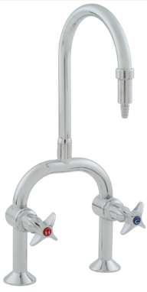 | - Made from Lead Safe DR Brass  - Australian Made  - Vandal resistant aerator also available  - Fixed outlet also available  - WELS 6* & 5* rated
TEACHER LAB TAP OPTION 2; hot and cold | TL19SJ16C  GalvinLab® CP-BS Lab Set H&C Mixing Unit Type 19 Swivel J/V #16XT Tube Nozzle | 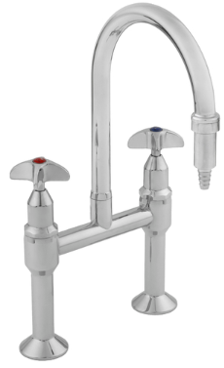 | - Australian Made  - Vandal resistant aerator also available  - Fixed outlet also available  - Lever option also available for AS1428 applications  - WELS 6* & 5* rated
TEACHER LAB TAP OPTION 3; hot and cold with DDA Lever Handle | TC50SJ80C  CliniLever® CP-BS Hospital Hob Mixing Set Type 50 Swivel 80mm Levers J/V | 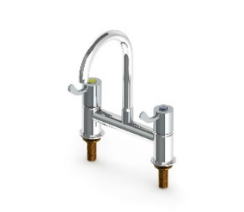 | - Made from Lead Safe DR Brass  - Australian Made  - Fixed outlet also available  - Suitable for AS1428 applications  - WELS 5* rated
LAB TAP VARIOUS OPTION 1; cold only | TL07FJ1-16C  GalvinLab® CP-BS Lab Set 3-Way Type 7 Fixed J/V #1 Aerator & #16XT Tube Nozzles | 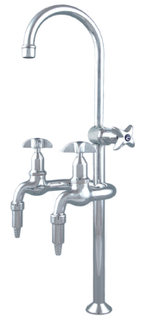 | - Australian Made  - Can have any nozzle set up from aerated and tube nozzle  - WELS 4* rated
LAB TAP VARIOUS OPTION 2; hot and cold | TL14SJ16C  GalvinLab® CP-BS Lab Set H&C Mixing Unit Type 14 Swivel J/V #16XT Tube Nozzles | 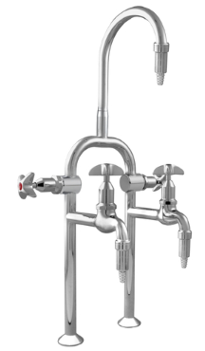 | - Australian Made  - Can have any nozzle set up from aerated and tube nozzle  - Fixed outlet also available  - WELS 5* rated
LAB TAP SCIENCE PREP; hot & cold | TF83HJP  Ezy-Wash® CP-BS Hob Mtd Exposed Mixing Pre-Rinse Unit Type 83 MI Inlet - Pot Filler | 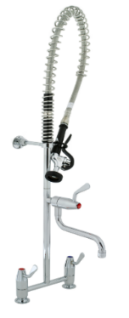 | - Australian Made  - Stainless steel spring  - Trigger hand spray  - 250mm pot filler  - WELS 6* rated
GAS TURRET OPTION 1; single outlet | TG37C  GalvinLab® CP-BS Lab 1-Way Straight Gas Turret Type 37 | 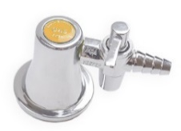 | - Australian Made  - Angled outlets also available
GAS TURRET OPTION 2; dual outlet | TG40C  GalvinLab® CP-BS Lab 2-Way Straight Gas Turret Type 40 - 90° | 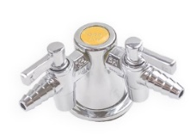 | - Australian Made  - Angled outlets also available

