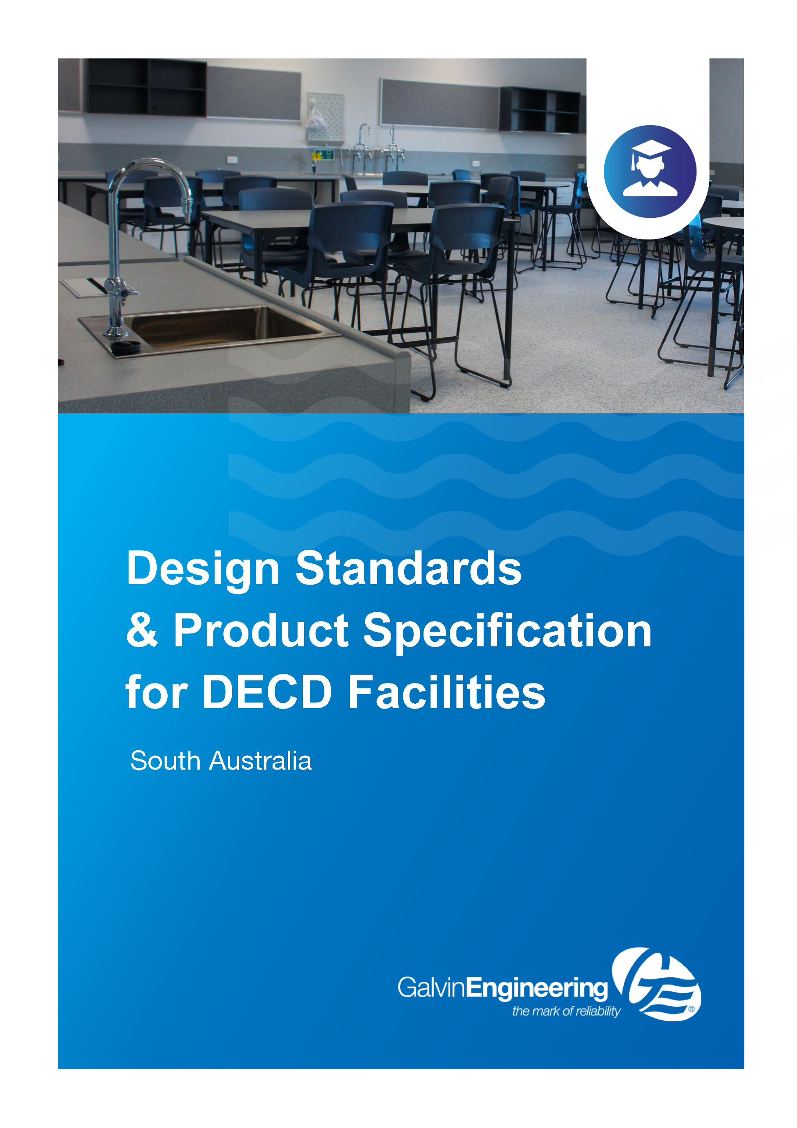

Education Facilities Design Standards 2020
Guidelines relevant to Galvin Engineering product selection

Plumbing
Plumbing waste systems must include the following specific requirements:

- Science laboratory waste pipes preferred to be enclosed in service ducts with removable access panels.
- Provide acid resistant high density polyethylene pipework to be used for laboratory waste pipes.
- Laboratory waste system to include a waste treatment pit sized to suit the particular requirements of the site.
- Laboratory safety showers to be provided with floor traps, draining to the laboratory waste treatment system.
- Floor trap grates in vinyl floor areas must be fitted with a damp type fitting as “Blucher” or equivalent.
- Internal surface inspection openings (SIO) must be chrome plated brass inserts.
- External surface inspection openings must be cast iron and concrete ring.
- Sewer vents through metal roofs must be flashed with an up-stand of similar material to the roof and fitted with a PVC weathering cone.
- The tops of gully trap grates in paved areas must finish 12mm above surrounding paving.
- Paving is to ramp up to the top of the grates.
- In reactive soils construct flexible joins and expansion joints for sewer at the building line. Type of joint required will depend on soil conditions.

Water services
- Potable and non-potable water services are to be strictly separated.
- Provide potable water to safety shower and shower/eye wash unit in laboratories and preparation/store rooms, sinks and troughs to all other learning areas.
- Recycled water (rainwater) may be used for toilet flushing.
- Non-potable water must be used for all other laboratory water services from separately piped water reticulation circuit. Provide approved backflow prevention device on the water supply to each laboratory, testable double check. Locate in an accessible position with a label. Provide signs in each laboratory indicating “Caution – water not for drinking” in accordance with AS/NZS 3500.1
- Provide isolation of the water supply to a laboratory or group of laboratories with an isolation valve positioned in an accessible location. If the valve is external to the building locate in a secure enclosure.
- Press (crimp) type copper fittings must not be used.

Water temperatures
- Cold water is to be provided in general student toilet hand basins, sinks and hand basins in general learning areas.
- In laboratories potable and non-potable water services are to be separated. Provide potable water for safety shower and shower/eye wash unit. Non-potable water must be used for all other laboratory water services.
- Heated water must be provided in accordance with AS 3500 Plumbing and drainage Part 4 – Heated water services.
- Water at a maximum 45°C is to be provided to the following ‘general areas’ (locations not listed must only be serviced by cold water):
  - Staff and Student disabled access toilet hand basins
  - Staff and Student showers
  - Staff toilet hand basins
  - Sick room hand basins
  - Staff room hand basins
  - Canteen hand basins
  - High school home economics hand basins and sinks
  - High school VET hand basins
  - High school student common room sinks
  - Science staff preparation area sink (1 hot water outlet only)
  - Art learning area sink (1 hot water outlet only)
  - Stephanie Alexander Kitchen Garden kitchen sinks
  - Nappy change hand basins
  - Baths and showers in early childhood centres
  - Early childhood kitchen hand basins and sinks
  - Staff materials clean up trough in early childhood centres
  - Laundry troughs.
  - Hot water at 60-65°C (via mixer taps) can be provided to the following areas:
  - Design and technology – metalwork, automotive etc (1 per workshop)
  - VET Commercial kitchens (sinks only)
  - Canteen sinks (provided they are not accessible by children)
  - Staff room sinks (provided they are not accessible by children)
  - Sluice sinks
  - Cleaners sinks/troughs (provided they are not freely accessible by children)
  - Washing machine outlets.

Hot water services
- Locations to receive water at a maximum of 45°C must have a Thermostatic Mixing Valve (TMV) conforming with AS 4032.1 and adjusted to an outlet temperature not exceeding 45°C at each outlet supplied from the TMV or a thermostatically controlled tap conforming with AS 4032.4 and adjusted to an outlet temperature not exceeding 45°C at each outlet.
- Electric Instantaneous hot water units are not to be installed or hot water supplied to student accessible spaces.
- All electric instantaneous units are to be installed within a lockable vented cabinet preferably away from student accessible spaces.
- Only proprietary electric instantaneous hot water units with the ability to revert back to its pre-set temperatures automatically after tampering or modification must be installed.
- Tempering valves are not to be used under any circumstance.
- Continuous flow gas and electric hot water heaters are preferred over storage heaters in most situations to reduce energy consumption. Electric continuous flow hot water services can provide an energy efficient option where long pipe-runs are required (subject to AS/NZS 3500). Storage water heaters must be set at 60-65°C in accordance with AS 3500.4 to avoid the likelihood of the growth of Legionella bacteria.
- All pipe work joins to be brazed or welded. Press fittings must not be used.
- Mains pressure storage hot water services must not be located in cabinetry inside buildings where they could compromise occupied areas, fixtures or fittings through flooding due to leakage or malfunction.
- Where no alternative exists and mains pressure storage hot water systems must be installed inside, it must be located to ensure flooding is directed outside of the building or flooding is contained within waterproofed and bunded areas eg wet areas with impervious floors graded to a drainage outlet.

Temperature Monitoring Systems
Location | Product Description | Image | Notes
TMV OPTION 1 | 201.70.11.09  CliniMix® 1500 Lead Safe™ Thermostatic Mixing Valve | 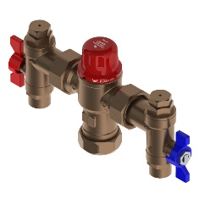 | - Made from Lead Safe DR brass (<0.25% lead)  - Thermal disinfection capable
TMV OPTION 2: in cabinet | 201.10.70.10  CliniMix® 1500 Lead Safe™ Thermostatic Mixing Valve in Cabinet | 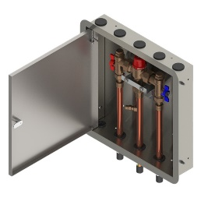 | - Made from Lead Safe DR brass (<0.25% lead)  - Thermal disinfection capable
TMV OPTION 3: in cabinet with bypass | 201.11.70.10  CliniMix® 1500 Lead Safe™ Thermostatic Mixing Valve with Cold Bypass in Cabinet | 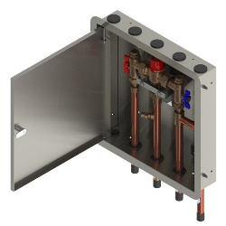 | - Made from Lead Safe DR brass (<0.25% lead)  - Thermal disinfection capable

Tapware
General
- Basin and sink taps must be specified to the highest practicable Water Efficiency Labelling Scheme (WELS) rating.
- All outlets and breeching pieces must be manufactured from de-zincification resistant material approved by SA Water.
- Taps can be wall or bench mounted. If bench mounted they must be secured to the bench top and not just to the sink or trough.
- Swivel outlets must not be used.
- Taps must have lever handles unless otherwise indicated in this standard. Lever handles must have not less than 50mm clearance from an adjacent surface.
- All single lever mixers need to be commercial grade and have highly visible colour indicators which are permanently attached.
- Student ablution areas in schools must have 1 pillar cock for cold water to each basin, push button activated timeflow with delayed return. Provide soft touch push button timeflow tap in preschool and early learning settings.
- Staff ablution areas must have commercial grade single lever mixers with colour indicator.

Basin Tapware
Location | Product Description | Image | Notes
STUDENT BASINS OPTION 1: time-controlled tap | 173.15.21.00  Ezy-Push® CP-BS Lead Safe™ Timeflow Push Button Pillar Tap - 6 Sec | 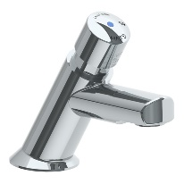 | - Made from Lead Safe DR Brass  - WELS 6* rated
STUDENT BASINS OPTION 2: time-controlled tap | 368696X  Ezy-Push® SS316 Lead Safe™ Timeflow Push Button Pillar Tap 6 Sec – MI | 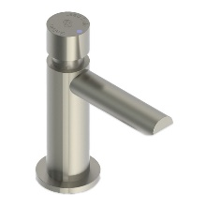 | - Made from Lead Safe SS316  - WELS 6* rated
STUDENT BASINS OPTION 3: time-controlled tap, lever handle | 173.15.23.00  Ezy-Lever CP-BS Lead Safe™ Timeflow Lever Action Vandal Resistant Pillar Tap | 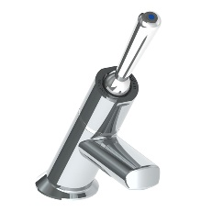 | - Made from Lead Safe DR Brass  - Lever handle to assist younger children who haven't yet developed the strength for push buttons  - WELS 6* rated
STAFF BASINS OPTION 1: basin mixer | TM-BASX  CliniLever® Stainless Steel Lead Safe™ Basin Mixer | 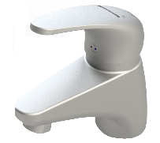 | - Made from Lead Safe SS316 WELS 6* & 5* rated
STAFF BASINS OPTION 2: basin set | 49910  Vandal Resistant CP-BS J/V Basin Set (NSW) with Aerator | 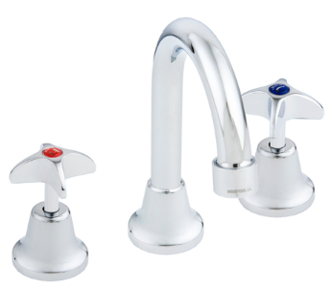 | - WELS 5* rated
DISABLED BASINS: basin mixer | TM-BASXD  CliniLever® Stainless Steel Lead Safe™ Basin Mixer with Accessible Lever | 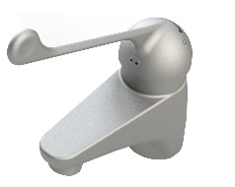 | - Made from Lead Safe SS316  - WELS 6* & 5* rated
ADDITIONAL BASIN OPTIONS: sensor tap option 1 | TZ-FL20SM  Conti Electronic Flamingo IR Hob Basin Tap without Temp Mixer - Mains Power | 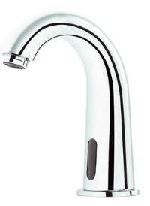 | - Battery powered option also available  - Lead Safe technology  - WELS 6* rated
ADDITIONAL BASIN OPTIONS: sensor tap option 2 | TZ-FLOWHOBSP  Flowmatic® Hob Basin Tap Single Temperature - Mains Power | 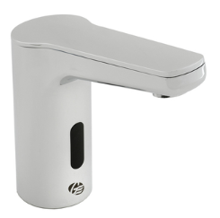 | - Made from Lead Safe DR Brass  - Battery powered option also available  - Temperature mixing models also available  - WELS 6* rated
ADDITIONAL BASIN OPTIONS: integrated TMV | 100.00.71.00  CliniMix® Lead Safe™ Hob Mtd Thermostatic Progressive Basin Mixer – Lever | 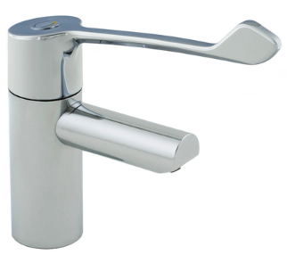 | - Made from Lead Safe DR Brass  - Integrated TMV making it ideal for singular basin installations  - Min flow rate 6 LPM

Sink Tapware
Location | Product Description | Image | Notes
SINK MIXER OPTION 1 | TM-SNKX  CliniLever® Stainless Steel Lead Safe™ Sink Mixer | 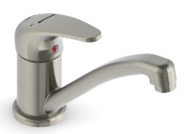 | - Made from Lead Safe SS316  - WELS 6* & 5* rated
SINK MIXER OPTION 2 | TM-SNKGX  CliniLever® Stainless Steel Lead Safe™ Gooseneck Sink Mixer | 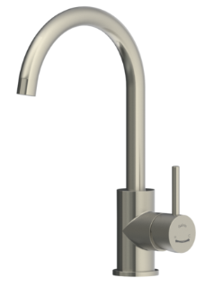 | - Made from Lead Safe SS316  - WELS 6* & 5* rated

Cleaners Room Tapware
Location | Product Description | Image | Notes
CLEANER SINK | 49952  Vandal Resistant CP-BS Wall Mtd Sink Set with Swivel Upswept Outlet | 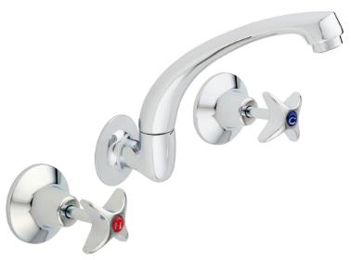
HOSE COCK | 49965  Vandal Resistant CP-BS J/V Hose Tap - Cold | 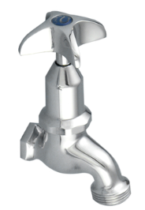 | - Hot option available also

Drinking troughs/fountains
Where new drinking fountains are being specified, or where existing fountains are being replaced, disability provisions must be considered to ensure equitable access. Although not required at every fountain, convenient access for both able bodied and people with disability must be considered.
They must be stainless steel proprietary items in convenient locations around the school and must be located away from toilet areas and entrances to reduce the likelihood of cross-contamination and conflicts in student movement. For ease of maintenance and cleaning, it is preferable that the drinking outlets are above stainless steel troughs, particularly if they are located outside of buildings. All drains must be ferrous if easily accessible.

Provide a sturdy, low maintenance chrome plated bubbler outlet with integral rubber bacteria preventative mouthguard and a self-closing tap. The drinking bubbler must also have an integral bottle filler for filling water bottles in a quick and easy manner. Drinking fountain outlets must aim to be the highest practicable WELS rating. The bubbler outlet must be set at the following heights except where disability provisions are specified:
- Junior primary schools: 600 to 650mm
- Primary and middle schools: 750 to 800mm
- Secondary schools: 900 to 1000mm

Provision of refrigeration and/or filters to the drinking water is not a standard provision and is not financially supported by the department. Where schools or preschools elect to install refrigeration and/or filters, installation and ongoing maintenance (as per the manufacturer’s instructions) is the responsibility of the school. If provided ensure any electrical connections are hard wired and that cabling and the like does not pose a trip hazard.

Trough Tapware
Location | Product Description | Image | Notes
ABLUTION TROUGHS OPTION 1: timeflow tapware | 173.46.21.00  Ezy-Push® CP-BS Lead Safe™ Timeflow Push Button Deluxe Bib Tap - 6 Sec (MI) | 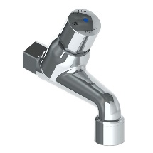 | - Made from Lead Safe DR Brass  - WELS 6* rated
ABLUTION TROUGHS OPTION 2: timeflow tapware | 173.46.23.00  Ezy-Lever CP-BS Lead Safe™ Timeflow Lever Action Vandal Resistant Deluxe Bib Tap | 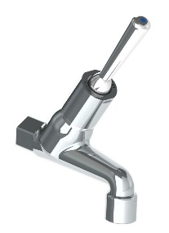 | - Made from Lead Safe DR Brass  - Lever handle to assist younger children who haven't yet developed the strength for push buttons  - WELS 6* rated
ABLUTION TROUGHS OPTION 3: timeflow tapware, lever | 49882  Vandal Resistant CP-BS J/V Deluxe Bib Tap Aerated Cold | 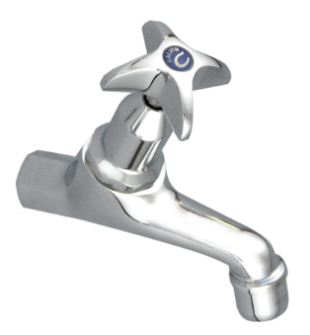 | - Hot version also available  - WELS 3* rated
STUDENT LEARNING AREA TROUGHS VARIOUS OPTION 1: bib tap | 167.16.32.00  GalvinLab® CP-BS Lead Safe™ Lab Set 1-Way Type 16 DPW Fixed J/V #8 Aerator | 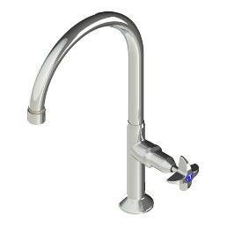 | - Made from Lead Safe DR Brass  - Comes with anti-rotation pins  - Lever handle available for AS1428 applications  - Wall mounted version also available  - WELS 5* rated
STUDENT LEARNING AREA TROUGHS VARIOUS OPTION 2: type 16 lab tap | TD15XP  Ezy-Drink® SS316 Lead Safe™ Remote Push Button Drinking Bubbler Tap – FI | 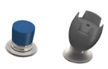 | - Made from Lead Safe SS316  - Automatic shut off  - WELS 6* rated
DRINK TROUGHS OPTION 1 | TD00XP  Ezy-Drink® SS316 Lead Safe™ Vertical Push Button Drinking Bubbler Tap – MI | 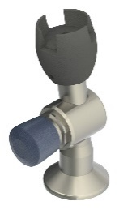 | - Made from Lead Safe SS316  - Automatic shut off  - Available in left and right-hand models  - WELS 6* rated
DRINK TROUGHS OPTION 2 | 173.46.23.00  Ezy-Lever CP-BS Lead Safe™ Timeflow Lever Action Vandal Resistant Deluxe Bib Tap |  | - Made from Lead Safe DR Brass  - Lever handle to assist younger children who haven't yet developed the strength for push buttons  - WELS 6* rated
DRINK TROUGHS OPTION 3: electronic | TD15XEM  Ezy-Drink®316 SS Lead Safe™ Remote Electronic Drinking Bubbler Tap FI - Mains | 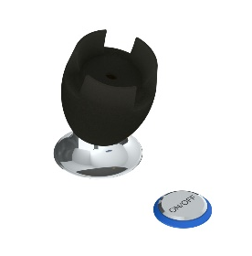 | - Made from Lead Safe SS316  - Mains power (battery option also available)  - Customisable settings including auto-line purge after periods of non-use  - Suitable for AS1428 applications  - WELS 6* rated
DRINK TROUGHS BOTTLE FILLER OPTION 1 | 170.13.33.00  Ezy-Drink® CP-BS Lead Safe™ Hob Mounted Bottle Filler Tap RH- MI |  | - Made from Lead Safe DR brass  - WELS 6* rated
DRINK TROUGHS BOTTLE FILLER OPTION 2: electronic | TDBFXEB  Ezy-Drink® 316 Stainless Steel Lead Safe™ Remote Electronic Bottle Filler Tap FI - Battery | 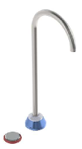 | - Made from Lead Safe SS316  - Battery power (mains option also available)  - Customisable settings including auto-line purge after periods of non-use  - Suitable for AS1428 applications  - WELS 6* rated
WALL BOTTLE FILLER OPTION 1 | 170.53.13.00  Ezy-Drink® CP-BS Lead Safe™ Wall Mtd Push Button Bottle Filler | 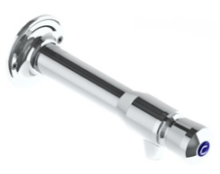 | - Made from Lead Safe SS316  - WELS 6* rated
WALL BOTTLE FILLER OPTION 2 | 170.53.14.00  Ezy-Drink® CP-BS Lead Safe™ Wall Mtd Lever Action Bottle Filler | 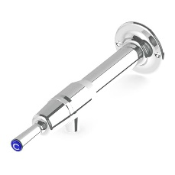 | - Made from Lead Safe SS316  - WELS 6* rated

Toilet pans
- Specify the most water efficient equipment practicable, aiming for within 1 star of the best available WELS rating.
- Toilet pans must be white vitreous china of basic design, with single flap seat (no lids). Disability toilets must have a dual flap.
- Toilet pans must be adult size in all primary and high schools and junior size in preschools and early learning settings.
- Disability access toilet pans to be provided in accordance with AS 1428.1.
- Ambulant facilities for children in preschools and early learning settings are to be junior size.
- Cisterns must be vitreous china dual flush with vandal-proof push buttons.
- Urinals must not be provided in male student or staff/visitor toilets. The required male student urinals stipulated in the NCC are to be converted to closet pans. Please refer to section toilet provisions and design for more information.

Toilet Pans
Location | Product Description | Image | Notes
TOILET SUITE STANDARD | 105.10.00.00  GalvinAssist® Wall Faced, Clean Flush, Easy Care Toilet Suite with Soft Close Seat | 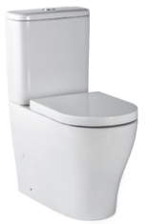 | - Clean Flush rimless pan design for an efficient, powerful flush  - Suitable for S or P trap installations  - Universal cistern, suits back entry or bottom entry plumbing
TOILET SUITE AMBULANT | 105.10.20.00  GalvinAssist® Wall Faced, Clean Flush, Easy Care, Ambulant Toilet Suite with Soft Close Seat | 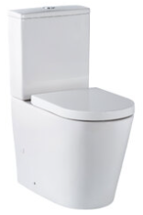 | - Clean Flush rimless pan design for an efficient, powerful flush  - Suitable for S or P trap installations  - Universal cistern, suits back entry or bottom entry plumbing
TOILET SUITE DISABLED | 105.10.10.01  GalvinAssist® Wall Faced, Clean Flush, Easy Care, Accessible Toilet Suite with Blue Seat | 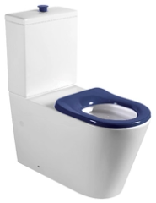 | - Suitable for S or P trap installations  - Universal cistern, suits back entry or bottom entry plumbing
STANDARD TOILET PAN – INWALL CISTERN | 105.11.20.00  GalvinAssist® Wall Faced, Clean Flush, Easy Care, Toilet Pan with Soft Close Seat | 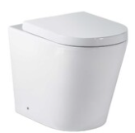 | - Universal traps suitable for S or P trap installations  - Hidden cistern activated through a premium pneumatic system connected to the flush plate buttons
AMBULANT TOILET PAN – INWALL CISTERN | 105.11.00.00  GalvinAssist® Wall Faced, Clean Flush, Easy Care, Ambulant Toilet Pan with Soft Close Seat | 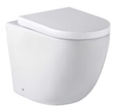 | - Universal traps suitable for S or P trap installations  - Hidden cistern activated through a premium pneumatic system connected to the flush plate buttons
DISABLED TOILET PAN – INWALL CITERN | 105.11.10.01  GalvinAssist® Wall Faced, Clean Flush, Easy Care, Accessible Toilet Pan with Blue Seat | 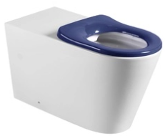 | - Care toilet seat, soft closing, quick-release for easy removal and cleaning  - Suitable for S or P trap installations
INWALL CISTERN | 105.94.00.00  GalvinAssist® Slim Design Inwall Cistern less buttons | 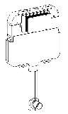
PUSH BUTTONS FOR STANDARD INWALL SUITE | 105.95.00.00  GalvinAssist® Chrome, Dual Flush Plate, Pneumatic Push to Suit Inwall Cistern | 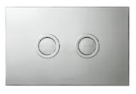
PUSH BUTTONS FOR DISABLED INWALL SUITE | 105.96.00.00  GalvinAssist® Chrome, Accessible Dual Flush Plate, Pneumatic Push to Suit Inwall Cistern | 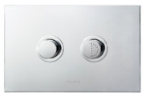

Hand basins
Hand washing facilities must be provided within or in close proximity to all learning and common areas. The number of hand basins or sinks provided must consider the number of students entering the learning area, common area or building at one time to ensure hand washing can be undertaken for all students efficiently. These provisions are in addition to those provided in student amenities.
Hand basins must be also be provided for personal hygiene and where food preparation is undertaken in the following areas:
- Staff and Student toilet amenities
- Nappy change areas
- Sick rooms
- Staff room kitchen
- Early childhood kitchens
- Canteen
- Primary school serviced learning areas used for cooking activities
- High school home economics/food technology
- High school VET commercial kitchens
- High school commercial kitchens
- Hand basins must be mounted at the following heights:
- Early learning centres: 550mm for children under 2 years of age, 600mm for children over 2 years of age.
- Preschools: 600mm.
- Primary schools: 700mm.
- Secondary schools: 850mm.
- Staff facilities: 900mm.

Hand basins must be white vitreous china mounted on heavy duty brackets. All drains to be ferrous if easily accessible.

Hand Basins

Location | Product Description | Image | Notes
WALL BASIN | 105.32.10.01 (1TH)  105.32.10.03 (3TH)  GalvinAssist® 500mm Wall Mount Basin with Overflow | 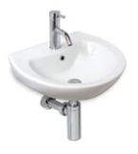 | - Maximises bowl capacity in a compact space  - Optional shroud available
SEMI-RECESSED BASIN | 105.36.01.01 (1TH)  105.36.01.03 (3TH)  GalvinAssist® Semi Recessed Basin, 500mm with Overflow | 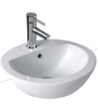 | - Semi-recessed basin  - 7 litre capacity
DISABLED BASIN – LEFT HAND BOWL | 105.33.10.01 (1TH)  105.33.11.03 (3TH)  GalvinAssist® Accessible, 600mm Wall Mount Basin, LH Bowl with Overflow | 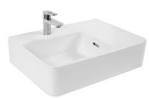 | Shelf wall basin
DISABLED BASIN – RIGHT HAND BOWL | 105.33.11.01 (1TH)  105.33.10.03 (3TH)  GalvinAssist® Accessible, 600mm Wall Mount Basin, RH Bowl with Overflow | 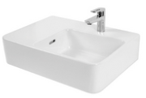 | Shelf wall basin

Toilet amenities fixtures and fittings
- Provide shelf space adjacent to the washbasin in accessible toilet amenities in accordance with AS 1428.1.
- Provide fixtures including clothing hooks, soap dispensers, toilet paper dispensers, hand dryers and folding shower seats in accessible and ambulant toilet amenities in accordance with AS 1428.1.
- Provide a clothing hook to staff toilet cubicle doors: for inward opening doors provide Part 297SSS with rubber bumper, for outward opening doors provide Part 296SSS without rubber bumper.
- Toilet roll holders must be adequately secure to prevent rolls being removed by students. Double roll holders are recommended.
- Provide grab rails to ambulant toilets, accessible toilets and showers to comply with AS 1428.1. Grab rails to ambulant toilets in preschools and early learning centres to be mounted at 600mm AFL. Install adequate bracing to wall framing for grab rail fixing.
- Sanitary disposal in female cubicles will be supplied by the department as freestanding units, under a separate servicing contract.

Grab Rails
Location | Product Description | Image | Notes
BACKREST | 105.76.02.01  GalvinAssist® PWD Backrest | 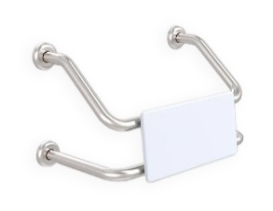 | - Suits single PWD cubicle with either conventional or wall faced pans  - Suits combined PWD compartment featuring WC and shower recess grab rail  - Polar White UV stabilised HDPE rounded edge back support
GRAB RAIL ANGLED | 105.05.03.31 (L/Hand)  105.05.03.41 (R/Hand)  GalvinAssist® Angled 700 x 450 Grab Rail | 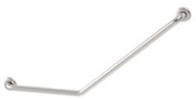 | - Suit Ambulant  - Other finishes/colours also available
GRAB RAIL 90D | 105.08.09.31 (L/H)  105.08.09.41 (R/H)  GalvinAssist® Angled 960 x 600mm Grab Rail | 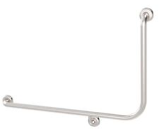 | - Suit Ambulant  - Other finishes/colours also available
GRAB RAIL STRAIGHT | 105.00.00.01 (300mm)  105.00.03.01 (450mm)  105.00.09.01 (900mm)  GalvinAssist® Straight Grab Rail Stainless Steel | 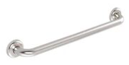 | - Available finishes: polished, machined diamond and white.

Showers
Student and staff showers
- Shower heads must be specified to the highest practicable WELS rating eg if 6 star is the highest available rating however does not provide an appropriate solution, a 5 star minimum must be specified.
- Student showers are normally only provided as part of change rooms in secondary schools.
- Separate cubicles including a seat must be provided for male and female change rooms.
- A single unisex staff shower must be provided as part of the school administration facilities. This can be part of the staff toilet suite or included in the disability/special needs toilet area.
- Refer to DPTI Drawing DD02 – Pre-finished Fibre Cement Shower Partition

Shower Tapware
Location | Product Description | Image | Notes
ALL SHOWERS; shower mixer | TM-SHWX  CliniLever® Stainless Steel Lead Safe™ Shower or Bath Mixer | 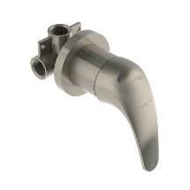 | - Made from Lead Safe SS316
ALL SHOWERS; shower mixer option 2 | TM-SHWCP  CliniLever® CP Single Lever Shower Mixer - Hot/Cold | 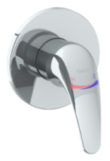 | - XL hot & cold indicators assisting people with visual impairment
DISABLED SHOWERS OPTION 1; rail shower | 41999  GalvinAssist® Hand Shower Kit with 900 x 32mm SS Hygienic Grab Rail | 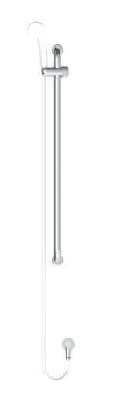 | - Available with white or chrome plated PVC hose and handpiece  - WELS 3* rated
DISABLED SHOWERS OPTION 2; inverted T rail shower | 41978  GalvinAssist® Hand Shower with Inverted T 700 x 1100mm SS Hygienic Grab Rail (Centre) | 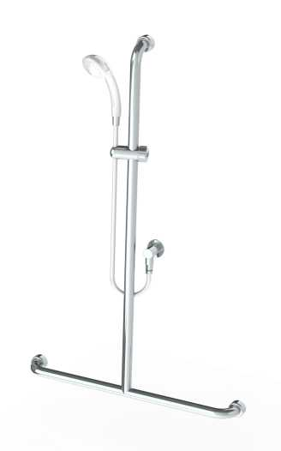 | - Available in left, right and centre inverted T rail  - WELS 3* rated
DISABLED SHOWERS OPTION 3; CLEVA shower | CLEVA035  GalvinAssist® Hand Shower Kit with 900 x 32mm SS Hygienic Grab Rail, ClevaCare® Shower - Low Wall Outlet | 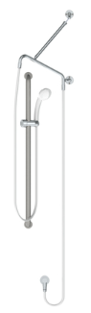 | - Available with white or chrome plated PVC hose and handpiece  - WELS 3* rated
STAFF AND STUDENT SHOWERS | 121.33.64.00  GalvinCare® CP-BS Lead Safe™ Mental Health Anti-Ligature Wall Mtd Shower Rose 65 - Std | 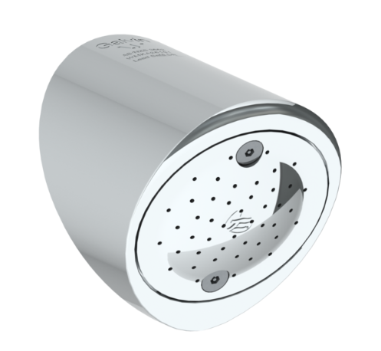 | - Made from Lead Safe DR Brass  - WELS 4* rated

Emergency shower and eyewash
A hand-held shower must be provided in every science laboratory and design and technology workshop, mounted on a bench adjacent to a sink. Final location to be determined in consultation with the site users. A drench shower and eye wash unit must be provided in the science laboratory preparation/store room.

The following provisions apply to all emergency shower/eyewash facilities:
- Locate in an easily accessible, visible and unobstructed location.
- Provide a floor trap connected to the building sewer waste system.
- Controlled flow of flushing fluid is to be provided to both eyes simultaneously at a low velocity.
- Provide with a separate potable water supply.

Emergency Showers and Eyewash Equipment
Location | Product Description | Image | Notes
EYE WASH OPTION 1 | 190.12.55.32  GalvinSafe® Eye/Face Wash, Hob Mtd, Hand Held , AXION® MSR Eyewash Head (HAWS) | 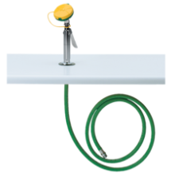
EYE WASH OPTION 2 | 190.42.65.32  GalvinSafe® Eye/Face Wash, Wall Mtd, Hand Held, 3.6mtr Recoil Hose, AXION® MSR Head (HAWS) | 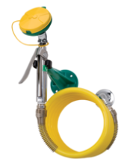
DELUGE SHOWER OPTION 1 | 190.80.10.12  GalvinSafe® Free Standing Combi Shower, AXION® MSR ABS Eye/Face Wash, Hand Act (HAWS) | 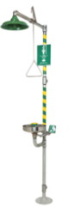 | - Powder coating various colours available  - Audio visual alarms also available
DELUGE SHOWER OPTION 2 | 190.80.10.90  GalvinSafe® Free Standing Combi Shower, AXION® MSR ABS Eye/Face Wash, Hand & Foot Act (HAWS) | 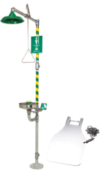 | - Powder coating various colours available  - Audio visual alarms also available

Drainage and Cleanouts
Location | Product Description | Image | Notes
FLOOR DRAIN OPTION 1; tile/concrete floor | 302182X  HeelGrate® SS316 Floor Drain Grate Round 100x80 PVC Slip-In | 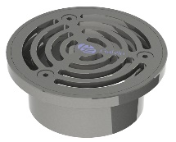 | - Square also available  - Other sizes also available  - Kits with cast iron bodies and buddle flanges also available
FLOOR DRAIN OPTION 2; tile/concrete floor | 302185X  HeelGrate® SS316 Floor Drain Grate Round 150x100 PVC/HDPE/CU Slip-In | 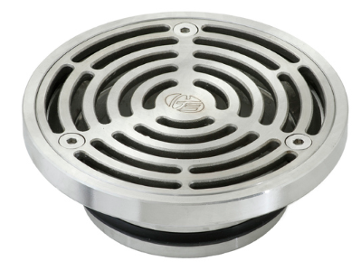 | - Square also available  - Other sizes also available  - Kits with cast iron bodies and buddle flanges also available
FLOOR DRAIN OPTION 3; vinyl floor | 303176X  Stainless Steel Floor Drain Grate Vinyl 100X80PVC Slip-In | 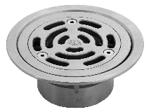 | - Square also available  - Other sizes also available  - Kits with cast iron bodies and buddle flanges also available
FLOOR DRAIN OPTION 4; vinyl floor | 303185X  HeelGrate® SS Floor Drain Vinyl Round 150 x 100 with SS Body PVC/HDPE/CU Slip-In | 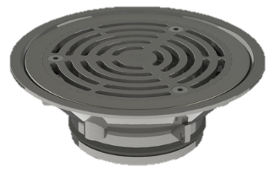 | - Square also available  - Other sizes also available  - Kits with cast iron bodies and buddle flanges also available
CLEANOUT OPTION 1; tile/concrete floor | 67790X  Slip-Safe® SS316 Bolted Cleanout Round 150x100 PVC/HDPE/CU Slip-In | 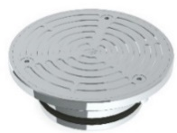 | - Square also available  - Other sizes also available  - Kits with cast iron bodies and buddle flanges also available
CLEANOUT OPTION 2; tile/concrete floor, square | 67778X  HeelGrate® Slip-Safe® SS316 Bolted Cleanout Square 150x100 PVC / HDPE Slip-In | 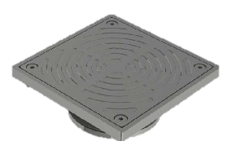 | - Kits with cast iron bodies and buddle flanges also available
CLEANOUT OPTION 3; vinyl floor | 69468X  Slip-Safe® SS Vinyl Bolted Cleanout 150 x 100 PVC/HDPE/CU Slip-In | 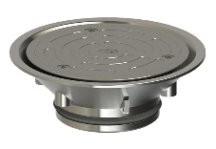 | - Other sizes also available  - Kits with cast iron bodies and buddle flanges also available

Laboratory Tapware
Location | Product Description | Image | Notes
STUDENT LAB TAP; cold only | TL16FJ16C  GalvinLab® CP-BS Lab Set 1-Way Type 16 Fixed J/V #16XT Tube Nozzle | 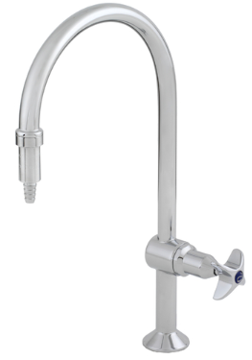 | - Australian Made  - Vandal resistant aerator available  - Swivel outlet available  - Anti-rotation pins available  - for AS1428 applications  - WELS 6* & 5* rated
TEACHER LAB TAP OPTION 1; hot and cold | 167.13.11.00  GalvinLab® CP-BS Lead Safe™ Lab Set H&C Mixing Unit Type 13 Swivel J/V #16XT Tube Nozzle | 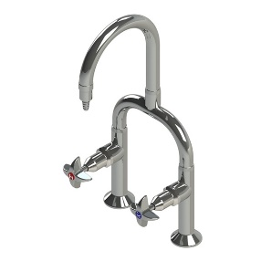 | - Made from Lead Safe DR Brass  - Australian Made  - Vandal resistant aerator also available  - Fixed outlet also available  - WELS 6* & 5* rated
TEACHER LAB TAP OPTION 2; hot and cold | TL19SJ16C  GalvinLab® CP-BS Lab Set H&C Mixing Unit Type 19 Swivel J/V #16XT Tube Nozzle | 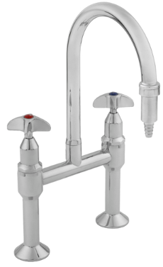 | - Australian Made  - Vandal resistant aerator also available  - Fixed outlet also available  - WELS 6* & 5* rated
LAB TAP VARIOUS OPTION 1; cold only | TL07FJ1-16C  GalvinLab® CP-BS Lab Set 3-Way Type 7 Fixed J/V #1 Aerator & #16XT Tube Nozzles | 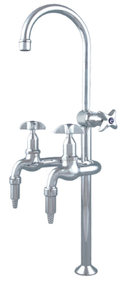 | - Australian Made  - Can have any nozzle set up from aerated and tube nozzle  - WELS 4* rated
LAB TAP VARIOUS OPTION 2; hot and cold | TL14SJ16C  GalvinLab® CP-BS Lab Set H&C Mixing Unit Type 14 Swivel J/V #16XT Tube Nozzles | 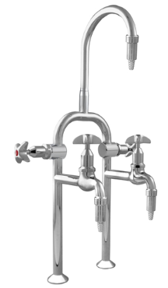 | - Australian Made  - Can have any nozzle set up from aerated and tube nozzle  - Fixed outlet available  - WELS 5* rated
GAS TURRET OPTION 1; single outlet | TG37C  GalvinLab® CP-BS Lab 1-Way Straight Gas Turret Type 37 | 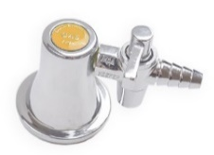 | - Australian Made  - Angled outlets also available
GAS TURRET OPTION 2; dual outlet | TG40C  GalvinLab® CP-BS Lab 2-Way Straight Gas Turret Type 40 - 90° | 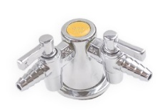 | - Australian Made  - Angled outlets also available
GAS TURRET OPTION 3; dual outlet, non return valve | TG40.DRAC  GalvinLab® CP-BS Lab 2-Way Right Angle Gas Turret Type 40 DPW - 90° with Non-Return Valve | 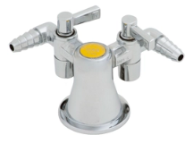 | - Australian Made

