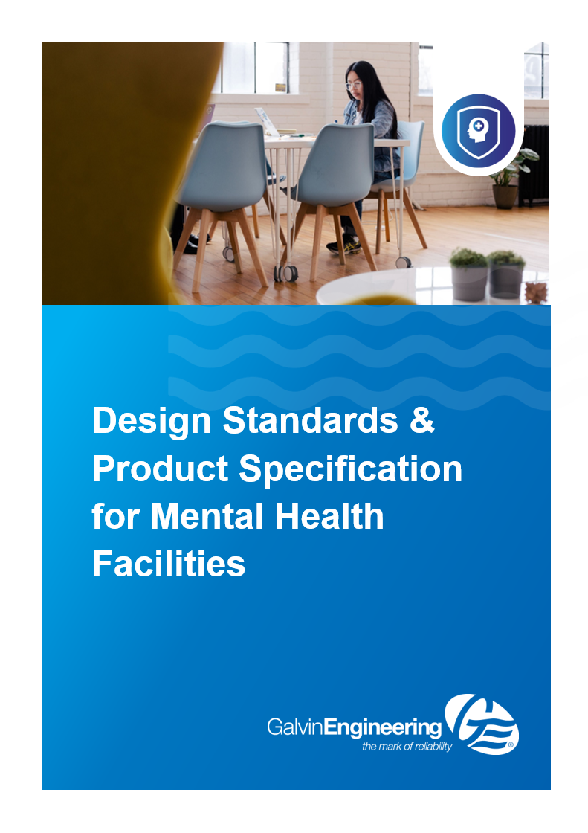

AusHFG Mental Health Facilities Design Standards

Guidelines relevant to Galvin Engineering product selection

This design standard and product specification guide includes the following:
- B.0133 - Psychiatric Emergency Care Centre PECC
- B.0134 - Adult Acute Mental Health Inpatient Unit
- Seclusion Ensuite
- Forensic & Behavioural Mental Health
- B.0135 - Older Peoples Acute Mental Health Inpatient Unit
- B.0136 - Non-Acute Inpatient Mental Health Unit

B.0133 - Psychiatric Emergency Care Centre PECC
01.02 Introduction
This Health Planning Unit has been developed as a resource to assist project teams in the planning and design of a Psychiatric Emergency Care Centre (PECC).

Psychiatric Emergency Care Centres are located with acute hospitals and are a component of broader mental health emergency services that includes community mental health teams, emergency department mental health clinicians, consultation liaison psychiatry services and on-site mental health teams.

PECC is a model commonly used in NSW but other jurisdictions have similar services such as Psychiatric Assessment and Planning Unit (PAPU) and Mental Health Assessment Units (MHAU).

While the operational arrangements of these services may differ, this HPU can be used as a starting point for planning and design. This document should be read in conjunction with the Australasian Health Facility Guidelines (AusHFG) generic requirements and Standard Components described in:
- Part A: Introduction and Instructions for Use;
- Part B: Section 80: General Requirements and Section 90: Standard Components, Room Data Sheets and Room Layout Sheets;
- Part C: Design for Access, Mobility, OHS and Security;
- Part D: Infection Prevention and Control;
- Part E: Building Services and Environmental Design; and
- Part F: Project Implementation.

A ‘patient’ will be referred to as the ‘consumer’ in this document as this reflects the terminology used within a mental health context.

03.04 Infection Prevention and Control
Alcohol based had rub (ABHR) should not be mounted on walls or beds in consumer areas of the PECC. Staff may carry ABHR instead.

Refer to:
- jurisdiction policies relating to infection prevention and control; and
- AusHFG Part D Infection Prevention and Control.

03.09 Fixtures, Fittings & Equipment
GENERAL
Refer to the Room Data Sheets (RDS) and Room Layout Sheets (RLS) for further detailed information regarding the design of consumer accommodation and to:
- AusHFG Part C: Design for Access, Mobility, OHS and Security, Space Standards and Dimensions; and
- AusHFG Part F: Section 680 Furniture Fittings and Equipment

All fixtures, fittings and equipment in consumer accessible areas must be of a type specifically manufactured and marketed as anti-ligature type and installed in accordance with the manufacturer’s instructions.

Psychiatric Emergency Care Centre PECC

Item | Location | Galvin Engineering Product Description | Image
HYBA-078 HYTP-024 | PECC Ensuite Mental Health | WHB-201W-NB-AUS  Wallgate Anti-Ligature, Anti-Vandal Solid Surface Basin with Single Out No Tap Holes
FIDI-038 | PECC Ensuite Mental Health | TRH-04  Wallgate Anti-Ligature, Anti-Vandal Recessed Toilet Roll Holder Solid Surface
HYTP-002 | PECC Ensuite Mental Health | CWC-155W-AST-AUS  Wallgate Anti-Ligature, Anti-Vandal Solid Surface Back To Wall Pan S&P with Grey Integrated Seat 446x702
 |  | 601602  Pneumatic Activated Concealed Dual Flush Cistern 3/4.5Ltr Cistern Only | 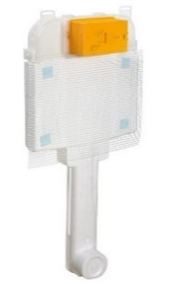
 |  | 656504  Vandal Resistant Dual Flush Push Button Assembly with Polished Stainless Steel Plate - Pneumatic | 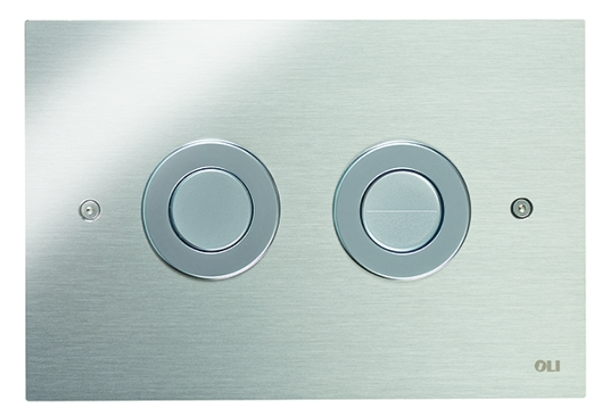
FIDI-051 | PECC Ensuite Mental Health | ALF-04  Wallgate Anti-Ligature, Anti-Vandal Recessed Shower Shelf Solid Surface
FIBM-022 | PECC Ensuite Mental Health | ALM-06W  Wallgate Anti-Ligature, Anti-Vandal Polycarb Mirror with Solid Surface Surround 450 x 1010
HYTP-019 | PECC Ensuite Mental Health | 121.33.64.00  GalvinCare® CP-BS Lead Safe™ Mental Health Anti-Ligature Wall Mtd Shower Rose 65 - Std | 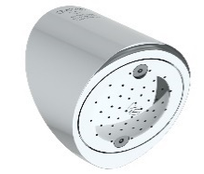
HYTP-047 | PECC Ensuite Mental Health | 121.01.03.01 / 121.01.03.02  Safe-Cell® CP-BS Lead Safe™ Prison Ezy-Grip Wall Top Assembly Complete Hot & Cold C/D | 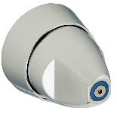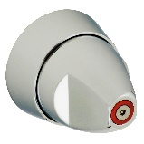
HYTP-046 | PECC Ensuite Mental Health | 120.52.11.04  GalvinCare® CP-BS Lead Safe™ Inwall Progressive Mental Health Anti-Ligature Shower Mixer (Non TMV) W&C
HYDR-011 | PECC Ensuite Mental Health | 69468X  Slip-Safe® SS Bolted Cleanout Vinyl 150x100 with ABS Body PVC/HDPE/CU Slip-In | 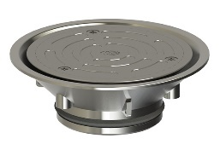
HYDR-010 | PECC Ensuite Mental Health | 303077X  Safe-Cell® Polished SS316 (CRR) Prison Floor Drain Vinyl 100 x 80 BSP | 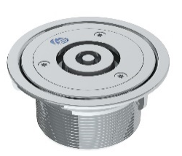
 |  | 302168  PPR Floor Drain Adaptor Ring 80BSP FI x100PVC/HDPE Slip-in | 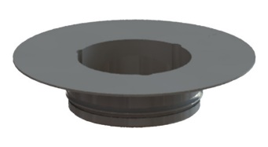

B.0134 - Adult Acute Mental Health Inpatient Unit
01.02 Introduction
HPU 131 Mental Health – Overarching Guideline describes the generic planning and design requirements that should be used when planning mental health inpatient units. This document contains information that is common across all mental health inpatient units and should be read in conjunction with service specific HPU documents to ensure that planning considers both principles and design requirements. These service specific documents include:
- HPU 132 Child and Adolescent Mental Health Unit;
- HPU 133 Psychiatric Emergency Care Centre (PECC);
- HPU 134 Adult Acute Mental Health Inpatient Unit;
- HPU 135 Older Peoples Acute Mental Health Inpatient Unit;
- HPU 136 Non Acute Mental Health Unit which includes rehabilitation, extended care and forensics; and
- HPU 137 Mental Health Intensive Care Unit.

The focus of this document is Adult Acute Mental Health Inpatient Units and information relating to consumers using this type of facility is addressed. This document also includes detailed information on functional planning and a schedule of accommodation.

This document should be read in conjunction with the Australasian Health Facility Guideline (AusHFG) generic requirements and standard components described in:
- Part A: Introduction and Instructions for Use;
- Part B: Section 80 - General Requirements & Section 90 - Standard Components;
- Part C: Design for Access, Mobility, Safety and Security; and
- Part D: Infection Prevention and Control

02.04.02 Entry Foyer, Reception and Waiting
The entry and waiting area should have a comfortable and ‘soft’ waiting space with access to amenities for visitors, families and the public, including an accessible toilet and drinking water.

04.03.09 Trolley Bay or Kitchen / Servery
The kitchen/servery should be a safe, secure environment for staff and consumers in compliance with WHS and infection control guidelines, with ample bench top area, open shelving and lockable cupboards for sharp utensils, supplies, etc., adequate secure storage for food and equipment and sufficient space to store food trays and distribution trolleys. A dedicated power outlet for heating / cooling food trolleys may be required.

Consumer access to power supply controls and hot water systems should be restricted by placing these behind keyed doors.

02.04.04 High Dependency Inpatient Zone
This zone should be capable of secure separation from the general / open zone, but able to be used as an unlocked facility at other times depending on clinical need. The layout should facilitate the controlled movement of staff and consumers between zones, as well as safe access for families and carers.

Bedrooms may open onto a dedicated central lounge and dining area to enable ready engagement of consumers by staff. Sound attenuation is important to reduce stimulus. Depending upon the size of the high dependency zone and its layout, the following should be considered:
- provision of shared consumer living and support areas that align with the model of care for this consumer cohort;
- ease of access for emergency admissions and assessments; and
- careful planning for safe and efficient patient flow.

A higher level of attention to building fabric and design of fittings and fixtures will be required in the high dependency zone.

Access to ensuites may be decided on a project-by-project basis. Individual toilets and showers accessed directly from a corridor may provide better supervision.

02.04.07 Staff Work Areas, Meeting Rooms and Amenities
Meeting Rooms
Meeting rooms will be required for staff meetings, training and other education requirements. These should be located on the periphery of the staff zone to enable ease of access by external staff.

Staff Amenities comprise staff room, property bay, toilets and shower. The latter is optional depending on proximity to main hospital amenities.

The size of the Unit and the number of staff employed will determine the number and configuration of spaces in this zone. A quiet space for staff to withdraw from the consumer environment should be provided. Access to a courtyard or external space is important for the well-being of staff who work in demanding clinical environments.

The staff room should not double up as a meeting room to ensure staff are not prevented from accessing food and refreshments during their breaks.

Amenities will need to be accessible 24 hours per day, seven days a week and are for the use of all staff – permanent and visiting. Depending on the location of amenities, it may be necessary to provide lockers and toilets within the envelope of inpatient areas for ready access, particularly at night.

Staff-only rooms located in the consumer zones should be lockable and accessible via swipe-card or similar. An accessible toilet should be available to staff.

Adult Acute Mental Health Inpatient Unit
Item | Location | Product Description | Image
HYBA-078 HYTP-024 | Ensuite Acute In Patient Zone | WHBV-101W-LH-NB / WHBV-101W-RH-NB  Wallgate Anti-Ligature, Anti-Vandal Solid Surface Front Fixed Basin with LH/RH Shelf Integral Outlet 0TH | 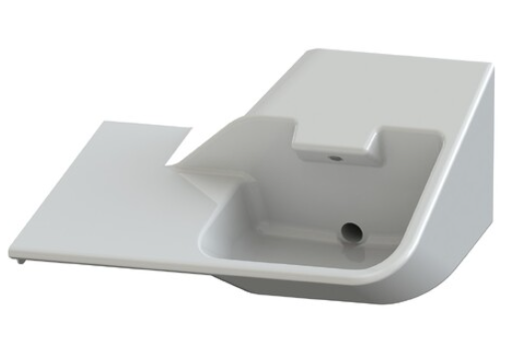
FIDI-038 | Ensuite Acute In Patient Zone | TRH-04  Wallgate Anti-Ligature, Anti-Vandal Recessed Toilet Roll Holder Solid Surface
HYTP-002 | Ensuite Acute In Patient Zone | CWC-155W-AST-AUS  Wallgate Anti-Ligature, Anti-Vandal Solid Surface Back to Wall Pan S&P with Grey Integrated Seat 446x702
 |  | 601602  Pneumatic Activated Concealed Dual Flush Cistern 3/4.5Ltr Cistern Only | 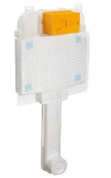
656504
Vandal Resistant Dual Flush Push Button Assembly with Polished Stainless Steel Plate - Pneumatic
FIDI-051 | Ensuite Acute In Patient Zone | ALF-04  Wallgate Anti-Ligature, A/V Recessed Shower Shelf Solid Surface
FIBM-022 | Ensuite Acute In Patient Zone | ALM-06W  Wallgate Anti-Ligature, Anti-Vandal Polycarb Mirror with Solid Surface Surround 450 x 1010
HYTP-019 | Ensuite Acute In Patient Zone | 121.33.64.00  GalvinCare® CP-BS Lead Safe™ Mental Health Anti-Ligature Wall MTD Shower Rose 65 - Std
 |  | SNC-02  Wallgate Anti-Ligature brushed SS Ceiling Mounted Shower with Removable Plate & Anti-Ligature Screw | 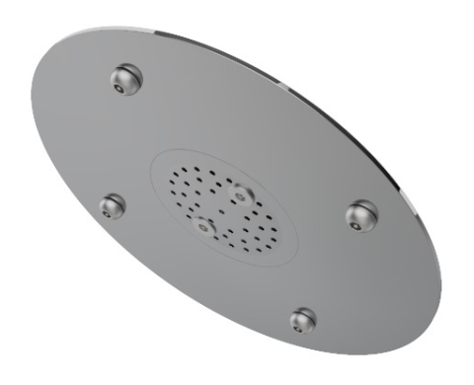
HYTP-047 | Ensuite Acute In Patient Zone | 121.01.03.01 / 121.01.03.02  Safe-Cell® CP-BS Lead Safe™ Prison Ezy-Grip Wall Top Assembly Complete Hot & Cold C/D
HYTP-046 | Ensuite Acute In Patient Zone  Accessible  Ensuite Acute In Patient Zone | 120.52.11.04  GalvinCare® CP-BS Lead Safe™ Inwall Progressive Mental Health Anti-Ligature Shower Mixer (Non TMV) W&C
 | Accessible Ensuite Acute In Patient Zone | 120.71.16.01 / 120.71.16.02  GalvinCare® CP-BS Mental Health Anti-Ligature Paddle Handle WTA Comp 1/4 Turn C/D Cold Warm | 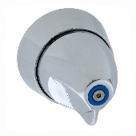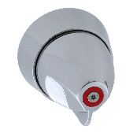
HYDR-011 | Ensuite Acute In Patient Zone | 69468X  Slip-Safe® SS Bolted Cleanout Vinyl 150x100 with ABS Body PVC/HDPE/CU Slip-In
HYDR-010 | Ensuite Acute In Patient Zone | 303077X  Safe-Cell® Polished SS316 (CRR) Prison Floor Drain Vinyl 100 x 80 BSP
302168
PPR Floor Drain Adaptor Ring 80BSP FI x100PVC/HDPE Slip-in
FIRT-004 | Accessible Ensuite Acute In Patient Zone | 42249 (LH) / 42256 (RH)  GalvinCare® Mental Health Anti-Ligature Grab Rail 900mm Powder Coated - LH RH (Vert or Horiz) | 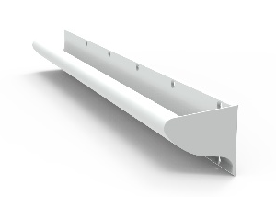
FIRT-009 | Accessible Ensuite Acute In Patient Zone | 42284 (LH) / 42287 (RH)  GalvinCare® Mental Health A/Ligature 30 deg Grab Rail 700x900mm Powder Coated - LH (Vert or Horiz) | 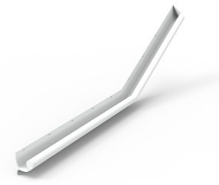
 | Accessible Ensuite Acute In Patient Zone | 42200  GalvinCare® Mental Health Anti-Ligature Grab Rail 300mm Powder Coated - LH (Vert or Horiz) | 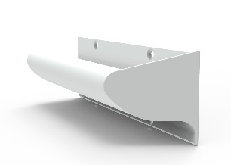
FHR-027 | Accessible Ensuite Acute In Patient Zone | THK-01  GalvinCare® Anti-Ligature Single Robe/Towel Hook | 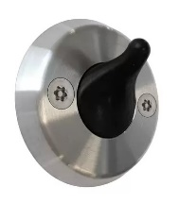
 | Accessible Ensuite Acute In Patient Zone | THK-02  GalvinCare® Anti-Ligature Double Robe/ Towel Hook
HYWC-005 | Accessible Ensuite Acute In Patient Zone | CWC-155W-AST-BCA  Wallgate Anti-Ligature, Anti-Vandal Disabled Solid Surface BTW Pan S&P with Grey Integrated Seat 460x810 | 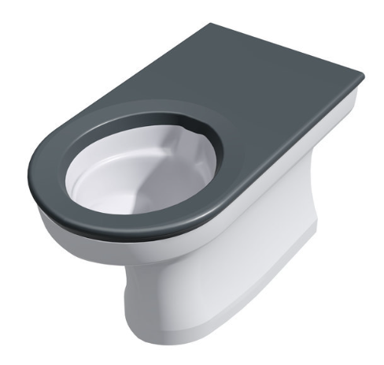
 |  | 601602  Pneumatic Activated Concealed Dual Flush Cistern 3/4.5Ltr Cistern Only | 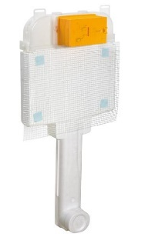
 |  | 656512  SS Vandal Resistant D/F Plate Assembly for Pneumatic Inwall Cistern w/ CP-BS Raised Buttons | 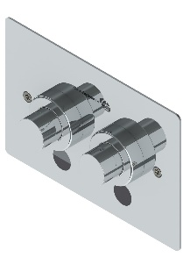
HYTP-021 | Accessible Ensuite Acute In Patient Zone | 42020  GalvinCare® CP-BS Mental Health Anti-Ligature Safe-Connect Shower Head with Hand Shower | 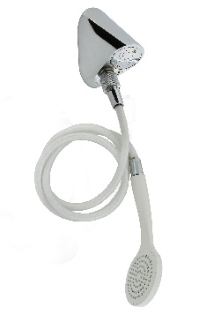
HYWC-005 | Bariatric Ensuite Acute In Patient Zone | CWC-155W-AST-BCA  Wallgate Anti-Ligature, Anti-Vandal Disabled Solid Surface BTW Pan S&P with Grey Integrated Seat 460x810
 | Bariatric Ensuite Acute In Patient Zone | 601602  Pneumatic Activated Concealed Dual Flush Cistern 3/4.5Ltr Cistern Only
 | Bariatric Ensuite Acute In Patient Zone | 656512  SS Vandal Resistant D/F Plate Assembly for Pneumatic Inwall Cistern w/ CP-BS Raised Buttons
HYTP-024 | Acute In Patient Zone Corridore Basin | 121.41.40.00  GalvinCare® CP-BS Lead Safe™ Mental Health Anti-Ligature Wall Outlet 15 FI | 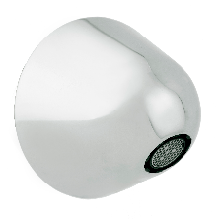
 |  | 121.47.40.00  GalvinCare® CP-BS Lead Safe™ Mental Health Anti-Ligature Wall Extended Outlet 110mm Long 15 FI | 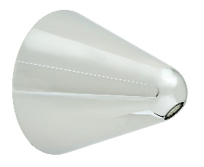
HYTP-042 | Acute In Patient Zone Corridore Basin | TZ-FLOWTAPC24  Flowmatic® Automatic Concealed Sensor Assembly 24v AC for Basin/Sink with Stainless Steel Face Plate | 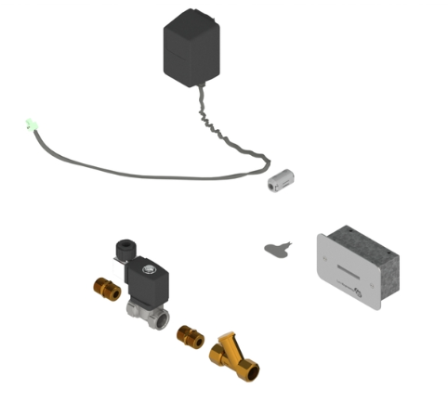
 |  | 100.81.10.20  CliniMix® Lead Safe™ CMV2 Wall Mtd Handsfree POU, Wave On/Off, Mains, Chrome Face Plate with Anti-Ligature Outlet | 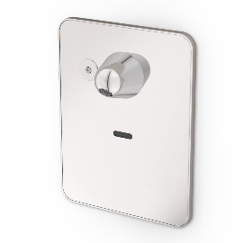

Seclusion Ensuite

Item | Location | Galvin Engineering Product Description | Image
HYBA-078 HYTP-024 | Ensuite Seclusion ENSMH-B | WHB-201W-NB-AUS  Wallgate Anti-Ligature, Anti-Vandal Solid Surface Basin with Single Out No Tap Holes - White
HYTP-002 | Ensuite Seclusion ENSMH-B | CWC-155W-AST-AUS  Wallgate Anti-Ligature, Anti-Vandal Solid Surface Back to Wall Pan S&P with Grey Integrated Seat 446x702
601602
Pneumatic Activated Concealed Dual Flush Cistern 3/4.5Ltr Cistern Only
656504
Vandal Resistant Dual Flush Push Button Assembly with Polished Stainless Steel Plate - Pneumatic
HYTP-047 | Ensuite Seclusion ENSMH-B | 121.01.03.01 / 121.01.03.02  Safe-Cell® CP-BS Lead Safe™ Prison Ezy-Grip Wall Top Assembly Complete Hot & Cold C/D
HYTP-046  HYTP-019 | Ensuite Seclusion ENSMH-B | 121.51.13.03  GalvinCare® CP-BS Lead Safe™ Vandal Resistant Ezy-Grip Shower Set C/D
FIRT-004 | Accessible Ensuite Acute In Patient Zone | 42249 (LH) / 42256 (RH)  GalvinCare® Mental Health Anti-Ligature Grab Rail 900mm Powder Coated - LH RH (Vert or Horiz)

Forensic & Behavioural Mental Health

Item | Location | Product Description | Image
FIBM-022 | Acute Psychiatric Ensuite Mental Health | ALM-06W  Wallgate Anti-Ligature, Anti-Vandal Polycarb Mirror with Solid Surface Surround 450 x 1010 - White
FIDI-038 | Acute Psychiatric Ensuite Mental Health | TRH-04  Wallgate Anti-Ligature, A/V Recessed Toilet Roll Holder Solid Surface
FIDI-051 | Acute Psychiatric Ensuite Mental Health | ALF-02FFW  Wallgate Anti-Ligature, Anti-Vandal Solid Surface Shelf Front Fixed 235 x 100 - White | 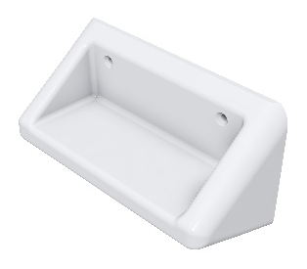
FHR-027 | Acute Psychiatric Ensuite Mental Health | THK-01  GalvinCare® Anti-Ligature Single Robe/Towel Hook
THK-02
GalvinCare® Anti-Ligature Double Robe/ Towel Hook
FIRT-004 | Accessible Acute Psychiatric Ensuite Mental Health | 42249 (LH) / 42256 (RH)  GalvinCare® Mental Health Anti-Ligature Grab Rail 900mm Powder Coated - LH RH (Vert or Horiz)
FIRT-009 | Acute Psychiatric Ensuite Mental Health | 42284 (LH) / 42287 (RH)  GalvinCare® Mental Health A/Ligature 30 deg Grab Rail 700x900mm Powder Coated - LH (Vert or Horiz)
42200
GalvinCare® Mental Health Anti-Ligature Grab Rail 300mm Powder Coated - LH (Vert or Horiz)
HYBA-014 | Acute Psychiatric Ensuite Mental Health | WHB-201W-2-AUS  Wallgate Anti-Ligature, Anti-Vandal Solid Surface Basin with Single Out, 2x Piezo Activation - White
HYDR-011 | Acute Psychiatric Ensuite Mental Health | 69468X  Slip-Safe® SS Bolted Cleanout Vinyl 150x100 with ABS Body PVC/HDPE/CU Slip-In | 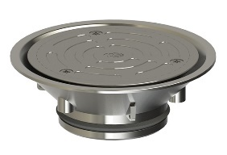
HYDR-010 | Acute Psychiatric Ensuite Mental Health | 303077X  Safe-Cell® Polished SS316 (CRR) Prison Floor Drain Vinyl 100 x 80 BSP
302168
PPR Floor Drain Adaptor Ring 80BSP FI x100PVC/HDPE Slip-in
HYTP-002 | Acute Psychiatric Ensuite Mental Health | CWC-155W-AST-AUS  Wallgate Anti-Ligature, Anti-Vandal Solid Surface Back to Wall Pan S&P with Grey Integrated Seat 446x702
 |  | TZ-FLOWTPANMIN  Safe-Cell® Electronic Dual Flush Pan Assembly with Controller (Concealed) | 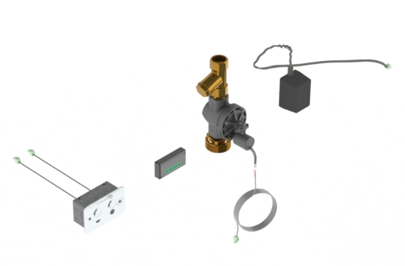
 |  | TZ-FLOWTPANMDT  Safe-Cell® Electronic Dual Flush Pan Assembly with Controller (Duct Mtd) | 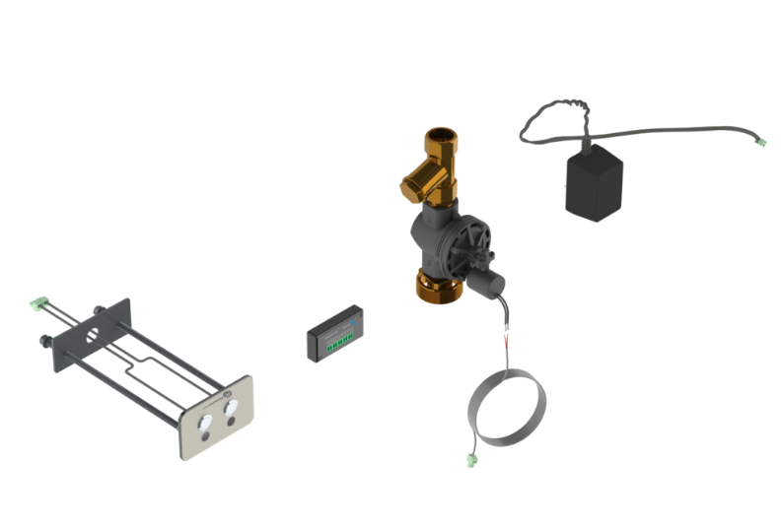
HYTP-019 | Ensuite Acute In Patient Zone | 121.33.64.00  GalvinCare® CP-BS Lead Safe™ Mental Health Anti-Ligature Wall Mtd Shower Rose 65 - Std
SNC-02
Wallgate Anti-Ligature brushed SS Ceiling Mounted Shower with Removable Plate & Anti-Ligature Screw
HYTP-021 | Accessible Acute Psychiatric Ensuite Mental Health | 42020  GalvinCare® CP-BS Mental Health Anti-Ligature Safe-Connect Shower Head with Hand Shower
HYTP-046 | Accessible Acute Psychiatric Ensuite Mental Health | TZ-FLOWTMSHWINR  GalvinCare® Electronic Mental Health Conceal Shower Mixer with GalvinCare® Handle & Controller | 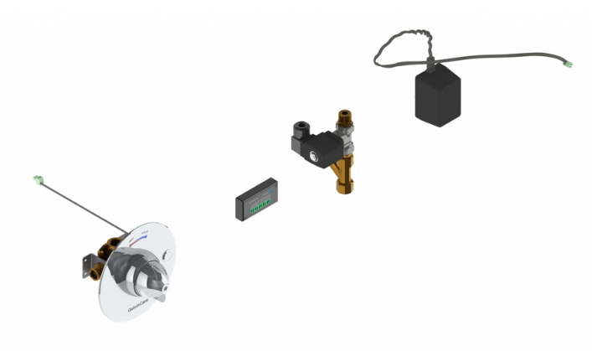
HYWC-005 | Accessible Acute Psychiatric Ensuite Mental Health | CWC-155W-AST-BCA  Wallgate Anti-Ligature, Anti-Vandal Disabled Solid Surface BTW Pan S&P with Grey Integ Seat 460x810
TZ-FLOWTPANMIN
Safe-Cell® Electronic Dual Flush Pan Assembly with Controller (Concealed)
TZ-FLOWTPANMDT
Safe-Cell® Electronic Dual Flush Pan Assembly with Controller (Duct Mtd)
 | Accessible Acute Psychiatric Ensuite Mental Health | WDC100  Wallgate Electronic Water Controller 1 Room / 4 Outlets Programmable | 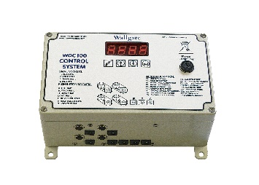
 |  | WDC200  Wallgate Electronic Water Controller 2 Rooms / 8 Outlets Programmable | 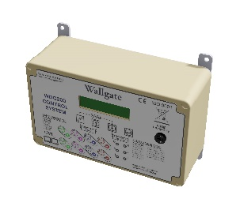

B. 0135 - Older Peoples Acute Mental Health Inpatient Unit
1.2 Introduction
HPU 131 Mental Health – Overarching Guideline describes the generic planning and design requirements that should be used when planning mental health inpatient units. This document contains information that is common across all mental health inpatient units and should be read in conjunction with service specific HPU documents to ensure that planning considers both principles and design requirements. These service specific documents include:
- HPU 132 Child and Adolescent Mental Health Unit;
- HPU 133 Psychiatric Emergency Care Centre (PECC);
- HPU 134 Adult Acute Mental Health Inpatient Unit;
- HPU 135 Older Peoples Acute Mental Health Inpatient Unit;
- HPU 136 Non Acute Mental Health Unit which includes rehabilitation, extended care and forensics; and
- HPU 137 Mental Health Intensive Care Unit.

The focus of this document is Older Peoples Acute Mental Health Inpatient Units and information relating to consumers using this type of facility is addressed. This document also includes detailed information on functional planning and a schedule of accommodation. This document should be read in conjunction with the Australasian Health Facility Guideline (AusHFG) generic requirements and standard components described in:
- Part A: Introduction and Instructions for Use;
- Part B: Section 80 - General Requirements & Section 90 - Standard Components;
- Part C: Design for Access, Mobility, OHS and Security; and
- Part D: Infection Prevention and Control.

2.4.8 Staff Work Areas, Meeting Rooms and Amenities
Staff Amenities comprise staff room, property bay, toilets and shower. The latter is optional depending on proximity to main hospital amenities. The size of the Unit and the number of staff employed will determine the number and configuration of spaces in this zone.
A quiet space for staff to withdraw from the consumer environment should be provided. Access to a courtyard or external space is important for the well-being of staff who work in demanding clinical environments.
The staff room should not double up as a meeting room as this will invariably prevent staff from accessing food and refreshments during their breaks.
Amenities need to be accessible 24 hours per day, seven days a week and are for the use of all staff – permanent and visiting. Depending on the location of amenities, it may be necessary to provide lockers and toilets within the envelope of inpatient areas for ready access, particularly at night.
Staff-only rooms located in the consumer zones should be lockable and accessible via swipe-card or similar. An accessible toilet should be available to staff.

3.4 Fixtures, Fittings and Equipment
While mental health units typically seek to provide Fixtures, Fittings and Equipment (FF&E) solutions that minimise and / or eliminate risk, e.g. anti-ligature approaches, a balanced approach is required for older people to encourage independence and safe mobility. For example mobile hoists may be used as an alternative to ceiling mounted hoists. The choice of Furniture, Fittings and Equipment should consider design elements, e.g. use of colour to reduce unhelpful stimuli and optimise helpful stimuli (Fleming et al 2003; NSW Agency for Clinical Innovation 2014). For example, in consumer bedrooms, visibility to the toilet / ensuite should be optimised through direct line of sight from the bed and use of contrasting colour for the toilet. The project team should seek to identify the most appropriate FF&E items as early in the planning phase as possible as some items may need to be sourced internationally and will require extended delivery timeframes.

3.2.1 Ergonomics
Furniture and fittings should be selected to functionally assist older people with age-related physical limitations. For example:
- chairs with arms and higher seats to assist sitting and standing;
- tap ware / door handles designed for people with reduced hand function;
- raised toilet seats to assist with sitting and standing;
- electric, adjustable height beds that may be lowered to the floor when used with consumers in the context of falls risk assessment and tailored fall prevention intervention. These beds may have a role in fall prevention and minimising injury resulting from falls, and can be raised when staff are administering consumer care; and
- firm, secure and steady furniture.

Hand rails and grab rails are an essential aid to the prevention of falls for older people, particularly in bathrooms, corridors, outdoor areas and activity spaces (Karlin and Zeiss 2006).
Mental health units typically seek to utilise design solutions that minimise and / or eliminate the risk of potential self-harm by consumers, e.g. anti-ligature approaches. However, the needs of older people requires a balanced approach to avoid the risk of deconditioning and falls.
Early in the planning process, the project team should undertake and document a rigorous assessment of anti-ligature fixtures and fittings available for potential use within consumer areas of the unit to identify those that best achieve the dual objectives of reducing the risk of self-harm and reducing the risk of falls. Where an anti-ligature product that satisfies both criteria cannot be sourced and the installation of an anti-ligature product is assessed as likely to increase the risk of resident falls and associated adverse outcomes, the project team may select a non-anti-ligature product but should note this as a potential ligature risk within their risk register and ensure that the potential risk is regularly communicated to staff and is routinely monitored and assessed.

Older Peoples Acute Mental Health Inpatient Unit

Item | Location | Product Description | Image
HYBA-078 HYTP-024 | ENS-MH-A Older Person Ensuite (Geriatric) | WHBV-101W-LH-NB / WHBV-101W-RH-NB  Wallgate Anti-Ligature, Anti-Vandal S/Surface Front Fixed Basin with LH/RH Shelf Integral Outlet 0TH
FIDI-038 | ENS-MH-A Older Person Ensuite (Geriatric) | TRH-04  Wallgate Anti-Ligature, A/V Recessed Toilet Roll Holder Solid Surface
HYTO-047 | ENS-MH-A Older Person Ensuite (Geriatric) | 120.71.16.01 / 120.71.16.02  GalvinCare® CP-BS Mental Health Anti-Ligature Paddle Handle WTA Comp 1/4 Turn C/D Cold Warm
HYTP-021 | ENS-MH-A Older Person Ensuite (Geriatric) | 42020  GalvinCare® CP-BS Mental Health Anti-Ligature Safe-Connect Shower Head with Hand Shower
HYTP-046 | ENS-MH-A Older Person Ensuite (Geriatric) | 120.52.11.04  GalvinCare® CP-BS Lead Safe™ Inwall Progressive Mental Health Anti-Ligature Shower Mixer (Non TMV) W&C
HYWC-005 | ENS-MH-A Older Person Ensuite (Geriatric) | CWC-155W-AST-BCA  Wallgate Anti-Ligature, Anti-Vandal Disabled Solid Surface BTW Pan S&P with Grey Integ ratedSeat 460x810
601602
Pneumatic Activated Concealed Dual Flush Cistern 3/4.5Ltr Cistern Only
656512
SS Vandal Resistant D/F Plate Assembly for Pneumatic Inwall Cistern w/ CP-BS Raised Buttons
HYDR-011 | ENS-MH-A Older Person Ensuite (Geriatric) | 69468X  Slip-Safe® SS Bolted Cleanout Vinyl 150x100 with ABS Body PVC/HDPE/CU Slip-In
HYDR-010 | ENS-MH-A Older Person Ensuite (Geriatric) | 303077X  Safe-Cell® Polished SS316 (CRR) Prison Floor Drain Vinyl 100 x 80 BSP
302168
PPR Floor Drain Adaptor Ring 80BSP FI x100PVC/HDPE Slip-in
FIRT-004 | ENS-MH-A Older Person Ensuite (Geriatric) | 42249 (LH) / 42256 (RH)  GalvinCare® Mental Health Anti-Ligature Grab Rail 900mm Powder Coated - LH RH (Vert or Horiz)
FIRT-009 | ENS-MH-A Older Person Ensuite (Geriatric) | 42284 (LH) / 42287 (RH)  GalvinCare® Mental Health A/Ligature 30 deg Grab Rail 700x900mm Powder Coated - LH (Vert or Horiz)
42200
GalvinCare® Mental Health Anti-Ligature Grab Rail 300mm Powder Coated - LH (Vert or Horiz)

B.0136 - Non-Acute Inpatient Mental Health Unit
1.2 Introduction
HPU 131 Mental Health – Overarching Guideline describes the generic planning and design requirements that should be used when planning mental health inpatient units. This document contains information that is common across all mental health inpatient units and should be read in conjunction with service specific HPU documents to ensure that planning considers both principles and design requirements. These service specific documents include:
- HPU 132 Child & Adolescent Mental Health Unit;
- HPU 133 Psychiatric Emergency Care Centre (PECC);
- HPU 134 Adult Acute Mental Health Inpatient Unit;
- HPU 135 Older Peoples Acute Mental Health Inpatient Unit;
- HPU 136 Non Acute Mental Health Unit which includes rehabilitation, extended care and forensics; and
- HPU 137 Mental Health Intensive Care Unit.

The focus of this document is Non Acute Inpatient Mental Health Units and information relating to this group of consumers is addressed. This document also includes detailed information on functional planning and a schedule of accommodation. This document should be read in conjunction with the Australasian Health Facility Guideline (AusHFG) generic requirements and standard components described in:
- Part A: Introduction and Instructions for Use;
- Part B: Section 80 - General Requirements & Section 90 - Standard Components;
- Part C: Design for Access, Mobility, Safety and Security; and
- Part D: Infection Prevention and Control.

2.4.6 Staff Areas including Work Areas, Meeting Rooms and Amenities
Staff Amenities comprise staff room, property bay, toilets and shower. The latter is optional depending on proximity to main hospital amenities. The size of the Unit and the number of staff employed will determine the number and configuration of spaces in this zone. It should provide a quiet space for staff to withdraw from the consumer environment. Access to a courtyard or external space is important for the well-being of staff who work in demanding clinical environments. Staff-only rooms located in the consumer zones should be lockable and accessible via swipe card or similar. An accessible toilet should be available to staff.
2.4.4 Consumer Zone
Bathrooms and Ensuites
Provision of private ensuites to each bedroom is preferred in non acute rehabilitation units, giving consumers a greater sense of privacy and dignity, reduced concern of intrusion by others and reduced risk relating to sexual safety. Private ensuites may have a door that can be locked in the open or closed position, depending on individual requirements. An optional common bathroom, including bath, may be included in the HPU so that consumers may choose to take a bath for therapeutic purposes.
4.2.10 Kitchen / Servery (Optional)
The kitchen / servery should be a safe, secure environment for staff in compliance with work, health and safety and infection control guidelines. There should be ample bench top area, open shelving, lockable cupboards, secure storage for food and equipment, and space to store food trays and distribution trolleys. A dedicated power outlet for heating / cooling food trolleys may be required. Regular tapware should be installed for hot and cold water so as to maximise consumers’ ability to access their own drinks, wash dishes etc.

Non-Acute Inpatient Mental Health Unit

Item | Location | Product Description | Image
FIBM-022 | Non Acute Ensuite Mental Health | ALM-06W  Wallgate Anti-Ligature, Anti-Vandal Polycarb Mirror with Solid Surface Surround 450 x 1010
FIDI-038 | Non Acute Ensuite Mental Health | TRH-04  Wallgate Anti-Ligature, Anti-Vandal Recessed Toilet Roll Holder Solid Surface
FIDI-051 | Non Acute Ensuite Mental Health | ALF-04  Wallgate Anti-Ligature, Anti-Vandal Recessed Shower Shelf Solid Surface
FHR-027 | Accessible Ensuite In Patient Zone | THK-01  GalvinCare® Anti-Ligature Single Robe/Towel Hook
THK-02
GalvinCare® Anti-Ligature Double Robe/ Towel Hook
FIRT-004 | Accessible Ensuite In Patient Zone | 42249 (LH) / 42256 (RH)  GalvinCare® Mental Health Anti-Ligature Grab Rail 900mm Powder Coated - LH RH (Vert or Horiz)
FIRT-009 | Accessible Ensuite In Patient Zone | 42284 (LH) / 42287 (RH)  GalvinCare® Mental Health Anti-Ligature 30 deg Grab Rail 700x900mm Powder Coated - LH (Vert or Horiz)
42200
GalvinCare® Mental Health Anti-Ligature Grab Rail 300mm Powder Coated - LH (Vert or Horiz)
HYBA-078 | Non Acute Ensuite Mental Health | 105.33.10.01  GalvinAssist® Accessible, 600mm Wall Mount Basin, LH Bowl, 1 TH with Overflow | 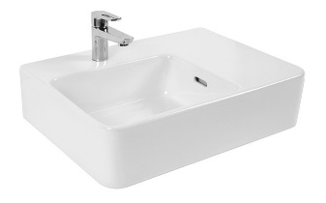
 |  | 105.33.11.01  GalvinAssist® Accessible, 600mm Wall Mount Basin, RH Bowl, 1 TH with Overflow | 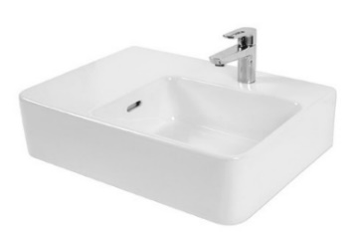
HYDR-011 | Non Acute Ensuite Mental Health | 69468X  Slip-Safe® SS Bolted Cleanout Vinyl 150x100 with ABS Body PVC/HDPE/CU Slip-In
HYDR-010 | Non Acute Ensuite Mental Health | 303077X  Safe-Cell® Polished SS316 (CRR) Prison Floor Drain Vinyl 100 x 80 BSP
302168
PPR Floor Drain Adaptor Ring 80BSP FI x100PVC/HDPE Slip-in
HYTP-002 | Non Acute Ensuite Mental Health | 105.11.20.00  GalvinAssist® Wall Faced, Clean Flush, Easy Care, Toilet Pan with Soft Close Seat | 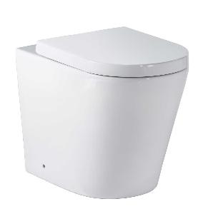
601602
Pneumatic Activated Concealed Dual Flush Cistern 3/4.5Ltr Cistern Only
656504
Vandal Resistant Dual Flush Push Button Assembly with Polished Stainless Steel Plate - Pneumatic
HYTP-019 | Non Acute Ensuite Mental Health | 121.33.64.00  GalvinCare® CP-BS Lead Safe™ Mental Health Anti-Ligature Wall Mtd Shower Rose 65 - Std
HYTP-024 | Non Acute Ensuite Mental Health | 121.41.40.00  GalvinCare® CP-BS Lead Safe™ Mental Health Anti-Ligature Wall Outlet 15 FI
85156
GalvinCare® CP-BS Angled (75°) Wall Fixed Outlet 130mm
HYTP-046 | Non Acute Ensuite Mental Health | 120.52.11.04  GalvinCare® CP-BS Lead Safe™ Inwall Progressive Mental Health Anti-Ligature Shower Mixer (Non TMV) W&C
HYTP-047 | Non Acute Ensuite Mental Health | 121.01.03.01 / 121.01.03.02  Safe-Cell® CP-BS Lead Safe™ Prison Ezy-Grip Wall Top Assembly Complete Hot & Cold C/D
TZ-FLOWTAPC24
Flowmatic® Automatic Concealed Sensor Assembly 24v AC for Basin/Sink with Stainless Steel Face Plate
HYWC-005 | Accessible Ensuite In Patient Zone | 105.11.10.01  GalvinAssist® Wall Faced, Clean Flush, Easy Care, Accessible Toilet Pan with Blue Seat | 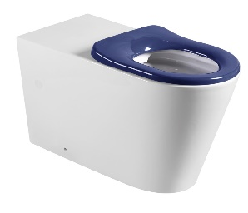
601602
Pneumatic Activated Concealed Dual Flush Cistern 3/4.5Ltr Cistern Only
656512
SS Vandal Resistant D/F Plate Assembly for Pneumatic Inwall Cistern with CP-BS Raised Buttons
 |  | 105.76.02.01  GalvinAssist® PWD Backrest | 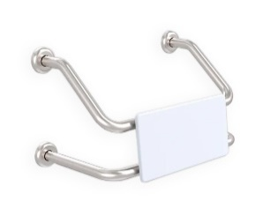

While all reasonable care has been taken in compiling the information in this document, the designs, dimensions and products shown are indicative only and should not be relied upon without our prior approval. Due to our policy of continuous development, we reserve the right to alter any details of specifications or products without notice. All information, drawings, technical specifications and product designs remain the property of Galvin Engineering Pty Ltd.

