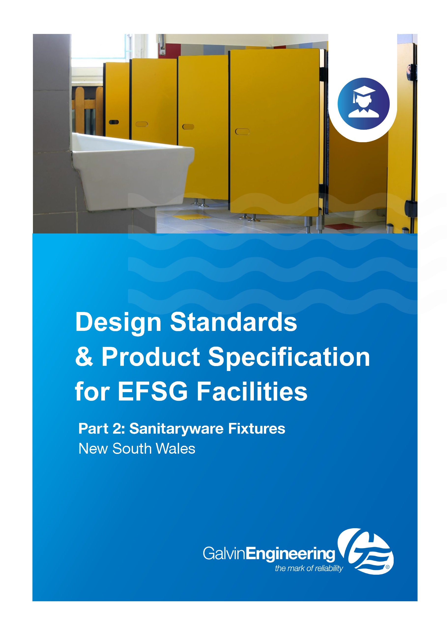

SG811 Sanitary Fixtures
GUIDE NOTE: Refer to Design Guide sections DG / HYDRAULICS GENERALLY DG DRAINAGE (&TRADE WASTE)

ID | TITLE | COMPLIANCE LEVEL
1 | GENERAL |  | MANDATORY
As per current NATSPEC except as follows
1.0 General
In accordance with the NSW Government Resource Efficiency Policy, all fixtures and fittings must be at least the average WELS star rating by product type. Where WELS rating is not available, use the alternative WaterMark rating scheme.

All new water-using appliances must be at least 0.5 stars above the average Water Efficiency Labelling and Standards (WELS) star rating by product type, except toilets and urinals, which must be purchased at the average WELS star rating.

Appliances and equipment purchased in the following categories with star ratings under the WELS scheme will be at least:

- showerheads – 3 stars (>7.5 but <=9.0 l/min)
- toilets – 4 stars
- urinals – 5 stars
- dishwashers – 5 stars
- taps and flow controllers – 5 stars.

2 | PRODUCTS |  | MANDATORY
As per current NATSPEC 0811.2 Products except as follows
3 | EXECUTION |  | MANDATORY
As per current NATSPEC 0811.3 Execution.
4 | SELECTIONS |  | MANDATORY
As per current NATSPEC 0811.4 elections except as follows

FIXTURE SCHEDULE

Basins schedule | Boys + Girls Communal Hall, Staff PS+HS, Materials Workshop HS
Property | Approved Product
Location | Hs Materials Workshop  Ps Bulk Store (General Assistant)  Ps Hs Staff Toilets  Hs Toilets Boys + Girls (Gym Used as Entertainment Venue)  Ps Toilets Boys + Girls (Hall Used by Community)
Catalogue Number  or Model | 105.32.10.01  GalvinAssist® 500mm Wall Mount Basin, 1 TH with Overflow  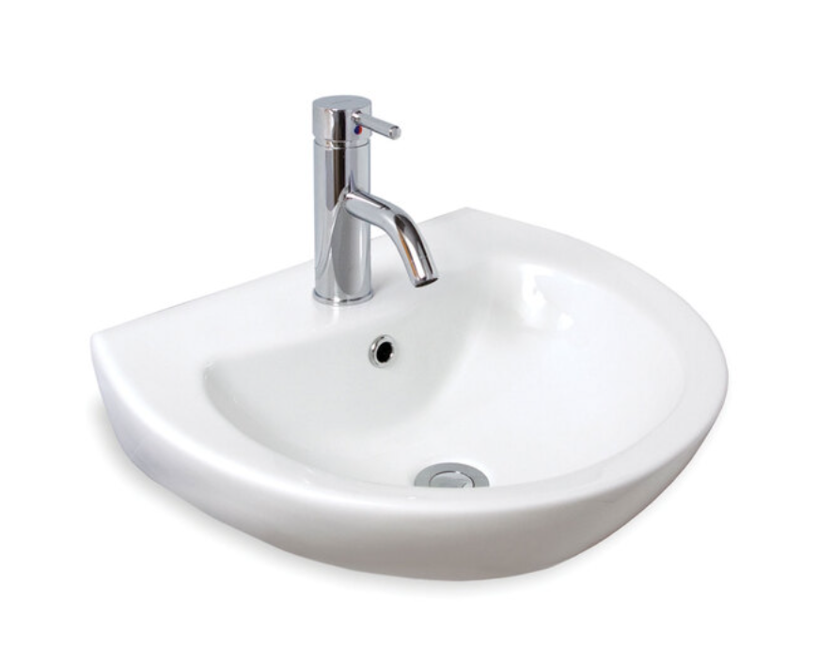
Material | Vitreous China
Colour | White
Size (L x W) (mm) | 500 W X 410 L
Tap Holes | One (1)
Soap Recesses | Two (2)
Trap + Shroud | Concealed Trap + Shroud
Bottle Traps | Not Accepted
Plug + Waste Outlet Size | Complete With Anti Vandal Waste 40-32mm Chrome Plated Brass and White Plastic Plug
Installation and Support | Wall Mount Fixing Kit Included
Overflow | Yes
AS Compliance | AS 1428.1

Basins schedule | Access (1 tap hole)
Property | Approved Product
Location | HS + PS Accessible Toilets  Accessible Bathrooms
Catalogue Number  or Model | 105.32.10.01  GalvinAssist® 500mm Wall Mount Basin, 1 TH with Overflow
Material | Vitreous China
Colour | White
Size (L x W) (mm) | 500 W X 410 L
Tap Holes | One (1)
Soap Recesses | Two (2)
Trap + Shroud | Concealed Trap + Shroud
Bottle Traps | Not Accepted
Plug + Waste Outlet Size | Complete With Anti Vandal Waste 40-32mm Chrome Plated Brass and White Plastic Plug
Installation and Support | Wall Mount Fixing Kit Included
Overflow | Yes
AS Compliance | AS 1428.1

Basins schedule | Access (3 tap holes)
Property | Approved Product
Location | HS + PS Accessible Shower & Toilet  Assisted Shower  Toilet  Change Room
CatalogueNumber  or Model | 105.32.10.03  GalvinAssist® 500mm Wall Mount Basin, 3 TH with Overflow
Material | Vitreous China
Colour | White
Size (L x W) (mm) | 500 W X 410 L
Tap Holes | Three (3)
Soap Recesses | Two (2)
Trap + Shroud | Concealed Trap + Shroud
Bottle Traps | Not Accepted
Plug + Waste Outlet Size | Complete With Anti Vandal Waste 40-32mm Chrome Plated Brass and White Plastic Plug
Installation and Support | Wall Mount Fixing Kit Included
Overflow | Yes
AS Compliance | AS 1428.1

Basins schedule | Individual Toilets, Clinic
Property | Approved Product
Location | HS + PS Staff  Staff Ambulant Toilets  Community Clinic
Catalogue Number  or Model | 105.32.13.01  GalvinAssist® Ultra-Compact, Wall Mount Basin, 1 TH with Overflow  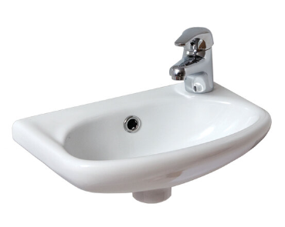
Material | Vitreous China
Colour | White
Size (L x W) (mm) | 385 W X 250 L
Tap Holes | One (1)
Soap Recesses | Two (1)
Trap + Shroud | Concealed Trap + Shroud
Bottle Traps | Not Accepted
Plug + Waste Outlet Size | Complete With Anti Vandal Waste 40-32mm Chrome Plated Brass and White Plastic Plug
Installation and Support | Wall Mount Fixing Kit Included
Overflow | Yes
AS Compliance

Basins schedule | PS Staff Shower SSP
Property | Approved Product
Location | PS Staff Shower
Catalogue Number
or Model
Material
Colour
Size (L x W) (mm)
Tap Holes
Soap Recesses
Trap + Shroud
Bottle Traps
Plug + Waste Outlet Size
Installation and Support
Overflow
AS Compliance

Baths schedule | Senior Student Unit Toilet
Property | Approved Product
Location | Senior Student Unit Toilet / Bathroom
Catalogue Number  or Model | 105.94.00.00 (Coming Soon)  GalvinAssist® Slim Design Inwall Cistern, Less Flush Plate
Material | Acrylic
Colour | White
Size (L x W) (mm) | 1525 L X 720 W X 390 D
Type | Built In - Rectangular
Wall Thickness (mm)
Waste Outlet Size
Installation and Support
Overflow | Yes
AS Compliance

Sink schedule | Canteen
Property | Approved Product
Location | HS + PS Canteens
Catalogue Number  or Model | 105.82.00.01  GalvinAssist® SS, 150mm Sink, Double Centre Bowls, 1 TH  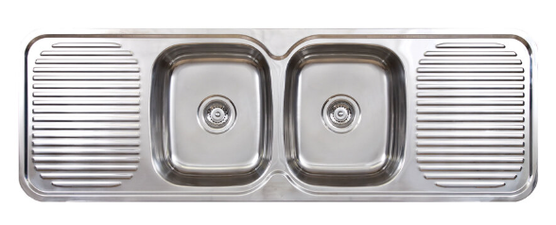
Material | Stainless Steel  Grade 304, Bright Finish
Bowls | Two (2)
Capacity Minimum | 18 Litres (Each Bowl)
Size (L x W) (mm) | 350 W x 405 L x 180 D (Each Bowl)
Drainer | Twin Located Both Sides Of Bowls. Fluted Finish.  380mm Each Drainer
Tap Holes | One (1)
Overflow | Yes
Overall Size | 1500 L X 500 W

Laundry Trough schedule | Laundry, GLS (Art) Science Lab (eye wash), Visual Arts + Materials Workshop
Property | Approved Product
Location | HS Visual Arts Workshop  HS Materials Workshop
Catalogue Number  or Model | 105.83.10.01 (Coming Soon)  GalvinAssist® Free Standing Laundry Tub  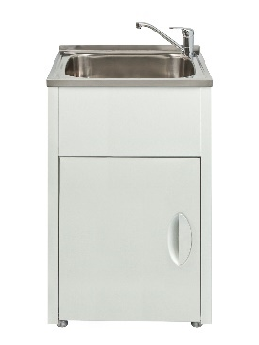
Material | Stainless Steel
Bowls | One (1)
Capacity Minimum | 45 Litre Bowls
Overall Size (L x W) mm | 600 W x 500 Lx 900 H
Tap Holes | One (1)
Splashback Flange | At Back 25mm H
Bypass | Yes
Trough Mounting | White Permacoat Steel Cabinet with Hinged Door
Waste | Stainless Steel Grate
Splash Back | Standard
Splashback Material | Stainless Steel Satin Finish
Splashback Height | 450 H
Splashback Width | Full Width of Laundry Trough

Bucket Sink schedule | hinged grate | Cleaners PS+HS, Botany/Zoology HS
Property | Approved Product
Location | HS + PS Cleaners Distributed Store Cleaning Supplies Store  HS Botany Store  * No vitreous china Bucket Sinks to be used on school projects
Catalogue Number
or Model
Material
Finish
Overall Size
Back Flange
Overflow
Mounting
Mounting Height
Drainer
Hinged Grate Material

Bucket Sink schedule | no hinged grate | Wood / metal workshop, Outdoor Covered Workshop HS
Property | Approved Product
Location | HS Wood/Metal Workshop  Outdoor covered workshop  * No vitreous china Bucket Sinks to be used on school projects
Catalogue Number
or Model
Material
Finish
Overall Size
Overflow
Back Flange
Mounting
Mounting Height
Drainer

Water Closet Assemblies | Access PS + HS
Property | Approved Product
Location | HS + PS Access Toilet Staff or Student  HS + PS Access Shower/Toilet  HS + PS Access Shower/ Toilet / Change
Catalogue Number  or Model | 105.10.10.01  GalvinAssist® Wall Faced, Clean Flush, Easy Care, Accessible Toilet Suite with Blue Seat  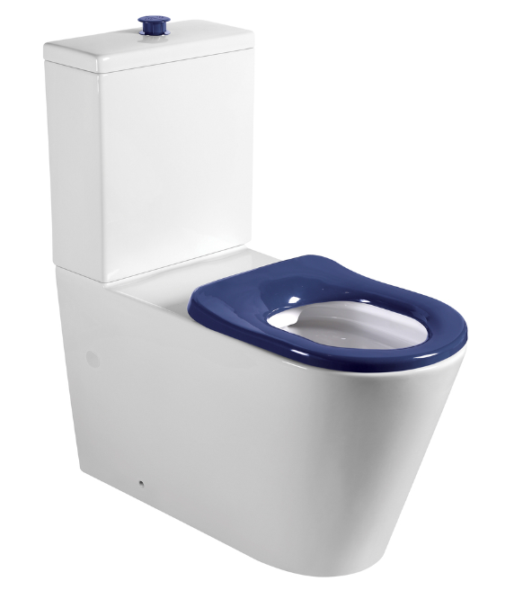
WELS Rating | 4 Star
Dual Flush | 4.5/ 3 Litre Dual Flush
Backrest | 105.76.02.01  GalvinAssist® PWD Backrest
Seat | Galvinassist® Single Flap Seat, Sorrento Blue, Institutional Hinges,  Rotatable/Buffers. Ensure Floor+ Wall Tile Colour Selection Achieves AS 1428.1 Luminous Contrast to Seat
Material | Vitreous China
Cistern | Complete With Integral Close Coupled Vitreous Cistern & Raised Buttons
Cistern Buttons | GalvinAssist® Raised Buttons
Flush Pipe
As Compliance | AS 1428.1

Water Closet Assemblies Schedule | Girls Boys PS + HS
Property | Approved Product
Location | PS Toilets Boys + Girls  HS Toilets Boys + Girls
Catalogue Number  or Model | 105.10.00.03  GalvinAssist® Close Coupled, Clean Flush, Easy Care, Toilet Suite, S-Trap, NSW EDU  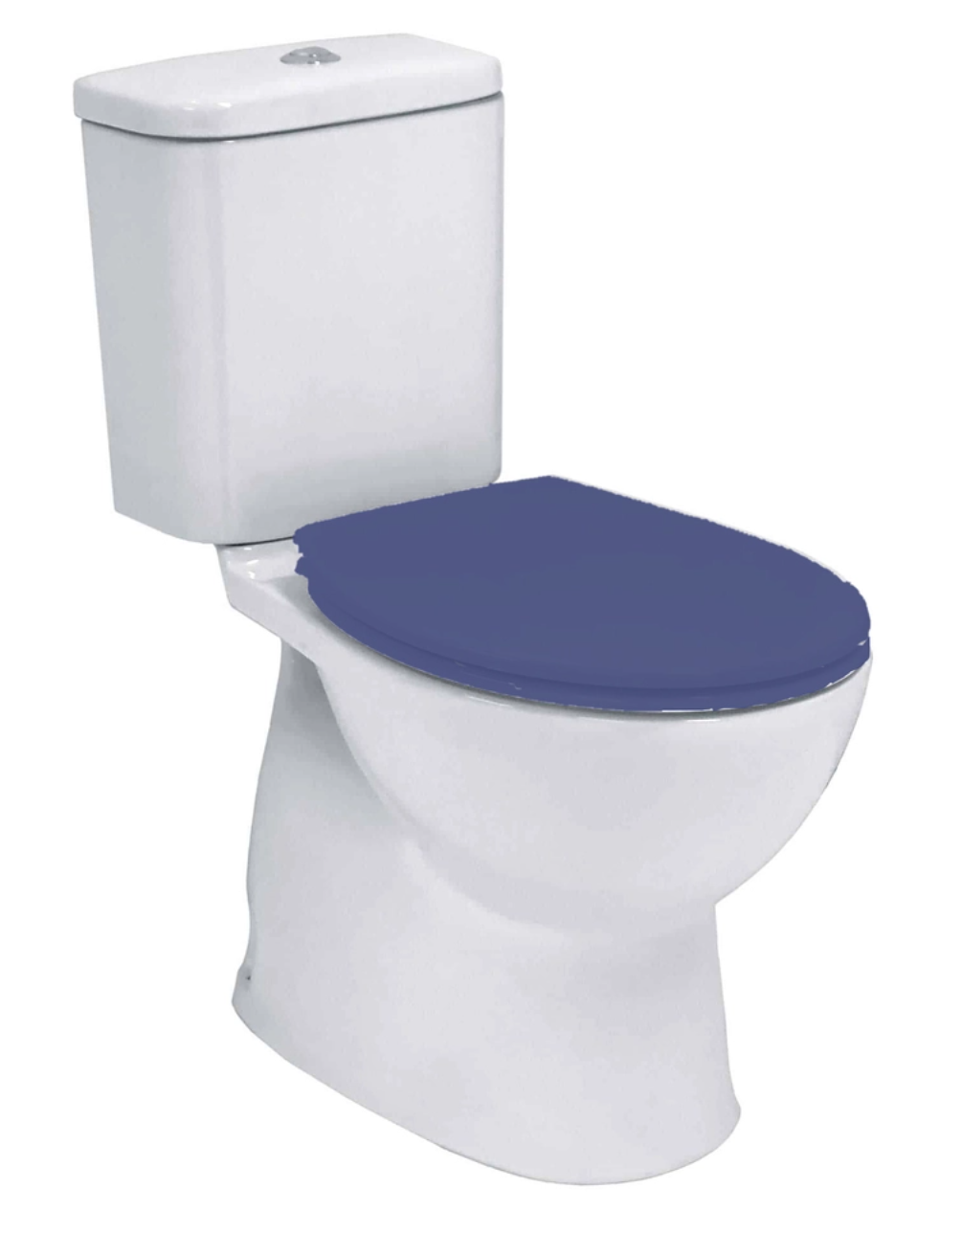
WELS Rating | 4 Star
Dual Flush | 4.5/ 3 Litre Dual Flush
Seat | Blue Single Flap Vandal Resistant Seat and Blind Fixings
Material | Vitreous China
Cistern | GalvinAssist® Vitreous Cistern with Adjustable Height Connector 4.5/ 3 L Dual Flush, Wall Fixed Low Level Cistern
AS Compliance | AS 1172

Water Closet Assemblies Schedule | Girls Boys Pre School + Early Childhood
Property | Approved Product
Location | Pre school  Early Childhood Unit
Catalogue Number
or Model
WELS Rating
Dual Flush
Height Floor to Seat
Seat
Material
Cistern
AS Compliance

Water Closet Assemblies Schedule | Staff, Ambulant
Property | Approved Product
Location | Staff  Staff + Student Ambulant
Catalogue Number  or Model | 105.10.20.00  GalvinAssist® Wall Faced, Clean Flush, Easy Care, Ambulant Toilet Suite with Soft Close Seat  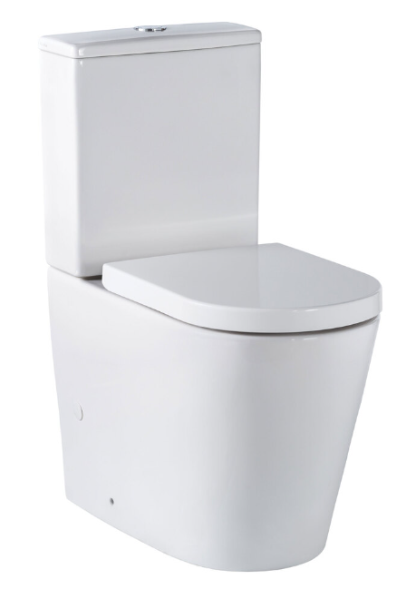
Dual Flush | 4.5/ 3 Litre Dual Flush
Seat | Galvinassist® Single Flap Seat White
Material | Vitreous China
Cistern | Galvinassist® Integral Cistern 4.5/ 3 L Dual Flush, Wall Fixed Low-Level Cistern
AS Compliance | AS1428.1

Urinal Assemblies Schedule | Boys PS + HS
Property | Approved Product
Location | PS + HS Toilets Boys
Catalogue Number
or Model
Length
Fall to Centre Waste
Material
Outlet
Inlet
Anti-Drum Compound

Urinal Flusher Schedule | Boys PS + HS
Property | Approved Product
Location | PS + HS Toilets Boys
Catalogue Number  or Model | TZ-FLOWFLUS  Flowmatic® Automatic Flusher Ceiling/Wall Mounted for Urinal 15 24v AC  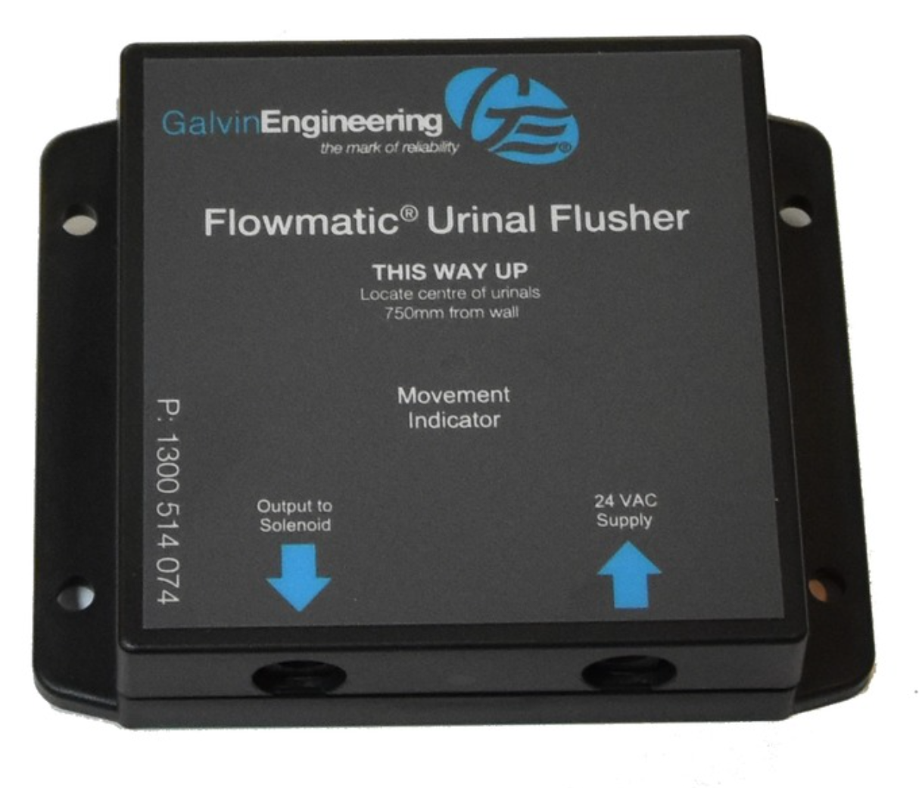
Type | Flowmatic® Automatic Flusher Ceiling/Wall Mounted for Urinal 15 24v AC
Solenoid Valve | Solenoid Valve  AS MP52 Spec 030slow Shut Off to Reduce Water Hammer  Capable Of Operating in The Range of Varying Water Pressures Across NSW
WELS | 5 Star – When Installed on 600mm of Urinal
Program Range | Flush Duration: 5,10 Seconds  Flush Interval: 6,8,12,24 Hrs
Reset | Auto Reset to Programmed Operation After Power Failure
Hygienic Flush | One Flush Within A 12-Hr Period When Inactive.
Power Supply | 240 V Via AC Adaptor
Installation | Fully Concealed  Allow Access for Servicing

Fabricated SS Trough | Wash / Drinking Trough PS + HS
Property | Approved Product
Location | Boys + Girls Toilets  Outdoor Learning Areas  Drinking Facilities General  HS Showers + Change
Catalogue Number
or Model
Material
Outlet
Corners + Edging
Identification
Plumbing
Rim Height to Ground or FFL |  | Wash Trough | Drinking Trough
 | Pre School
 | Primary School
 | Secondary
Trough Guard
Splash Back
Support Assembly

Fabricated SS Trough | Art Trough PS + HS
Property | Approved Product
Location | HS Visual Arts Workshop  HS Materials Workshop  HS GLS with Art Space
Catalogue Number
or Model
Type
Reference Drawing
Material
Size Type 1
Size Type 2
Outlet
Installation
Splash Back
Material

Fabricated SS Trough | Special Art Trough with Bench PS + HS
Property | Approved Product
Location | PS Outdoor Learning Area
Reference | Refer to EFSG / SG / SG DRAWING SG 504/1

Clay / Plaster Arrestor | Art Trough with Pottery Wheel HS
Property | Approved Product
Location | HS Visual Arts Workshop  GLS with Pottery Wheels
Type 1 | Stainless Steel Clay/Plaster Arrestor with Removable Lid, Perforated Stainless Steel Strainer Basket and Baffles On Castors
Reference Drawing | SG / SG Drawing SG 405/2
Material | Stainless Steel Grade 304  No4 Linish  0.9mm and 1.2 Mm Thick
Connection | 50mm Universal Trap
Inlet | PVC 50mm Diameter on Raised End of Unit
Outlet | PVC 50mm Diameter with Grate Removed
Overflow | Yes
Strainer Basket | Removable
Perforations | 2 mm Diameter  15 mm Centres
Locating Springs | Two (2) Attached to Baffle to Ensure Strainer Basket is Located Under Inlet Lip
Baffles | Two (2) Permanently Fixed
Type 2
Removable | One (1) Solid  One (1) Perforated
Perforations | 5 mm Diameter, 8 mm Centres
Outlet Control
Type | Box, Positioned Over Outlet with Open Bottom End and a 0.4 mm Diameter Hole in Top
Maintenance | Lid, Strainer Basket and Removable Baffles Must Be Able to be Removed while the Clay / Plaster Arrestor is in Position and without Disconnecting the Inlet and Outlet

Fabricated SS Trough | Plant Soaking Shelf Trough HS
Property | Approved Product
Location | HS
Type | Fabricated Flush SS Trough Assembly Recessed into Laminated Bench Top. Tapware with Anti-Rotation Lugs to be Fitted to Both Ends of The Tough
Reference Drawing | SG / SG Drawing SG 404/1  SG / SG Metalwork
Material | Stainless Steel Grade 304  Satin Finish  0.9 mm Thick
Size
Height | 950mm Rim Height from Floor
Outlet | 50mm, SS Grate with Sufficient Fall to Effectively Drain Water to the Grate, Locate in Centre
Overflow | Yes
Splash Back | Height 450 Mm from Top Of Benchtop  Fixed Securely to Wall
Material | Stainless Steel Grade 304  No4 Linish  0.9 mm Thick

Splashbacks | PS + HS
Property | Approved Product
Location | Refer to EFSG / SG / MISCELLANEOUS FURNITURE /  STANDARD DoE FURNITURE ITEMS  Include List of Location/a where Splashbacks are Required
Type | Stainless Steel Splashback
Material | Stainless Steel Grade 304  No4 Linish  0.9 mm Thick
Splash Back | Height 450 mm from Top of Bench Unless Nominated Otherwise
Length | To Suit Application
Installation | Fix Securely to Wall. Seal Between Bottom Edge of Splashback and Benchtop with White Silicone Mastic, Gunned in, Waterproof Seal

ID | TITLE | COMPLIANCE LEVEL
4.2 | SELECTIONS |  | MANDATORY
As per current NATSPEC 0811.4 Selections except as follows
GUIDE NOTE: Delete subclause "4.1 Sanitary Fixtures" nominated in NATSPEC Building Template/ Worksection and replace with the following text:

4.1 Items with integrated Sanitary Fixtures Installed by Contractor – Refer SG / Miscellaneous Furniture Section

All items to be installed by the building contractor in accordance with statutory requirements.

GUIDE NOTE: Remove fixtures not required. Insert project specific locations.
Refer to EFSG SG / MISCELLANEOUS FURNITURE.

B-05 Bench Cupboard PS + HS | Staff, Sick Bay, First Aid, Library, GLS | SK-42 sink
Property | Approved Product
Location | Staff Room Adjoining Staff Annex  Sick Bay  Office Workroom  GLS with Sink  Library Administration
Catalogue Number  or model | 105.82.00.01  GalvinAssist® SS, 1500mm Sink, Double Centre Bowls, 1 TH  (3 TH also available)
Material | Stainless Steel  Grade 304, Bright Finish
Bowls | Two (2)
Overflow | Yes
Capacity Minimum | 18 Litre (Each Bowl)
Size (L x W) (mm) | 350 W x 420 L x 180 D (Each Bowl
Drainer | Twin Located Both Sides Of Bowls. Fluted Finish.  380mm Each Drainer
Tap Holes | One (1) *3 TH Also Available
Overall Size | 1500 L X 500 W

B-06 Bench Cupboard HS | Science Learning Spaces | SK-32
Property | Approved Product
Location | Science Learning Spaces
Catalogue Number
or Model
Material
Capacity Minimum
Size (L x W) (mm)
Tap Holes
Overall Size

B-080S Bench Cupboard PS | PAA | SK-40
Property | Approved Product
Location | Practical Activities Area  Shared Practical Activity Area  Practical Activities Area io/is/p BD/CD/ED  Shared Practical Activity Area IO.IS/P BD/CD/ED
Catalogue Number
or Model
Material
Size (L x W) (mm)
Tap Holes
Overall Size

B-21 Bench Cupboard HS | PAA | SK-50
Property | Approved Product
Location | HS Practical Activities Area
Features | B21 Bench Cupboard, Technology and Top, Bench Technology, SK 50 Craft Trough
Catalogue Number
or Model
Material
Size (L x W) (mm)
Tap Holes

B-21 Bench Cupboard HS | Science Prep, Science GLS with Demonstration Bench | SK-32
Property | Approved Product
Location | HS Science Preparation Area  HS GLS with Science Demonstration Bench
Features | B21 Bench Cupboard and Top, Bench Technology, SK32 Sink
Catalogue Number
or Model
Material
Capacity Minimum
Size (L x W) (mm)
Tap Holes
Overall Size

B-21 Bench Cupboard HS | Staff, Community Clinic, Fitness Lab, Kitchen Type 1+2, GLS Type 7+14|SK-41
Property | Approved Product
Location | Community Clinic & Staff Room  HS Clinic Boys  HS Fitness Laboratory  HS GLS Type 7 + 14  HS Preparation/Printing  HS Kitchen Type 1 and 2
Features | B21 Bench Cupboard And Top, Bench Technology, Stainless Steel SK41 Sink
Catalogue Number  or Model | 105.82.00.01  GalvinAssist® SS, 1500mm Sink, Double Centre Bowls, 1 TH  (3 TH also available)
Material | Stainless Steel  Grade 304, Bright Finish
Bowls | Two (2)
Capacity Minimum | 18 Litre (Each Bowl)
Size (L x W) (mm) | 350 W x 420 L x 180 D (Each Bowl)
Drainer | Twin Located Both Sides Of Bowls. Fluted Finish.  380mm Each Drainer
Tap Holes | One (1) *3 TH Also Available
Overall Size | 1200L x 500mm W x 180mm D

B-21 Bench Cupboard PS + HS | Sick Bay, Girls Clinic, Tea Room, Special Programs, Staff | SK-42
Property | Approved Product
Location | Hs Clinic Girls  Tea Room  Special Programs Room  Staff Room  Ps Sick Bay
Features | B21 Bench Cupboard and Top, Bench Technology, Stainless Steel SK 42 Sink
Catalogue Number  or Model | 105.82.00.01  GalvinAssist® SS, 1500mm Sink, Double Centre Bowls, 1 TH  (3 TH also available)
Material | Stainless Steel  Grade 304, Bright Finish
Bowls | Two (2)
Capacity Minimum | 18 Litre (each bowl)
Size (L x W) (mm) | 350 W x 405 L x 180 D  each bowl
Drainer | Twin Located Both Sides of Bowls. Fluted Finish.  380mm Each Drainer
Tap Holes | Three (3)
Overall Size | 1500 L x 500 W

B-21 Bench Cupboard PS + HS | Support PAA, Tea Room, Kitchen Prep, Kitchen Type 1 + 2 | SK-34
Property | Approved Product
Location | Practical Activities Area BD/CD/ED  Practical Activities Area IO/IS/P  Shared Practical Activities Area IO/IS/P  Tea Room  HS Kitchen Preparation  HS Kitchen Domestic and Semi-Commercial
Features | B21 Bench Cupboard and Top, Bench Technology, Stainless Steel SK34 Sink
Catalogue Number  or Model | 105.82.00.01  GalvinAssist® SS, 1500mm Sink, Double Centre Bowls, 1 TH  (3 TH also available)
Material | Stainless Steel  Grade 304, Bright Finish
Bowls | Two (2)
Capacity Minimum | 18 Litre (Each Bowl)
Size (L x W) (mm) | 350 W x 420 L x 180 D (Each Bowl)
Drainer | Twin Located Both Sides of Bowls. Fluted Finish.  380mm Each Drainer
Tap Holes | One (1) *3 TH Also Available
Overall Size | 1200L x 500mm W x 180mm D

B-48 Bench Cupboard HS | Science Laboratory | SK-32
Property | Approved Product
Location | HS Science Laboratory
Features | B48 Bench Demonstration Science
Catalogue Number
or Model
Material
Capacity Minimum
Size (L x W) (mm)
Tap Holes
Overall Size

B-70 Darkroom Trough HS | Visual Art | SK-41
Property | Approved Product
Location | HS Dark Room
Features | B70 Darkroom Trough with Bench Support T Aps, Trough and Tapware Supplied by the Nominated Furniture Supplier.  Installation, Install, Test and Commission all Fittings in Accordance with Statuary Requirements.
Catalogue number or model | 105.82.00.01  GalvinAssist® SS, 1500mm Sink, Double Centre Bowls, 1 TH  (3 TH also available)
Material | Stainless Steel  Grade 304, Bright Finish
Bowls | Two (2)
Capacity minimum | 18 Litre (Each Bowl)
Size (L x W) (mm) | 350 W x 420 L x 180 D (Each Bowl)
Drainer | Twin Located Both Sides of Bowls. Fluted Finish.  380mm Each Drainer
Tap Holes | One (1) *3 TH Also Available
Overall Size | 1200L x 500mm W x 180mm D

M-79 Top PS| PAA | SK-40
Property | Approved Product
Location | Practical Activities Area
Features | M-79 Top, Bench Technology, SK-40 (PA Trough)
Catalogue Number
or Model
Material
Size (L x W) (mm)
Tap Holes
Overall Size

Sp-48 Bench Cupboard HS | Science | SK-32
Property | Approved Product
Location | HS Science Laboratory
Supply | Sp-48 Bench, height adjustable (front wind), Science, flexible waste connection
Catalogue Number
or Model
Material
Capacity Minimum
Size (L x W) (mm)
Tap Holes
Overall Size

Sp-49 Bench Cupboard HS | Kitchen Type 1 | SK-41
Property | Approved Product
Location | HS Kitchen Domestic
Supply | Sp-49 Bench, Height Adjustable (Front Wind), Kitchen, Flexible Waste Connection
Catalogue Number  or Model | 105.82.00.01  GalvinAssist® SS, 1500mm Sink, Double Centre Bowls, 1 TH  (3 TH also available)
Material | Stainless Steel  Grade 304, Bright Finish
Bowls | Two (2)
Capacity Minimum | 18 Litre (Each Bowl)
Size (L x W) (mm) | 350 W x 420 L x 180 D (Each Bowl)
Drainer | Twin Located Both Sides of Bowls. Fluted Finish.  380mm Each Drainer
Tap Holes | One (1) *3 TH Also Available
Overall Size | 1200L x 500mm W x 180mm D

B-0506 Bench Cupboard | Support PAA | SK-41
Property | Approved Product
Location | Practical Activities Area BD/CD/ED
Supply | B-0506 Bench Cupboard 1200, Sink (white)
Catalogue Number  or Model | 105.82.00.01  GalvinAssist® SS, 1500mm Sink, Double Centre Bowls, 1 TH  (3 TH also available)
Material | Stainless Steel  Grade 304, Bright Finish
Bowls | Two (2)
Capacity Minimum | 18 Litre (Each Bowl)
Size (L x W) (mm) | 350 W x 420 L x 180 D (Each Bowl)
Drainer | Twin Located Both Sides of Bowls. Fluted Finish.  380mm Each Drainer
Tap Holes | One (1) *3 TH Also Available
Overall Size | 1200L x 500mm W x 180mm D

