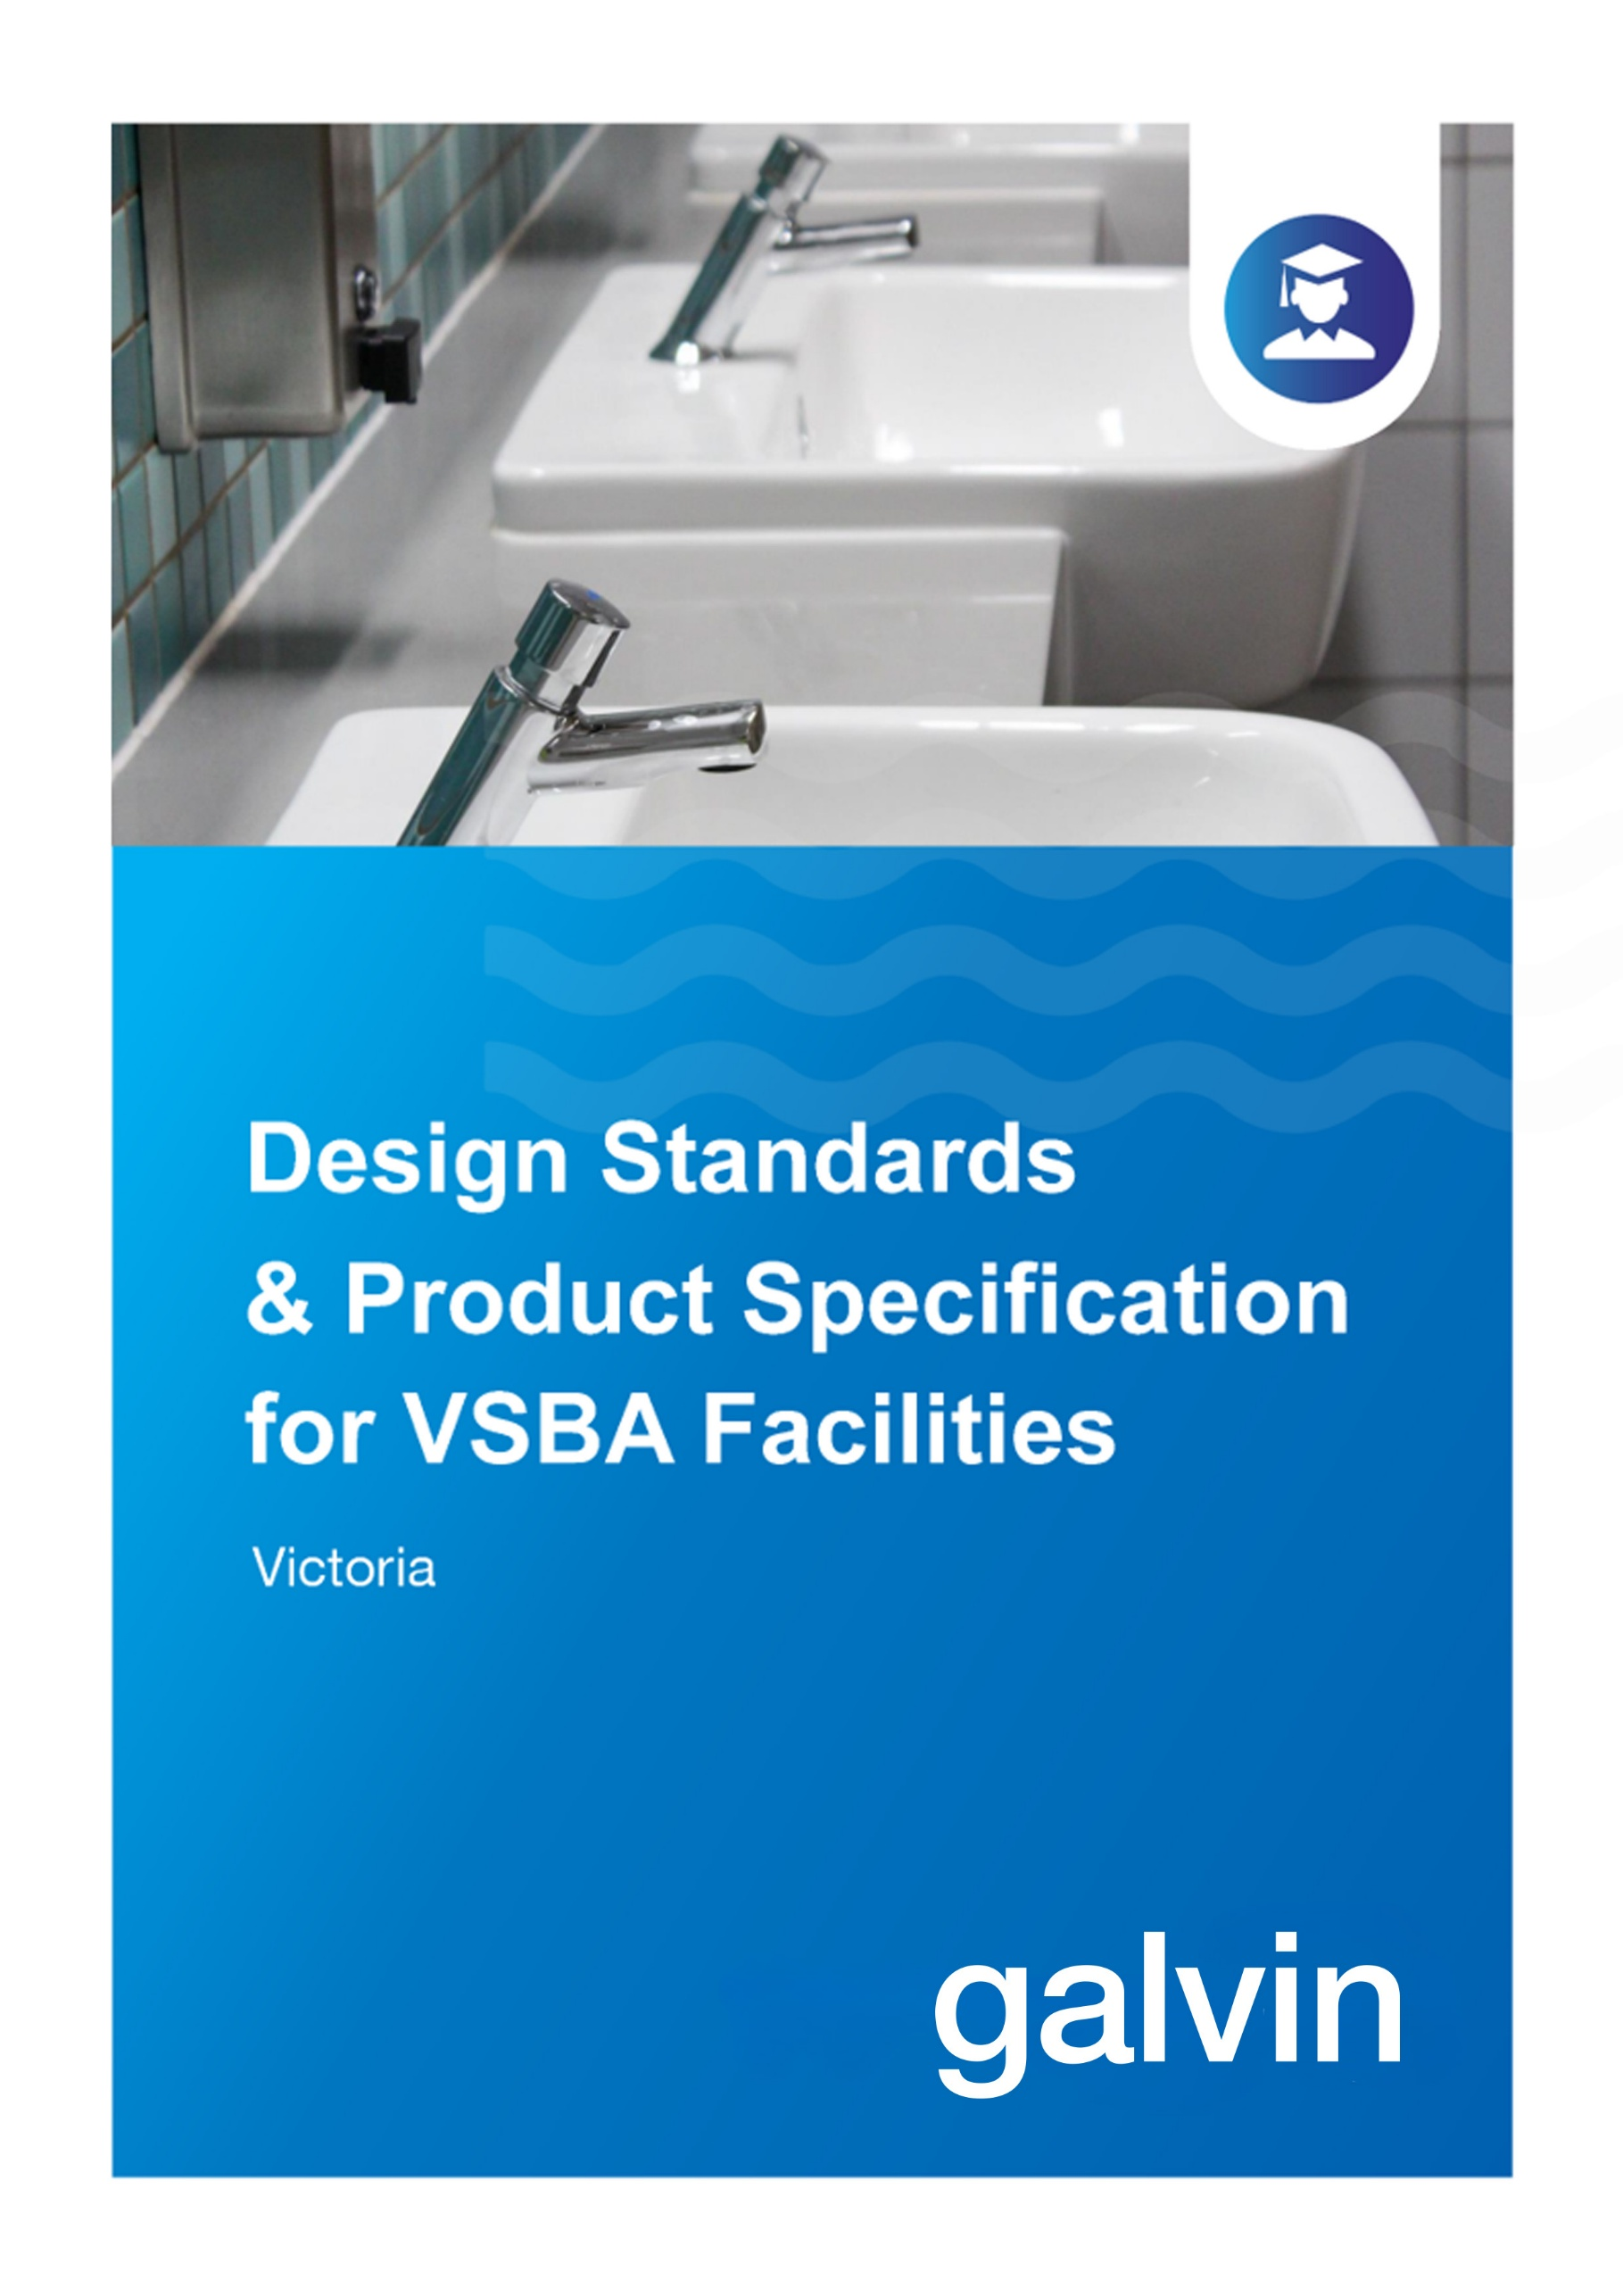

Building Quality Standards Handbook May 2022
VSBA Guideline Pages relevant to Galvin Engineering product selection

Lead Content in School Plumbing
Any piping, tapware or ﬁttings that hold or distribute potable water, or form part of a water source where a child could ﬁll a cup or drink bottle for consumption, must be comprised of products that either:
- Do not contain lead, or
- Do not allow contact between brass-containing lead and water (referred to here as ‘lead-safe’ products), where appropriate products are available on the Australian market.
In scope are all tapware, ﬁttings, piping systems and infrastructure that form part of a drinking water service. Pipe ﬁttings, breeches and thermostatic mixing valves, hot and cold tapware, and boiling water units are subject to this requirement. These elements can be made from stainless steel, copper, cross-linked polyethylene and copper tubing, lead-safe and plastic plumbing products.
This requirement does not apply to ﬁxtures such as sinks, troughs and basins, external vandal-proof taps or infrastructure associated with ﬁre, waste or sewerage plumbing systems, however, tapware for troughs, sinks and basins that is not vandal-proof must comply with above lead-safe or -free requirements.
Deadlegs must be avoided in all parts of a plumbing system. The design team must log any departures and rationale for these during the design phase.
Additionally, all plumbing ﬁxtures, materials and ﬁttings installed in new Victorian schools or in upgrades to existing schools must be certiﬁed under the WaterMark Certiﬁcation Scheme.

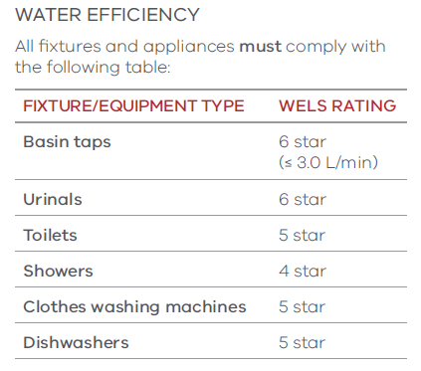

Tap Fittings and Fixtures
Robust, tamper-proof tap fittings and fixtures are required with either timed delivery or appropriate water-saving requirements.
Project consultants must select and satisfy tap fittings and fixtures that meet the following requirements:
- Be satin chrome-plate finish on metal
- Where possible, use the same model and manufacture throughout a school.
Tapware for later stages is to match the first stage.
Cold water tapware must be coded ‘blue’ and hot water tapware must be coded ‘red’. Cold water tapware must be fixed on the right-hand side of the fixture and hot water tapware must be fixed on the left-hand side.
Laboratory-type tapware must be high goose-neck type, bench-mounted or sink-mounted, and must be acid resistant to suit the application.
Drinking fountain tapware must be lever spring-action drinking cocks with mouthguard and 100mm-long flanged horizontal extension to tap. Location of taps and troughs must minimise potential vandalism or other damage.
For hygiene, water conservation and consistency with the principles of inclusion, taps should be press button self-closing systems or top lever timeflow bib taps. Taps in kitchen situations must be pillar mixer taps.
Where cleaners’ taps are provided, these must be positioned at a height to allow a bucket to be easily filled and be fitted with anti-vandal tap spindles.
External taps that deliver recycled water must be fitted with anti-vandal tap spindles.
Hands-free tap operation must be provided at hand wash basins where required by local government by-laws for food service areas.
Press button, self-closing/timeflow taps, or top lever timeflow bib taps, that do not need to be manually turned off after use, must be installed at handwash basins for infection control (where fitted for junior students operation is to be sufficiently ‘soft’ for them to use).

Basin Tapware
Location | Product Description | Image | Notes
STUDENT BASINS OPTION 1: single lever mixer | 113.42.10.03  GalvinAssist® CP Lead Safe™ Basin Mixer with Short Paddle Handle H&C | 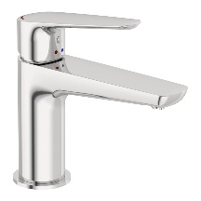 | - Made from Lead Safe DR Brass  - WELS 6* rated
STUDENT BASINS OPTION 2: single lever mixer | 113.42.20.03  GalvinAssist® CP Lead Safe™ Basin Mixer with Long Paddle Handle H&C | 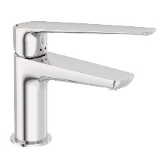 | - Made from Lead Safe DR Brass  - WELS 6* rated
STUDENT BASINS OPTION 3: time-controlled tap | 173.15.21.00  Ezy-Push® CP-BS Lead Safe™ Timeflow Push Button Pillar Tap - 6 Sec | 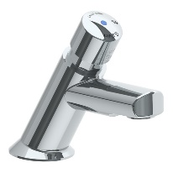 | - Made from Lead Safe DR Brass  - WELS 6* rated
STUDENT BASINS OPTION 4: time-controlled tap | 368696X  Ezy-Push® SS316 Lead Safe™ Timeflow Push Button Pillar Tap 6 Sec – MI | 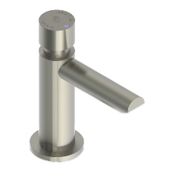 | - Made from Lead Safe SS316  - WELS 6* rated
STUDENT BASINS OPTION 5: time-controlled tap, lever handle | 173.15.23.00  Ezy-Lever CP-BS Lead Safe™ Timeflow Lever Action Vandal Resistant Pillar Tap | 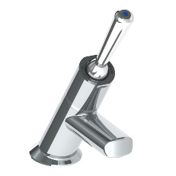 | - Made from Lead Safe DR Brass  - Lever handle to assist younger children who haven't yet developed the strength for push buttons  - WELS 6* rated
STAFF BASINS OPTION 1: basin mixer | TM-BASX  CliniLever® Stainless Steel Lead Safe™ Basin Mixer | 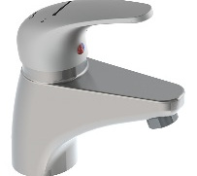 | - Made from Lead Safe SS316 WELS 6* & 5* rated
DISABLED BASINS: basin mixer | TM-BASXD  CliniLever® Stainless Steel Lead Safe™ Basin Mixer with Accessible Lever | 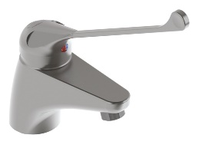 | - Made from Lead Safe SS316  - WELS 6* & 5* rated
ADDITIONAL BASIN OPTIONS: sensor tap | 151.10.22.00  Flowmatic® Lead Safe™ GC20 Hob Basin Tap | 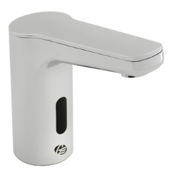 | - Made from Lead Safe DR Brass  - Battery and mains power options available  - Temperature mixing models also available  - WELS 6* rated
ADDITIONAL BASIN OPTIONS: single lever mixer | 113.41.10.03  GalvinAssist® CP Lead Safe™ Short Sink Mixer with Short Paddle Handle H&C | 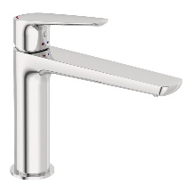 | - Made from Lead Safe DR Brass  - WELS 6* rated
ADDITIONAL BASIN OPTIONS: single lever mixer | 113.41.20.03  GalvinAssist® CP Lead Safe™ Short Sink Mixer with Long Paddle Handle H&C | 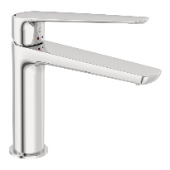 | - Made from Lead Safe DR Brass  - WELS 6* rated

Sink Tapware
Location | Product Description | Image | Notes
SINK MIXER OPTION 1 | 113.43.10.03  GalvinAssist® CP Lead Safe™ Tall Sink Mixer with Short Paddle Handle H&C | 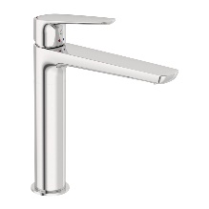 | - Made from Lead Safe DR Brass  - WELS 6* rated
SINK MIXER OPTION 2 | 113.43.20.03  GalvinAssist® CP Lead Safe™ Tall Sink Mixer with Long Paddle Handle H&C | 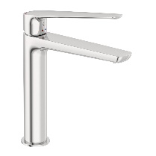 | - Made from Lead Safe DR Brass  - WELS 6* rated
SINK MIXER OPTION 3 | TM-SNKX  CliniLever® Stainless Steel Lead Safe™ Sink Mixer | 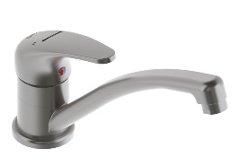 | - Made from Lead Safe SS316  - WELS 6* & 5* rated
SINK MIXER OPTION 4 | TM-SNKGX  CliniLever® Stainless Steel Lead Safe™ Gooseneck Sink Mixer | 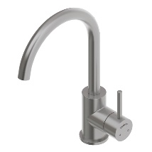 | - Made from Lead Safe SS316  - WELS 6* & 5* rated
SINK MIXER OPTION 5 | TM-SNKGVX  CliniLever® SS Lead Safe™ Gooseneck Sink Mixer with Pull Out Spray | 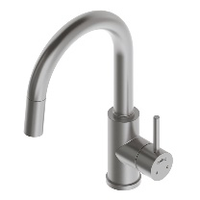 | - Made from Lead Safe SS  - WELS 6* & 5* rated
DISABLED SINKS: sink mixer | TM-SNKXD  CliniLever® Stainless Steel Lead Safe™ Sink Mixer with 225mm Accessible Lever | 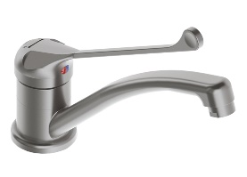 | - Made from Lead Safe SS316  - WELS 6* & 5* rated
Cleaners Room Tapware
Location | Product Description | Image | Notes
CLEANER SINK | 174.51.22.03  Vandal Resistant CP-BS Lead Safe™ Wall Sink Set with 200 Reach x 150H Swivel Gooseneck Outlet J/V | 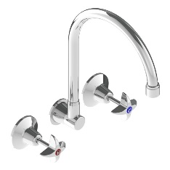 | - Made from Lead Safe DR Brass  - WELS 5* rated
CLEANER SINK | 174.53.42.03  Vandal Resistant CP-BS Lead Safe™ Wall Sink Set with 200 Reach Swivel Upswept Outlet J/V | 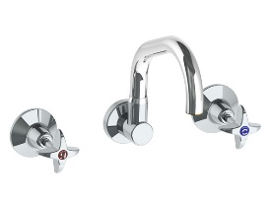 | - Vandal resistant design  - Made from Lead Safe DR Brass  - WELS 5* rated
HOSE COCK | 174.42.02.01  Vandal Resistant CP-BS Lead Safe™ Hose Tap J/V - Cold | 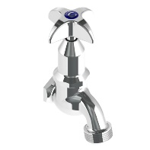 | - Vandal resistant design  - Made from Lead Safe DR Brass  - Hot option available also
HOSE COCK | 12575  BS Key for Key Control Tap Polished | 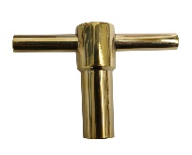 | - Made from DZR Brass
HOSE COCK | 13284LF  CP-BS Lead Safe™ Key Control Hose Tap 12 (15BSP) Less Key | 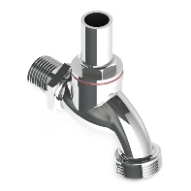 | - Vandal resistant design  - Made from Lead Safe DR Brass

Drinking Fountains
Accessible, potable water is a health and safety requirement. Drinking water should be provided based on one tap per 30 students.
Drinking fountains must be dispersed throughout the school in convenient areas, ensuring all students can access them when needed.
Project consultants must select and satisfy drinking fountains that meet the following requirements:
- Accessible to all users, including specific fountains dedicated for wheelchair accessibility
- Be made from lead-free or lead-safe products
- Appropriate to the age and height of users (ages 5–12 in primary schools, 12+ in secondary schools)
- Be placed near locations where physical activities occur, such as active play and sports areas, and where students are likely to eat lunch
- Be designed to allow students to fill water bottles.
Consideration should also be given in the design process to locating fountains in a way that minimises damage and vandalism.

Trough Tapware
Location | Product Description | Image | Notes
ABLUTION TROUGHS OPTION 1: timeflow tapware | 173.46.21.00  Ezy-Push® CP-BS Lead Safe™ Timeflow Push Button Deluxe Bib Tap MI - Cold (6 Sec) | 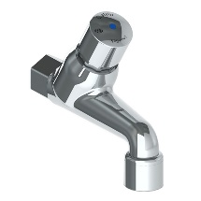 | - Made from Lead Safe DR Brass  - WELS 6* rated
ABLUTION TROUGHS OPTION 2: timeflow tapware | 368667X  Ezy-Push® SS316 Lead Safe™ Timeflow Push Button Deluxe Bib Tap MI - Cold (6 Sec) | 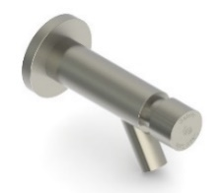 | - Made from Lead Safe SS316  - WELS 6* rated
ABLUTION TROUGHS OPTION 3: timeflow tapware, lever | 173.46.23.00  Ezy-Lever CP-BS Lead Safe™ Timeflow Lever Action Deluxe Bib Tap MI - 6 Sec | 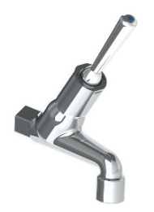 | - Made from Lead Safe DR Brass  - Lever handle to assist younger children who haven't yet developed the strength for push buttons  - WELS 6* rated
STUDENT LEARNING AREA TROUGHS VARIOUS:  bib tap | 174.41.12.01  Vandal Resistant CP-BS Lead Safe™ Deluxe Bib Tap J/V with Aerator MI - Cold | 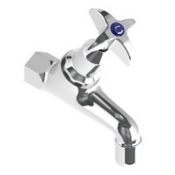 | - Made from Lead Safe DR Brass  - Hot version also available  - WELS 3* rated
DRINK TROUGHS | 170.81.13.01  Ezy-Drink® CP-BS Lead Safe™ Remote Push Button Drinking Bubbler Tap – FI | 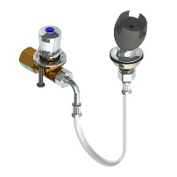 | - Made from Lead Safe SS316  - Automatic shut off  - WELS 6* rated
DRINK TROUGHS OPTION 4: | 170.50.14.00  Ezy-Drink® CP-BS Lead Safe™ Horizontal Lever Action Drinking Bubbler Tap - FI | 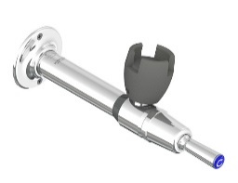 | - Made from Lead Safe DR Brass  - Lever handle to assist younger children who haven't yet developed the strength for push buttons  - WELS 6* rated
DRINK TROUGHS OPTION 5: | 170.50.13.01  Ezy-Drink® CP-BS Lead Safe™ Horizontal Push Button Drinking Bubbler - FI | 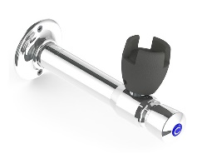 | - Made from Lead Safe DR Brass  - WELS 6* rated
DRINK TROUGHS BOTTLE FILLER | 170.13.33.00  Ezy-Drink® CP-BS Lead Safe™ Hob Mtd Bottle Filler Tap RH- MI | 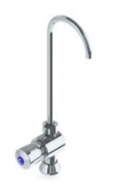 | - Made from Lead Safe DR Brass  - WELS 6* rated
WALL BOTTLE FILLER OPTION 1 | 170.53.13.00  Ezy-Drink® CP-BS Lead Safe™ Wall Mtd Push Button Bottle Filler | 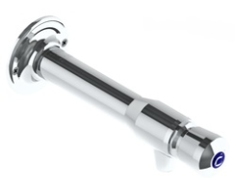 | - Made from Lead Safe SS316  - WELS 6* rated
WALL BOTTLE FILLER OPTION 2 | 170.53.14.00  Ezy-Drink® CP-BS Lead Safe™ Wall Mtd Lever Action Bottle Filler | 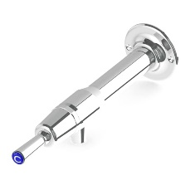 | - Made from Lead Safe SS316  - WELS 6* rated

Sanitaryware
Suitable sanitary fittings and fixtures are to be provided that support and complete the delivery of functional spaces and meet the needs of users. Installation of all sanitary fixtures and fittings connected to service pipework must include all required anchorages, fixings, lugged elbows and the like, as necessary for a robust, durable, impact-resistant installation.
Project consultants should select and satisfy sanitary fixtures and fittings that meet the following requirements:
- Be new, free from defects, damage, corrosion and surface blemishes
- Be chemically and electrolytically compatible with adjacent materials and products, substrates, and adjacent work, or separated by suitable spacers
- Adjacent materials and products, including adhesives and sealants, will not stain, corrode or contaminate, and must not cause visual or structural defects in adjacent materials
- All pans in schools are to be fixed at a standard height to maintain flexibility of use; junior pans are not required [refer kindergarten requirements below]
- Use similar models and manufacturers throughout to achieve design coherence
- Wall-mounted cisterns are preferred as they are easier to maintain (if unconcealed wall mounted, they must be made as tamperproof as possible)
- Press button, self-closing/timeflow taps, or top lever timeflow bib taps, that do not need to be manually turned off after use, must be installed at handwash basins for infection control (where fitted for junior students operation is to be sufficiently ‘soft’ for them to use)
- Pans and toilet pipes must be of an appropriate capacity and durability for school use
- Plumbing fixtures must drain adequately and not create blockages
- Low flushing toilets must only be used if gradients include a safety allowance to allow for low flushing.
Specifications for sanitaryware must be considered in line with Hydraulic services, and specifications relating to the trapment and drainage of water.
Toilets must be floor-mounted vitreous china with wall-backed pan and have a strong vandal-proof fixing between the seat and pan, with anti-vandal fixing accessories. Toilets provided for adults must have a double-flap hinged toilet seat with Single-flap toilet seats will be provided for student toilets.
All pans in schools are to be fixed at a standard height to maintain flexibility of use [i.e. junior pans are not required in schools. Refer below for kindergarten requirements].
Where required, accessible toilet pans as specified in the Disability Discrimination Act (DDA) must be provided, with wall extension pedestal and easily accessible flush button.
Accessible toilets must be provided as per DDA requirements and counted towards the base NCC toilet calculation.
Toilet Pans
Location | Product Description | Image | Notes
TOILET SUITE STANDARD | 105.10.00.03  GalvinAssist® Rimless Close Coupled Toilet Suite with Blue Seat, S-Trap (NSW) | 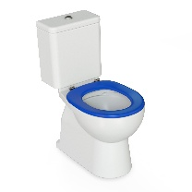 | - Rimless pan design  - 425MM Pan height for easier transfer  - High contrast seat  - Soft closing, quick release seat  - S trap installation
TOILET SUITE AMBULANT | 105.10.20.00  GalvinAssist® Rimless Ambulant Toilet Suite with Double Flap Soft Close White Seat | 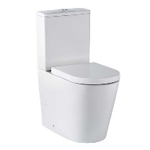 | - Rimless pan design  - Soft closing, quick release seat  - Universal cistern, suits back entry or bottom entry plumbing  - Grey seat option available  - Universal traps suitable for S or P trap installations  - WELS 4* Rating
TOILET SUITE DISABLED | 105.10.10.04  GalvinAssist® Rimless Accessible Toilet Suite with Single Flap Grey Seat | 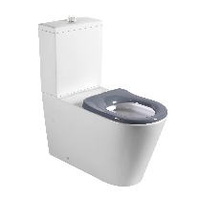 | - Rimless pan design  - Soft closing, quick release seat  - Universal traps suitable for S or P trap installations  - Universal cistern, suits back entry or bottom entry plumbing  - Blue seat option available
STANDARD TOILET PAN – INWALL CISTERN | 105.11.20.00  GalvinAssist® Clean Flush Ambulant Toilet Pan with Double Flap Soft Close White Seat | 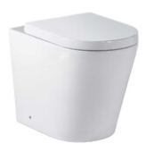 | - Universal traps suitable for S or P trap installations  - Hidden cistern activated through a premium pneumatic system connected to the flush plate buttons  - WELS 4* Rating
AMBULANT TOILET PAN – INWALL CISTERN | 105.11.20.00  GalvinAssist® Clean Flush Ambulant Toilet Pan with Double Flap Soft Close White Seat |  | - Universal traps suitable for S or P trap installations  - Hidden cistern activated through a premium pneumatic system connected to the flush plate buttons  - WELS 4* Rating
DISABLED TOILET PAN – INWALL CITERN | 105.11.10.01  GalvinAssist® Clean Flush Rimless Accessible Toilet Pan with Single Flap Blue Seat | 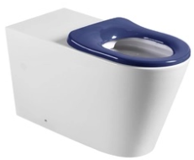 | - Care toilet seat, soft closing, quick release for easy removal and cleaning  - Suitable for S or P trap installations  - Grey Seat also available  - WELS 4*Rating
ROBUST STANDARD TOILET PAN – INWALL CISTERN | 123.40.12.40  Wallgate Ligature Resistant Solid Surface WC Pan with Integrated Grey Seat, 445x523mm | 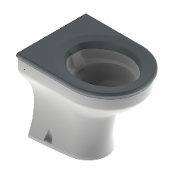 | - Ligature and vandal resistant  - Solid surface material  - Rimless design  - Refurbishable in-situ  - Front or rear fixing  - Two integrated seat colours  - WELS 4* Rating
ROBUST ACCESSIBLE TOILET PAN – INWALL CISTERN | 123.44.32.40  Wallgate Ligature Resistant Solid Surface Accessible WC Pan, Coved, with Integrated Grey Seat, 460x810mm | 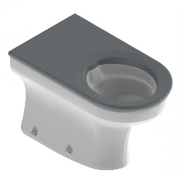 | - Ligature and vandal resistant  - Solid surface material  - Rimless design  - Refurbishable in-situ  - Front or rear fixing  - five integrated seat colours  - WELS 4* Rating
INWALL CISTERN  OPTION 1 | 105.94.00.00  GalvinAssist® Slim Design Inwall Cistern Only | 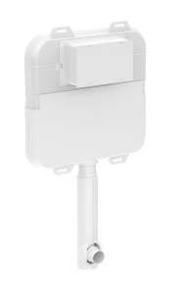 | - Slim design, 80 mm thick to suit floor mount pan  - Fits within standard wall cavity, front access through flush plate  - Fully insulated with anti-condensation foam to prevent moisture escape  - Hidden cistern activated through a premium pneumatic system connected to the flush plate buttons  - WELS 4* Rating
INWALL CISTERN  OPTION 2 | CIST19-PNEU-2  Wallgate Pneumatic Activated Concealed Slimline Cistern 3.0L & 4.5L | 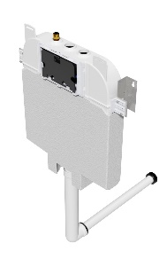 | - Slimline cistern  - Concealed  - No power required  - WELS 4* Rating
PUSH BUTTON COMMERCIAL  OPTION 1 | 656514  GalvinCare® SS Ligature Resistant Dual Flush Plate with Conical Buttons for Pneumatic Cistern | 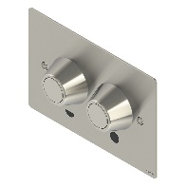 | - Pneumatic activation  - Ligature resistant design  - Vandal resistant design  - Conical buttons with smooth inner surfaces for ease of use
PUSH BUTTON COMMERCIAL  OPTION 2 | 656512  SS Vandal Resistant Dual Flush Plate Assembly for Pneumatic Inwall Cistern with CP-BS Raised Buttons | 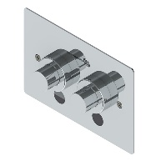 | - Raised Buttons  - Vandal Resistant
PUSH BUTTONS FOR STANDARD INWALL SUITE | 105.95.00.00  GalvinAssist® Chrome, Dual Flush Plate, Pneumatic Push to Suit Inwall Cistern | 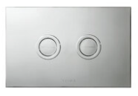 | - Pneumatic activation  - Concealed fixing
PUSH BUTTONS FOR DISABLED INWALL SUITE | 105.96.00.00  GalvinAssist® Chrome, Accessible Dual Flush Plate, Pneumatic Push to Suit Inwall Cistern | 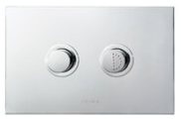 | - Pneumatic activation  - Raised Buttons  - Concealed fixing

Hand Wash Basins
Basins for hand washing are required throughout the school.
A soap dispenser unit must be installed at each handwash basin and positioned to avoid dripping on benchtops or floors.
Project consultants must select and satisfy hand wash basins that meet the following requirements:
- Vitreous china basins, wall hung
- Mounted at an appropriate height for students and staff, with particular basins adjusted for accessibility.
Self-rimming inset hand wash basins into joinery bench tops can be used in staff areas only.
For student areas, basins must be fixed into solid substructure and be resistant to damage by vandalism, including climbing.
Basins provided for primary school students must use cold water only. Basins in staff-assisted student bathrooms at special, supported inclusion and special development schools must be provided with cold and tempered hot water (45°C) to reduce the risk of scalding.
No plugs are required for all hand wash basins.

Hand Basins
Location | Product Description | Image | Notes
WALL BASIN | 500.310.01.7-KIT  Selnova Square Wall Basin 50cm with Overflow 1TH + Wall Fixing Kit | 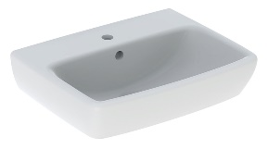 | - Vitreous china  - Optional shroud available
SEMI-RECESSED BASIN | 106.31.10.01  GalvinAssist® 550mm Semi Recessed Basin without Overflow 0TH | 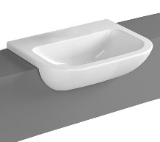 | - Vitreous china
BASIN SHROUD ONLY | 500.329.01.7-KIT  Top of Form  Bottom of Form  Selnova Basin Shroud + Wall Fixing Kit | 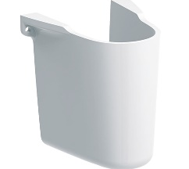 | - Fully glazed for infection control  - Fixing kit included
BASIN – BOTTLE TRAP | 105.93.00.00  GalvinAssist® Chrome, Round Bottle Trap, Wall Exit, Suits 32mm & 40mm Waste | 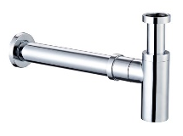 | - Material: Brass alloy  - Finish: Chrome
DISABLED BASIN – LEFT HAND BOWL | 105.30.71.02  GalvinAssist® 720mm Accessible Wall Basin LH Bowl with Overflow 1TH | 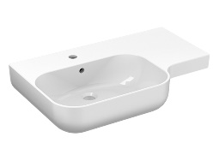 | - Vitreous china  - Choice of 0, 1 0r 3 tapholes  - Choice with or without overflow
DISABLED BASIN – RIGHT HAND BOWL | 105.30.70.02  GalvinAssist® 720mm Accessible Wall Basin RH Bowl with Overflow 1TH | 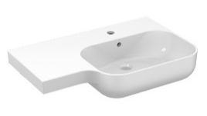 | - Vitreous china  - Choice of 0, 1 0r 3 tapholes  - Choice with or without overflow

Toilet Amenities Fixtures and Fittings
Grab Rails
Location | Product Description | Image | Notes
BACKREST | 105.76.02.01  GalvinAssist® PWD Backrest | 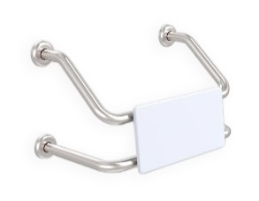 | - Suits single PWD cubicle with either conventional or wall faced pans  - Suits combined PWD compartment featuring WC and shower recess grab rail  - Polar White UV stabilised HDPE rounded edge back support
GRAB RAIL ANGLED | 105.05.03.31 (L/Hand)  105.05.03.41 (R/Hand)  GalvinAssist® Angled 700 x 450 Grab Rail | 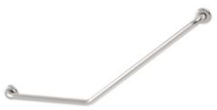 | - Suit Ambulant  - Other finishes/colours also available
GRAB RAIL 90D | 105.08.09.31 (L/H)  105.08.09.41 (R/H)  GalvinAssist® Angled 960 x 600mm Grab Rail | 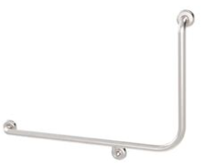 | - Suit Ambulant  - Other finishes/colours also available
GRAB RAIL STRAIGHT | 105.00.00.01 (300mm)  105.00.03.01 (450mm)  105.00.09.01 (900mm)  GalvinAssist® Straight Grab Rail Stainless Steel | 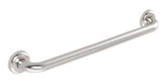 | - Available finishes: polished, machined diamond and white.

Showers
Showers are to be provided to student changing rooms, staff changing rooms and DDA accessible student toilet/bathroom facilities. Showers must be safe, self-draining and designed to allow for privacy for each user.
DDA accessible showers must be fitted with stainless steel grab rails, a shower seat and shower curtains, hooks and all other associated and required fittings to meet required Australian Standards. Where shower rooms are fitted with overhead hoists and ceiling-mounted hoist tracking, project consultants must provide a curtain solution that does not rely on ceiling support brackets.
Shower heads to general purpose showers must be anti-vandal, fixed head type outlets.
Shower heads for DDA accessible showers must comprise a vertical wall rail, hand shower on flexible hose, integral soap dish, and wall bracket.

Shower Tapware
Location | Product Description | Image | Notes
ALL SHOWERS; shower mixer | TM-SHWX  CliniLever® Stainless Steel Lead Safe™ Shower or Bath Mixer | 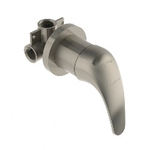 | - Made from Lead Safe SS316
ALL SHOWERS; shower mixer option 2 | 113.62.10.03  GalvinAssist® CP Lead Safe™ Shower Mixer Set with Short Paddle Handle H&C | 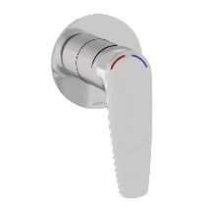 | - Oversized coloured indicators  - Choice of H&C or W&C indicators  - Lead Free DZR Brass
DISABLED SHOWERS OPTION 1; rail shower | 41999CP  GalvinAssist® CP Hand Shower Kit with 900 x 32mm SS Hygienic Grab Rail | 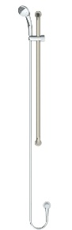 | - Available with white or chrome plated PVC hose and handpiece  - WELS 3* rated
DISABLED SHOWERS OPTION 2; inverted T rail shower | 41978CP  GalvinAssist® CP Hand Shower with Inverted T 700 x 1100mm SS Hygienic Grab Rail (Centre) | 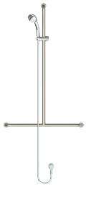 | - Available in left, right and centre inverted T rail  - WELS 3* rated
DISABLED SHOWERS OPTION 3; CLEVA shower | 113.62.20.03  GalvinAssist® CP Lead Safe™ Shower Mixer Set with Long Paddle Handle H&C | 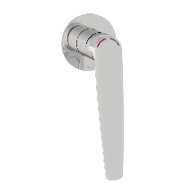 | - Oversized coloured indicators  - Choice of H&C or W&C indicators  - Lead Free DZR Brass
STAFF AND STUDENT SHOWERS | 121.33.64.00  GalvinCare® CP-BS Lead Safe™ Mental Health Anti-Ligature Wall Mtd Shower Rose 65 - Std | 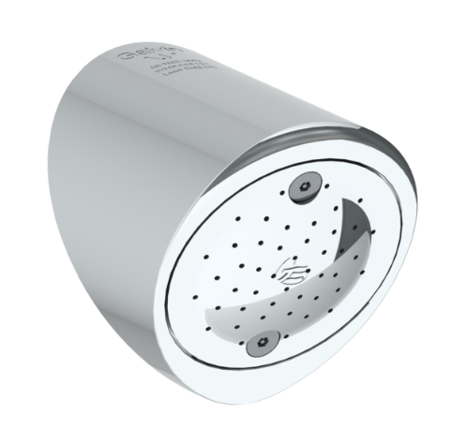 | - Made from Lead Safe DR Brass  - WELS 4* rated

Temperature Monitoring Systems
Location | Product Description | Image | Notes
TMV OPTION 1 | 201.70.11.09  CliniMix® 1500 Lead Safe™ Thermostatic Mixing Valve | 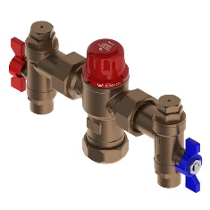 | - Made from Lead Safe DR brass (<0.25% lead)  - Thermal disinfection capable
TMV OPTION 2: in cabinet | 201.10.70.10  CliniMix® 1500 Lead Safe™ Thermostatic Mixing Valve in Cabinet | 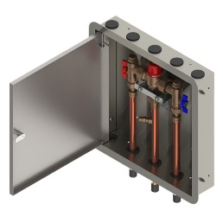 | - Made from Lead Safe DR brass (<0.25% lead)  - Thermal disinfection capable
TMV OPTION 3: in cabinet with bypass | 201.11.70.10  CliniMix® 1500 Lead Safe™ Thermostatic Mixing Valve with Cold Bypass in Cabinet | 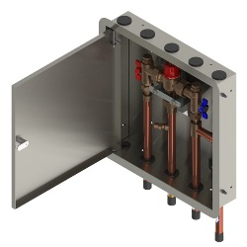 | - Made from Lead Safe DR brass (<0.25% lead)  - Thermal disinfection capable

Drainage and Cleanouts
Drains and Cleanouts
Location | Product Description | Image | Notes
FLOOR DRAIN OPTION 1; tile/concrete floor | 302505X  HeelGrate® SS316 Floor Drain Grate Square 150x100 PVC/HDPE/CU Slip-In | 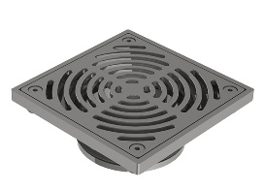 | - Heel-safe, crutch-tip-safe, wheelchair-wheel-safe
FLOOR DRAIN OPTION 2; tile/concrete floor | 302185X  HeelGrate® SS316 Floor Drain Grate Round 150x100 PVC/HDPE/CU Slip-In | 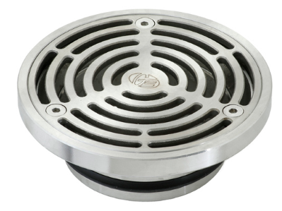 | - Square also available  - Other sizes also available  - Kits with cast iron bodies and buddle flanges also available
FLOOR DRAIN OPTION 3; vinyl floor | DI4M06VX  Industrial Floor Waste Combo - SS Vinyl Grate 150X100 PVC/HDPE /CU & SS Dual Strainers | 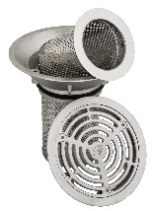 | - Easy-removal strainers
FLOOR DRAIN OPTION 4; vinyl floor | 303185X  HeelGrate® SS Floor Drain Vinyl Round 150 x 100 with SS Body PVC/HDPE/CU Slip-In | 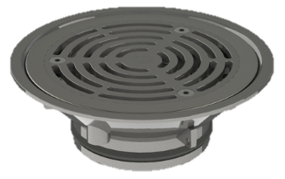 | - Square also available  - Other sizes also available  - Kits with cast iron bodies and buddle flanges also available
CLEANOUT OPTION 1; tile/concrete floor | 67790X  Slip-Safe® SS316 Bolted Cleanout Round 150x100 PVC/HDPE/CU Slip-In | 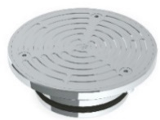 | - Square also available  - Other sizes also available  - Kits with cast iron bodies and buddle flanges also available
CLEANOUT OPTION 2; tile/concrete floor, square | 67778X  Slip-Safe® SS316 Bolted Cleanout Square 150x100 PVC / HDPE Slip-In | 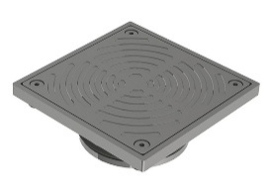 | - Slip-resistant textured grate
CLEANOUT OPTION 3; vinyl floor | 69468X  Slip-Safe® SS Vinyl Bolted Cleanout 150 x 100 PVC/HDPE/CU Slip-In | 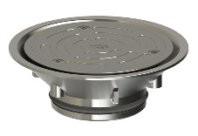 | - Other sizes also available  - Kits with cast iron bodies and buddle flanges also available

Laboratory Tapware
Laboratory Tapware
Location | Product Description | Image | Notes
STUDENT LAB TAP OPTION 1; cold only | 167.26.32.00  GalvinLab® CP Lead Safe™ Bib Tap Bench Mtd Type 26 DPW Fixed J/V #8 Aerator MI | 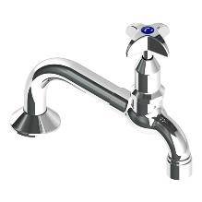 | - Australian Made  - Vandal resistant aerator  • WELS 6* & 5* rated
STUDENT LAB TAP OPTION 2; cold only | 167.16.21.00 (RH)  167.16.27.00 (LH)  GalvinLab® CP-BS Lead Safe™ Lab Set 1-Way Type 16 Fixed J/V #16XT Tube Nozzle | 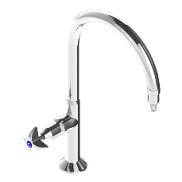 | - Australian Made  - Swivel outlet available  - Anti-rotation pins available  - Suitable for AS1428 applications  - Lead Free DZR Brass  - WELS 6* & 5* rated
STUDENT LAB TAP OPTION 3; cold only | 167.16.32.00 (RH)  167.16.33.00 (LH)  GalvinLab® CP-BS Lead Safe™ Lab Set 1-Way Type 16 DPW Fixed J/V #8 Aerator | 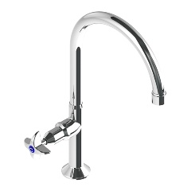 | - Australian Made  - Lead Free DZR Brass  - WELS 6* & 5* rated
STUDENT LAB TAP; cold only with DDA Lever Handle | 167.16.21.01 (RH)  167.16.27.01 (LH)  GalvinLab® CP-BS Lead Safe™ Lab Set 1-Way Type 16 Fixed J/V Lever Handle Tube Nozzle | 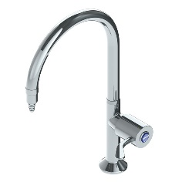 | - Australian Made  - Swivel outlet available  - Anti-rotation pins available  - Suitable for AS1428 applications  - Lead Free DZR Brass  - WELS 6* & 5* rated
STUDENT LAB TAP; cold only with DDA Lever Handle | 167.16.32.01  GalvinLab® CP-BS Lead Safe™ Lab Set 1-Way Type 16 Fixed J/V Lever Handle DPW #8 Aerator | 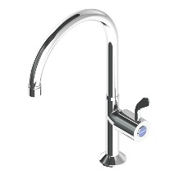 | - Australian Made  - Lead Free DZR Brass  - WELS 6* & 5* rated
TEACHER LAB TAP OPTION 1; hot and cold | 167.13.11.00  GalvinLab® CP-BS Lead Safe™ Lab Set H&C Mixing Unit Type 13 Swivel J/V #16XT Tube Nozzle | 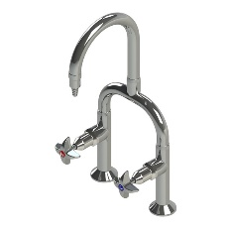 | - Australian Made  - Lead Safe DR Brass  - Vandal resistant aerator available  - Fixed outlet available  - WELS 6* & 5* rated
TEACHER LAB TAP OPTION 2; hot and cold | 167.13.12.00  GalvinLab® CP-BS Lead Safe™ Lab Set H&C Mixing Unit Type 13 Swivel J/V #1 Aerator | 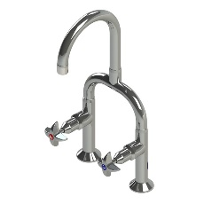 | - Australian Made  - Lead Safe DR Brass  - Fixed outlet available  - WELS 6* & 5* rated
TEACHER LAB TAP OPTION 3; hot and cold | 167.19.11.00  GalvinLab® CP-BS Lead Safe™ Lab Set H&C Mixing Unit Type 19 Swivel J/V #16XT Tube Nozzle | 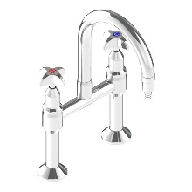 | - Australian Made  - Vandal resistant aerator available  - Fixed outlet also available  - Lever option also available for AS1428 applications  - Lead Free DZR Brass  - WELS 6* & 5* rated
TEACHER LAB TAP OPTION 4; hot and cold | 167.19.12.00  GalvinLab® CP-BS Lead Safe™ Lab Set H&C Mixing Unit Type 19 Swivel J/V #1 Aerator | 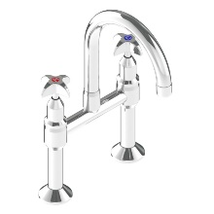 | - Australian Made  - Vandal resistant aerator available  - Fixed outlet also available  - Lead Free DZR Brass  - WELS 6* & 5* rated
LAB TAP VARIOUS OPTION 1; cold only | 167.07.20.00  GalvinLab® CP-BS Lead Safe™ Lab Set 3-Way Type 7 Fixed J/V #1 Aerator & #16XT Tube Nozzle | 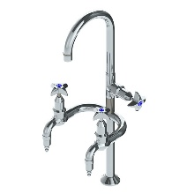 | - Australian Made  - Lead Free DZR Brass  - WELS 6* & 5* rated
LAB TAP VARIOUS OPTION 2; hot and cold | 167.14.20.00  GalvinLab® CP-BS Lead Safe™ Lab Set H&C Mixing Unit Type 14 Fixed J/V Aerator #1 #16XT Tube Nozzles | 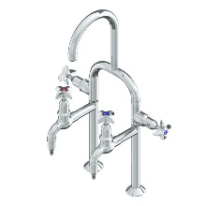 | - Australian Made  - Lead Free DZR Brass  - WELS 5* rated
LAB TAP SCIENCE PREP; hot & cold | 181.00.33.03  Ezy-Wash CP-BS Lead Safe™ Hob Mtd Exposed Mixing Pre-Rinse Unit Type 83 MI Inlet - Pot Filler | 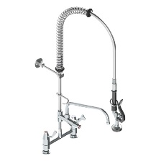 | - Australian Made  - Stainless steel spring  - Trigger hand spray  - 250mm pot filler  - Lead Free DZR Brass  - WELS 6* rated
LAB TAP SCIENCE PREP; hot & cold | 181.03.35.00  Ezy-Wash® CP-BS Lead Safe™ Hob Mtd Twin Mixer Pre-Rinse Unit Type 100 Flex Tail - Standard | 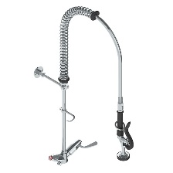 | - Australian Made  - Stainless steel spring  - Trigger hand spray  - Lead Free DZR Brass  - WELS 6* rated
GAS TURRET OPTION 1; single outlet | TG37C  GalvinLab® CP-BS Lab 1-Way Straight Gas Turret Type 37 | 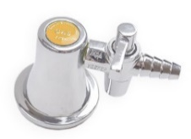 | - Australian Made  - Angled outlets also available
GAS TURRET OPTION 2; dual outlet | TG40C  GalvinLab® CP-BS Lab 2-Way Straight Gas Turret Type 40 - 90° | 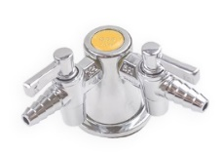 | - Australian Made  - Angled outlets also available

