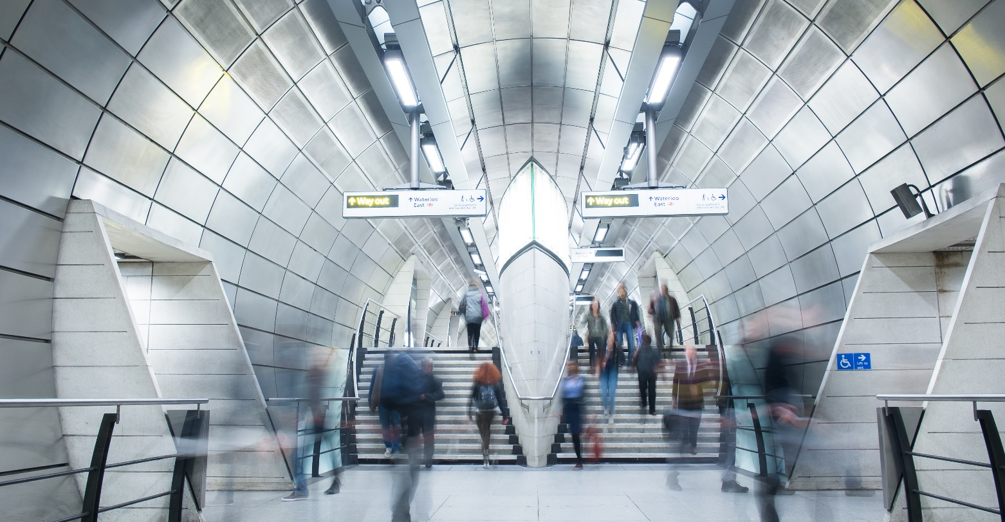

Sydney Trains
Sanitaryware and Tapware Fixtures

Specification Guide

Sydney Trains Toilet Fixtures
Specification Guide

Toilet Fixtures
Toilet facilities are provided at attended stations for the use of rail and intermodal customers.
- If toilets are provided, a minimum of one family accessible toilet with a baby change table facility, designed in accordance with AS 1428.1 (2001), is required. Where more than one toilet is to be provided, a minimum of one unisex toilet and one.
Toilet Interiors
- Fixtures must be positioned to eliminate the ability to hide or store unwanted items. Please refer to the diagram 5.9 for the interior layout of fixtures .
- Entry doors to the toilet/s shall be securely lockable by the station staff.
- Lighting and ventilation shall meet BCA and ASA Standard - ESB 001 Low Voltage Electrical Standard. Design toilet areas with natural ventilation where appropriate. If natural ventilation is not achievable, mechanical ventilation should be provided in the form of a sensor-operated exhaust system, with timer.
- The interior design should accommodate easy access for maintenance.
- The interior design should ensure full visibility of the inside area from the toilet entrance door.
- Emergency switch required inside the family accessible toilet.

Toilet Fixtures
- All materials, finishes, fixtures and fittings need to be highly durable, vandal resistant and easily cleaned.
- Installation, Design and Layout to be in accordance with relevant requirements, including but not limited to the National Construction Code BCA Volume One, Australian Standards (including AS1428.1 and AS1428.2), Disability Discrimination Act - Disability (Access to Premises - Buildings) Standards and Authority requirements.

Basins
 | Approved Product
Product Code | SHB-05W-LT
Product Name | Wallgate Wash Hand Basin Solid Surface - Front Fixed Exposed Services & LH Tap Holes  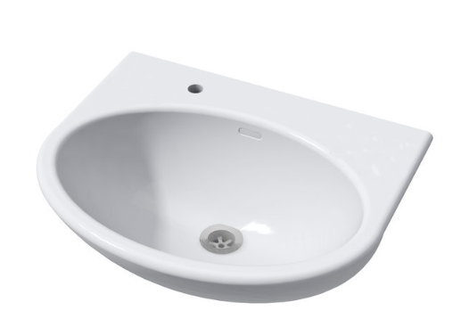
Finish | White
Product Information | Refer to Wallgate Wash Hand Basin Solid Surface - Front Fixed Exposed Services & LH Tap Holes

 | Approved Product
Product Code | SHB-05W-RT
Product Name | Wallgate Wash Hand Basin Solid Surface - Front Fixed Exposed Services & RH Tap Holes  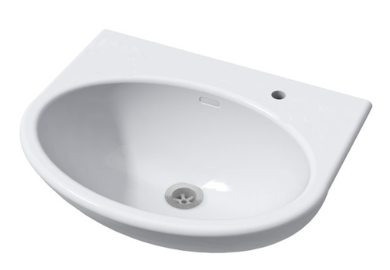
Finish | White
Product Information | Refer to Wallgate Wash Hand Basin Solid Surface - Front Fixed Exposed Services & RH Tap Holes

 | Approved Product
Product Code | SHB-05W-LRT
Product Name | Wallgate Wash Hand Basin Solid Surface - Front Fixed Exposed Services & LH/RH Tap Holes  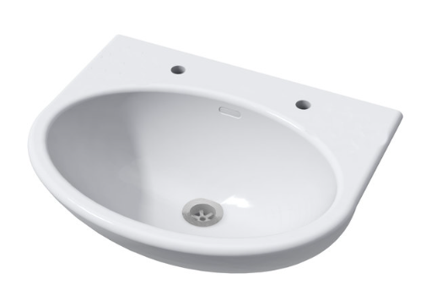
Finish | White
Product Information | Refer to Wallgate Wash Hand Basin Solid Surface - Front Fixed Exposed Services & LH/RH Tap Holes

 | Approved Product
Product Code | SHB-05W-NT
Product Name | Wallgate Wash Hand Basin Solid Surface - Front Fixed Exposed Services & No Tap Holes – White  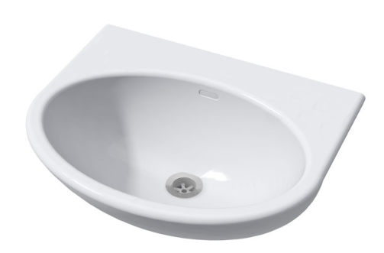
Finish | White
Product Information | Refer to Wallgate Wash Hand Basin Solid Surface - Front Fixed Exposed Services & No Tap Holes - White

Basin Shrouds
 | Approved Product
Product Code | SHBS01W
Product Name | Wallgate Small Shroud Only for SHB-05 Wall Mount Basin - Trap Cover Only  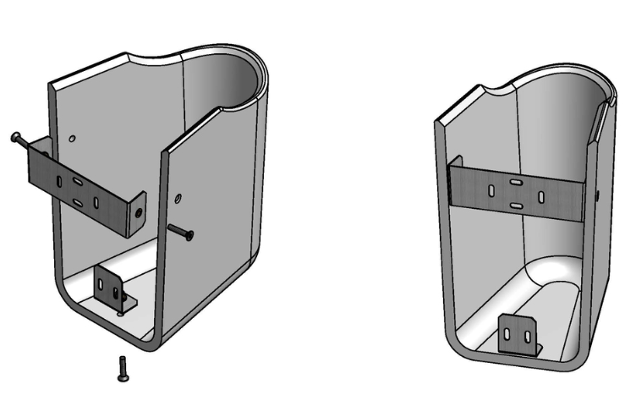
Finish | White
Product Information | Refer to Wallgate Small Shroud Only for SHB-05 Wall Mount Basin - Trap Cover Only

 | Approved Product
Product Code | SHBS02W
Product Name | Wallgate Large Full Shroud Only for SHB Wall Mount Basin - Trap & Fixture Cover  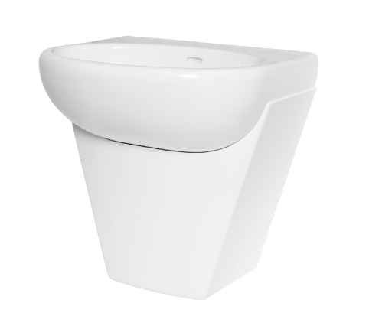
Finish | White
Product Information | Refer to Wallgate Large Full Shroud Only for SHB Wall Mount Basin - Trap & Fixture Cover
 | Approved Product
Product Code | SHB-04-RT
Product Name | Wallgate DDA Compliant Hand Basin Solid Surface - Front Fixed RH Tap Hole  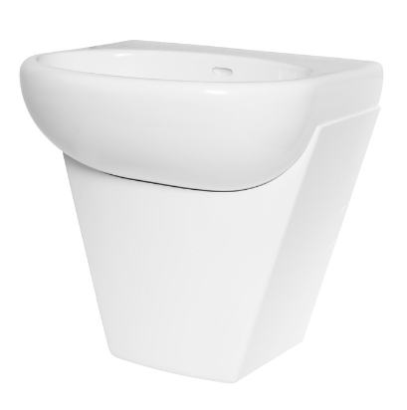
Finish | White
Product Information | Refer to Wallgate DDA Compliant Hand Basin Solid Surface - Front Fixed RH Tap Hole

 | Approved Product
Product Code | SHBS04
Product Name | Wallgate Full Shroud Only for SHB DDA Wall Mount Basin 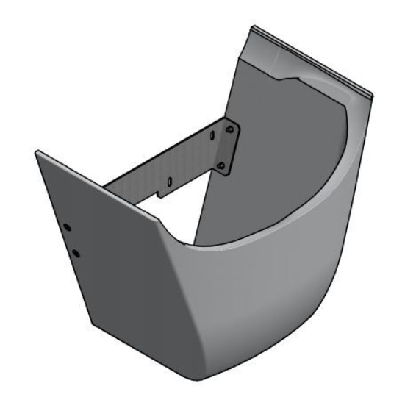
Finish | White
Product Information | Refer to Wallgate DDA Compliant Hand Basin Solid Surface - Front Fixed RH Tap Hole

Floor Waste
Non-slip finish to inspection point in accordance with BCA.
 | Approved Product
Product Code | 302505X
Product Name | HeelGrate® Stainless Steel Floor Drain Grate Square 150x100 PVC/HDPE/CU Slip-In  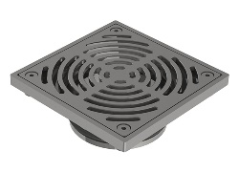
Finish | White
Product Information | Refer to HeelGrate® Stainless Steel Floor Drain Grate Square 150x100 PVC/HDPE/CU Slip-In
Tapware
Accessible Tapware
 | Approved Product
Product Code | 173.15.23.00
Product Name | Ezy-Lever CP-BS Lead Safe™ Timeflow Lever Action Vandal Resistant Pillar Tap  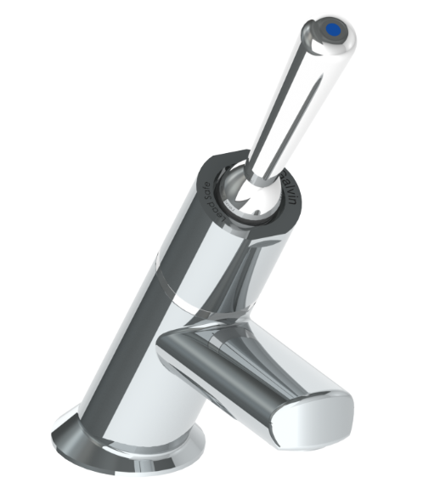
Finish | Chrome Plated
Product Information | Refer to Ezy-Lever CP-BS Lead Safe™ Timeflow Lever Action Vandal Resistant Pillar Tap

Tapware for Basins
 | Approved Product
Product Code | 173.15.21.00
Product Name | Ezy-Push® CP-BS Lead Safe™ Timeflow Push Button Pillar Tap - 6 Sec  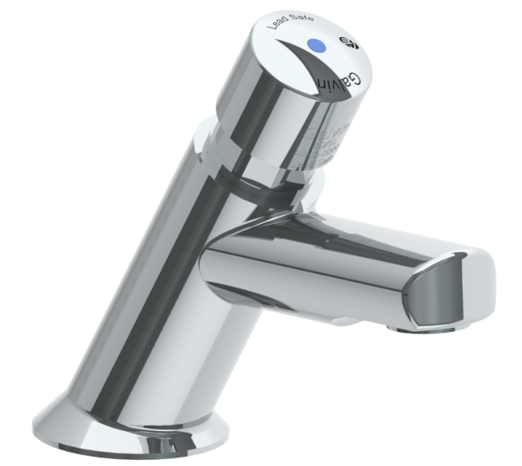
Finish | Chrome Plated
Product Information | Refer to Ezy-Push® CP-BS Lead Safe™ Timeflow Push Button Pillar Tap - 6 Sec

Tapware for Wash Plane
 | Approved Product
Product Code | 368667X
Product Name | Ezy-Push® 316 SS Lead Safe™ Timeflow Push Button Deluxe Bib Tap 6 Sec - MI  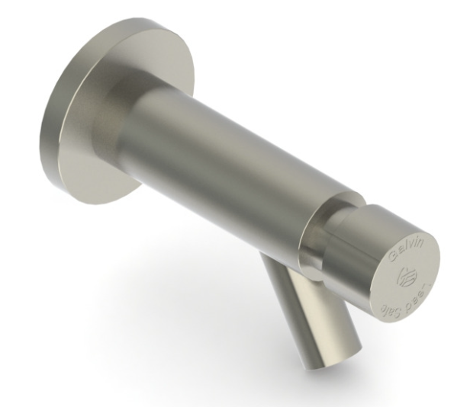
Finish | Stainless Steel
Product Information | Refer to Ezy-Push® 316 SS Lead Safe™ Timeflow Push Button Deluxe Bib Tap 6 Sec - MI

Toilets
Toilet Accessible - Compliant to AS1428.1
 | Approved Product
Product Code | CWC-155W-SF-BCA
Product Name | Wallgate Anti-Ligature, Anti-Vandal Solid Surface Disabled Pan - White 440(H) x 810(L) Floor & Seat Fixing  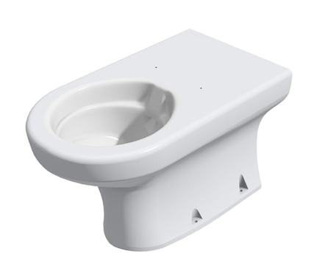
Finish | White
Location | Staf Toilets/Customer Toilets
Product Information | Refer to Wallgate Anti-Ligature, Anti-Vandal Solid Surface Disabled Pan - White 440(H) x 810(L) Floor & Seat Fixing
Notes | - Backrest and seat must be contrasting colour (Black) – Seat Ordered separately #TS0005 (Black)  - Available with integrated seat. Sydney Train approval required #CWC-155W-ST-AUS-BCA.  - Pan for hinged seat - Back to wall rear fixed and floor fixed (S&P Trap)

Flush Buttons Accessible – Compliant to AS1428.1
 | Approved Product
Product Code | CIPB-13FF
Product Name | Wallgate Secure WC Raised Push Button for Pneumatic Cistern 19-2, 0-15mm Wall with SS Mounting Plate
Finish | Stainless Steel
Product Information | Refer to Pneumatic WC, Basin & Shower Water Activation | Washroom Controls

 | Approved Product
Product Code | CIPB13
Product Name | Wallgate Secure WC Raised Push Button for Pneumatic Cistern 19-2, 0-15mm Wall  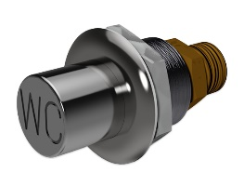
Finish | Stainless Steel
Product Information | Refer to Wallgate Secure WC Raised Push Button for Pneumatic Cistern 19-2, 0-15mm Wall

 | Approved Product
Product Code | CIPB14
Product Name | Wallgate Secure WC Palm Push Button for Pneumatic Cist 19-2, 0-50mm Wall  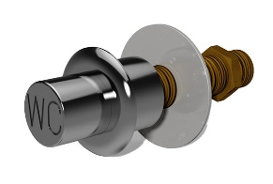
Finish | Stainless Steel
Product Information | Refer to Wallgate Secure WC Palm Push Button for Pneumatic Cist 19-2, 0-50mm Wall

 | Approved Product
Product Code | CIPB15
Product Name | Wallgate Secure WC Raised Push Button for Pneumatic Cistern 19-2, 0-15mm Wall with SS Mounting Plate  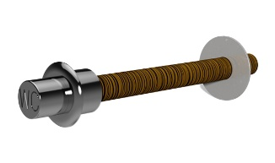
Finish | Stainless Steel
Product Information | Refer to Wallgate Secure WC Palm Push Button for Pneumatic Cist 19-2, 25-190mm Wall
Notes | Different button options provided, as varying walls and wall thickness will dictate button option

Vandal Resistant Inwall Cistern
 | Approved Product
Product Code | CIST19-PNEU-2
Product Name | Wallgate Pneumatic Activated Concealed Slim - Line 4.5L & 6L Cistern Only  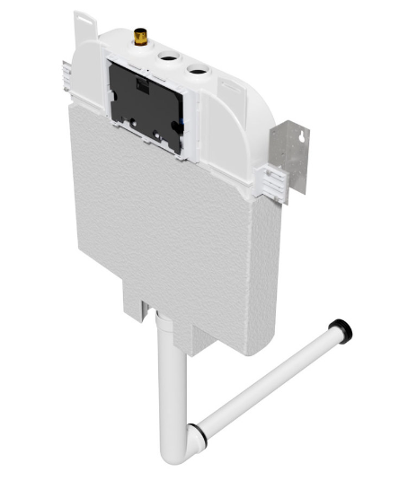
Finish | N/A
Location | Staff Toilets/ Customer Toilets
Product Information | Refer to Wallgate Pneumatic Activated Concealed Slim - Line 4.5L & 6L Cistern Only
Notes | - Single flush includes pipes and seals  - Areas where cisterns cannot be hidden in wall/ceiling then batten out wall to allow for concealed cistern (where possible)  - Single flush cisterns only and have a min capacity of 6L of water

Vandal Resistant Toilet Pans
 | Approved Product
Product Code | CWC-150W-SF-AUS
Product Name | Wallgate Anti-Ligature, Anti-Vandal Solid Surface Back To Wall Pan P Trap with Fix for Reg Seat 425x511  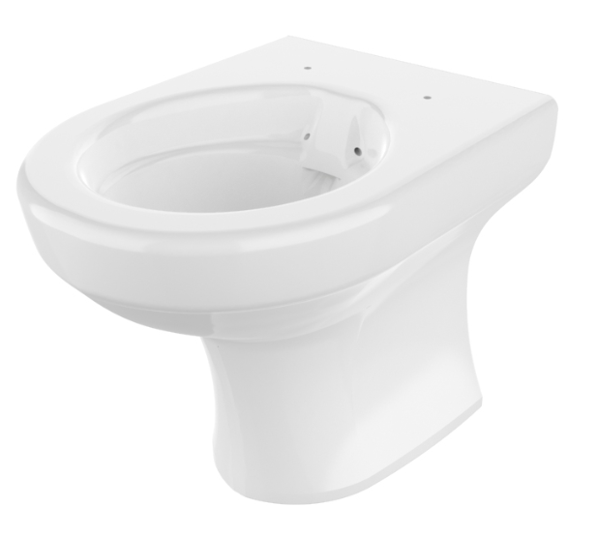
Finish | White
Location | Staff Toilets/ Customer Toilets
Product Information | Refer to Wallgate Anti-Ligature, Anti-Vandal Solid Surface Back To Wall Pan P Trap with Fix for Reg Seat 425x511
Notes | - 1. Confirm appropriate model to be used on site – this pan is designed as a through wall pan, whereby there is access and/or a duct for rear fixing  - Seat ordered separated (see below)

 | Approved Product
Product Code | CWC-155W-SF-AUS
Product Name | Wallgate Anti-Ligature, Anti-Vandal Solid Surface Back To Wall Pan S&P 425 x 691 with Seat Fixings - White 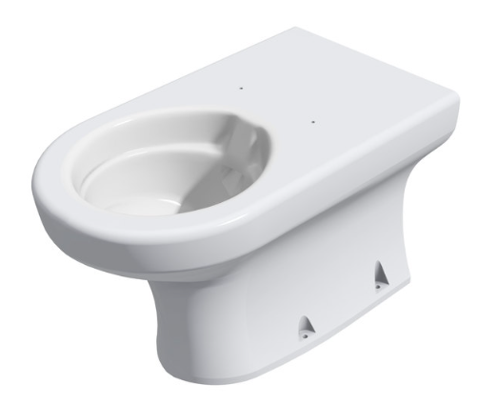
Finish | White
Location | Staff Toilets/ Customer Toilets
Product Information | Refer to Wallgate Anti-Ligature, Anti-Vandal Solid Surface Back To Wall Pan S&P 425 x 691 with Seat Fixings - White
Notes | - Confirm appropriate model to be used on site (i.e. S or P trap)  - Seat ordered separated (see below)

Toilet Seat
 | Approved Product
Product Code | TS0005
Product Name | Wallgate Hinged Toilet Seat Heavy Duty No Lid & Secure Fixings – Black  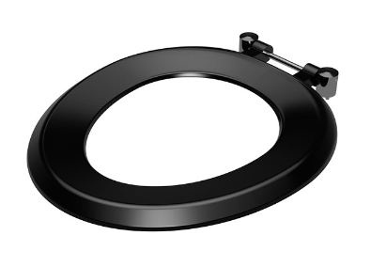
Finish | Black (also available in white)
Location | Staff Toilets/ Customer Toilets
Product Information | Refer to Wallgate Hinged Toilet Seat Heavy Duty No Lid & Secure Fixings - Black

Vandal Resistant Flush Buttons
 | Approved Product
Product Code | CIPB11-B
Product Name | Wallgate Secure WC Push Button for Pneumatic Cistern Cist19 PNEU-2; 0-50mm Wall-Single Push  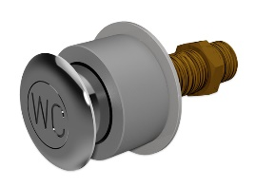
Finish | Black and White
Product Information | Refer to Wallgate Secure WC Push Button for Pneumatic Cistern Cist19 PNEU-2; 0-50mm Wall-Single Push

 | Approved Product
Product Code | CIPB12-B
Product Name | Wallgate Secure WC Push Button for Pneumatic Cistern Cist19 PNEU-2; 25-190mm Wall-Single Push  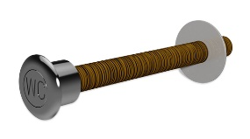
Finish | Stainless Steel
Product Information | Refer to Wallgate Secure WC Push Button for Pneumatic Cistern Cist19 PNEU-2; 25-190mm Wall-Single Push
Urinals
 | Approved Product
Product Code | CWU-01W-AUS
Product Name | Wallgate Anti-Vandal S/Surface Urinal with Through-Wall Concealed Services  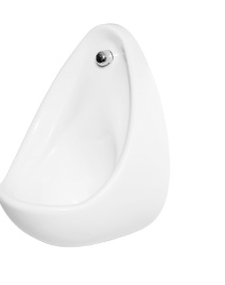
Finish | White
Location | Staff Toilets/ Customer Toilets
Product Information | Refer to Wallgate Anti-Vandal Solid Surface Urinal with Through-Wall Concealed Services - White
Notes | - Urinal with through wall concealed waste  - Exposed services option available if through wall isn’t possible.  - Cistern as instructed by Sydney Trains  - Sensor as instructed by Sydney Trains

 | Approved Product
Product Code | CWU-03W + Shroud
Product Name | Wallgate Anti-Vandal S/Surface Urinal w/ Exposed Vertical Waste Services - White [MTO]  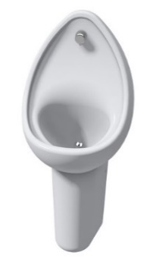
Finish | White
Location | Staff Toilets/ Customer Toilets
Product Information | Refer to Urinals, services shrouds & dividers | Urinals & Accessories
Notes | - Urinal with front of Wall concealed waste  - Exposed services option available if through wall is not possible.  - Cistern as instructed by Sydney Trains  - Sensor as instructed by Sydney Trains

